AVIATION HUMAN-COMPUTER INTERFACE (AHCI)
STYLE GUIDE

Version 2.2

May 1998

Foreword

The Aviation Human-Computer Interface (AHCI) Style Guide was developed by Veda Incorporated under contract with the Joint Cockpit Office. Technical direction was provided by Mr. Gilbert Boen (US Army Aviation Research Development and Engineering Center (AVRDEC)) who served as the Government project manager. Primary authors of the style guide were Mona Toms and Janet Williamson. Scott Cone provided technical oversight and served as Veda program manager, as well as a contributing author. Eric Martin provided additional technical review and editorial comments. Dr. Richard Shiffler served as a technical consultant during program concept definition. Finally, the authors wish to acknowledge Mr. Thomas Metzler who identified the need for human-computer interface (HCI) design guidance specific to the military aviation domain, and has been instrumental in defining and promoting this effort.

DISCLAIMER

This report was prepared as an account of work sponsored by an agency of the United States Government. Neither the United States Government nor any agency thereof, nor Veridian, nor any of their employees, makes any warranty, express or implied, or assumes any legal liability or responsibility for the accuracy, completeness, or usefulness of any information, apparatus, product, or process disclosed, or represents that its use would not infringe privately owned rights. Reference herein to any specific commercial product, process, or service by trade name, trademark, manufacturer, or otherwise does not necessarily constitute or imply its endorsement, recommendation, or favoring by the United States Government or any agency thereof, or Veridian. The views and opinions of authors expressed herein do not necessarily state or reflect those of the United States Government or any agency thereof.
TABLE OF CONTENTS
1. INTRODUCTION 1-1
1.1 BACKGROUND 1-1
1.2 OBJECTIVES 1-1
1.3 SCOPE AND INTENDED AUDIENCE 1-2
1.4 TECHNICAL APPROACH 1-2
1.4.1 Crew-Centered Design Philosophy 1-2
1.4.2 Operational Considerations 1-3
1.4.3 Functional Requirements of the AHCI 1-3
1.4.4 Design Goals 1-4
1.5 GUIDELINE DEVELOPMENT 1-5
1.6 INTENDED USAGE 1-6
1.6.1 Crew Station Design Process 1-6
1.6.2 Application of the AHCI Style Guide 1-8
1.7 DOCUMENT ORGANIZATION 1-8
1.8 REFERENCES 1-10

2. COCKPIT INFORMATION MANAGEMENT 2-1
2.1 CONSISTENT AND PREDICTABLE INTERFACE 2-3
2.2 SYSTEM COMPATIBILITY FOR TASK MANAGEMENT 2-7
2.3 INFORMATION CONTROL AND SYSTEM CONFIGURATION 2-10
2.3.1 System Configuration 2-14
2.3.2 Mode Management 2-15
2.4 DESIGNING FOR CREW COORDINATION 2-18
2.5 INTERACTING WITH AUTOMATED SUBSYSTEMS 2-21
2.6 EFFECTIVE USE OF DECISION AIDING 2-25
2.7 REFERENCES 2-28

3. DIALOGS AND IMPLEMENTATIONS 3-1
3.1 GENERAL GUIDELINES 3-3
3.2 MENU SYSTEMS 3-8
3.2.1 Definitions and Current Conventions 3-8
3.2.2 Menu Option Selection Methods 3-12
3.2.3 Menu Structure 3-13
3.2.4 Menu Navigation 3-16
3.3 GRAPHICAL INTERACTION 3-18
3.3.1 Definitions and Current Conventions 3-18
3.3.2 Graphical Element Selection Methods 3-18
3.3.3 Graphic Manipulation 3-19
3.3.4 Element Selection and Cursor/Icon Mechanization 3-20
3.3.5 Display Zooming 3-22
3.3.6 Display Panning 3-23
3.3.7 Updating of Graphical Displays 3-24
3.3.8 Window Design 3-25
3.4 ALPHANUMERIC DATA ENTRY 3-28
3.4.1 Definitions and Current Conventions 3-28
3.4.2 Data Entry Methods 3-28
3.4.3 General Alphanumeric Data Entry 3-30
3.4.4 Prompted Data Entry 3-33
3.4.5 Unprompted Data Entry (Free Text) 3-34
3.5 DIRECT SYSTEM COMMAND 3-36
3.5.1 Definitions and Current Conventions 3-36
3.5.2 Direct Command Methods 3-36
3.5.3 Direct System Command Guidelines 3-37
3.6 REFERENCES 3-38

4.0 INFORMATION PRESENTATION AND FORMATTING 4-1
4.1
PRESENTATION AND FORMATTING OF VISUAL INFORMATION 4-7
4.1.1 Format Selection and Design 4-7
4.1.2 Content/Organization of Display Information 4-9
4.1.3 Display Coding 4-15
4.1.4 Menu Formats 4-25
4.1.5 Alphanumeric Formats 4-27
4.1.6 Graphical/Pictorial Formats 4-31
4.1.7 Imagery Display Formats 4-42
4.1.8 HMD Formats 4-44
4.1.9 HUD Formats 4-47
4.2 PRESENTATION AND FORMATTING OF AUDITORY INFORMATION 4-49
4.2.1 Selection Criteria 4-49
4.2.2 General Auditory Presentation 4-51
4.2.3 Auditory Tones 4-52
4.2.4 Signal Characteristics 4-54
4.2.5 Voice Messages 4-56
4.2.6 Emerging Auditory Technology 4-58
4.3 REFERENCES 4-59

5. DISPLAY AND CONTROL DEVICES 5-1
5.1 COCKPIT DISPLAY TECHNOLOGIES 5-2
5.1.1 General Guidelines for Electronic Displays 5-5
5.1.2 Multifunction Displays 5-7
5.1.3 Helmet Mounted Displays 5-8
5.1.4 Head-Up Displays 5-11
- Audio Displays 5-12
5.2 COCKPIT CONTROL TECHNOLOGIES 5-15
5.2.1 General Guidelines for Controls 5-18
5.2.2 Hands-On Controls 5-21
5.2.3 Pointing/Cursor Devices 5-23
5.2.4 Pushbuttons 5-24
5.2.5 Keyboards 5-26
5.2.6 Voice Command and Controls 5-26
5.2.7 Touch Screens 5-29
5.3 REFERENCES 5-33

APPENDIX A: AHCI STYLE GUIDE ACRONYMS.………………………….…………A-1

APPENDIX B: INDEX…………………………………………………………….…………B-1

APPENDIX C: AHCI STYLE GUIDE VERIFICATION CHECKLIST..………………C-1

LIST OF FIGURES
Figure 2-1. Format Consistency: Distinguishing Status Information from Control Options 2-5
Figure 2-2. Organization by Functional Groupings 2-9
Figure 2-3. Use of Partial Intensity for Display of Non-Essential Information 2-11
Figure 2-4. The Longbow Apache’s Collective Grip 2-12
Figure 2-5. An Example of the Representation of Invalid Data 2-12
Figure 2-6. Example of Status Indication 2-16
Figure 3-1. Separation of a Non-Selectable Option 3-6
Figure 3-2. Option Selection via Menu 3-10
Figure 3-3. Option Selection via Rotary 3-11
Figure 3-4. Increment/Decrement Menu Selection 3-12
Figure 3-5. SuperCobra Menu Structure 3-14
Figure 3-6. Window Opened with Multifunction Key 3-26
Figure 3-7. Single Selection Pop-Up Window 3-27
Figure 3-8. Default Selection Highlighted 3-27
Figure 3-9. Entry of Numeric Data via Option Select Buttons 3-29
Figure 4-1. Proposed Apache Display Conventions 4-11
Figure 4-2. Bezel Button Labels Function as Menu Titles 4-13
Figure 4-3. Square Corner Options Distinct from Rounded Corner Status Windows 4-26
Figure 4-4. MFD Top-Level Menu Arrangement 4-27
Figure 4-5. Visual Angle Subtended 4-28
Figure 4-6. Consistent Labeling Convention 4-32
Figure 4-7. Configural Format and Emergent Features 4-34
Figure 4-8. Dedicated Status Area 4-39
Figure 4-9. An Example of a Perspective Format, the Pathway-in-the-Sky 4-41
Figure 5-1. Comparison of Notional AMLCD and CRT Color Envelopes 5-7
Figure 5-2. Design for Rotational Movement 5-19
Figure 5-3. Design for Linear Movement 5-19
Figure 5-4. Proximity of Movement 5-19
Figure 5-5. Touch Screen Area Dimensions 5-32

LIST OF TABLES
Table 4-1. Auditory Versus Visual Presentation 4-2
Table 4-2. Visual Display Format Types 4-7
Table 4-3. Display Coding Methods 4-16
Table 4-4. Normalized Standard Color Luminance (Y) 4-22
Table 4-5. Recommended Luminance Contrast Ratios 4-22
Table 4-6. Recommended Color Wavelengths 4-22
Table 4-7. Functional Evaluation of Audio Signals 4-51
Table 5-1. Advantages/Disadvantages of Cockpit Display Types 5-2
Table 5-2. Cockpit Control Types Advantages/Disadvantages 5-15
Table 5-3. Recommended Resistance for Touch Screen Touch Force 5-31

INTRODUCTION
The Aviation Human Computer Interface (AHCI) Style Guide is the cumulative result of efforts initiated by Program Executive Office Aviation in 1995 to define an Army Aviation System architecture. The AHCI Style Guide serves as an extension of the Weapon Systems Human Computer Interface (WSHCI) Style Guide, mandated by the Joint Technical Architecture - Army (JTA-A) for the Army’s weapon systems domain. The WSHCI Style Guide promotes standardization and effective principles of human-computer interface design for four U.S. Army weapon systems subdomains: Aviation, Ground Vehicle, Missile, and Soldier Systems. To address the unique characteristics of the Aviation subdomain, the AHCI Style Guide has tailored and extended those guidelines presented in the WSHCI Style Guide, wherever feasible. Because the AHCI Style Guide addresses design aspects common across most cockpit applications, the AHCI Style Guide is also applicable to tri-service and commercial aviation applications. The guidelines presented in the AHCI Style Guide are based on best available data. The AHCI Style Guide is intended to be a living document that will be updated at intervals based on emerging technologies and research.

BACKGROUND
The Aviation Human-Computer Interface (AHCI) Style Guide was developed in support of the Joint Aeronautical Commanders Group (JACG) Aircrew Systems Sub Board (ASSB) and Open Systems Joint Task Force (OS-JTF) requirements. It presents electronic interface design guidelines to be applied to the design and development of tri-service military aircraft cockpits, with emphasis on Army aviation. These guidelines will aid designers in developing effective cockpit interfaces that will enable crewmembers to fully exploit the aircraft’s capabilities within today’s information-intensive combat environment. In this way, the style guide will promote efficient task performance, safe operations, and reduced training costs.
The need for AHCI design guidance stems from the rapid development of software and hardware capabilities within the avionics industry. Technological advances in computers, sensors, data processing, digital data communications, and sophisticated electronic display formats have contributed to a profusion of information being provided to aircrew members and increased use of automated systems in the cockpit. A significant consequence of these technological advances is the expansion of the crewmember’s role from that of an active controller directly interacting with individual subsystems to that of a supervisory controller monitoring and managing multiple automated subsystems and information sources simultaneously.
Another significant consequence of these technological advances is the widespread use of electronic interfaces for cockpit applications. Electronic interfaces now play a crucial role in the modern cockpit interface, providing the crewmember with access to flight data, weapon systems, communication and navigation data, defensive systems, on- and off-board sensor systems, mission data, and other sources of mission essential information.
It is critical that these interfaces be designed to be flexible, efficient, and powerful in the support of a variety of aircrew functions within a highly dynamic combat environment. The cockpit human-computer interface (HCI) should be a natural, intuitive interface that supplements and complements the crewmember’s own capabilities, procedures, and techniques. If not properly designed, the interface may increase crewmember workload, increase the chance of human error, and potentially reduce overall system effectiveness.

OBJECTIVES
The AHCI Style Guide was developed in an environment of emerging Open Systems architecture and interoperability policy, acquisition reform mandates, and the need for human-computer standardization to accommodate new “virtual” interfaces and advanced cockpit technologies. This document addresses DoD Reg 5000.2, 15 March 1996 which states: “Human-computer interfaces shall comply with mandatory guidelines for all C4I systems, automated information systems, and weapon systems as defined in the Technical Architecture Framework for Information Management (TAFIM).”
Current military specifications and standards provide very limited guidance on the design of electronic cockpit interfaces and existing HCI style guides do not address the unique operational requirements of the military aviation domain. The first goal of the AHCI style guide is to fill this void. This guide presents guidelines that will aid designers in developing cockpit interfaces that will optimize performance, reduce workload, and enhance situational awareness (SA). These guidelines are intended to complement and extend those published in other Department of Defense (DOD) HCI Style Guides.
A second goal of the AHCI Style Guide is to facilitate the consistent appearance and behavior of electronic interfaces within and across military cockpits, while ensuring that the interface is optimized for its intended mission. Consistent, predictable interfaces that conform to user expectations can improve performance, can improve training efficiency within and across cockpits, and will support the DOD’s open systems and interoperability initiatives.

SCOPE AND INTENDED AUDIENCE
For the purposes of this document, an “Aviation Human-Computer Interface” (AHCI) encompasses all electronic, programmable, and automated crew-system interfaces within the military cockpit. It consists of a suite of interrelated display devices, programmable display formats, and programmable control devices that are linked together through dialogs that provide the method by which crewmembers accomplish “transactions” with aircraft subsystems. This style guide is organized to provide guidelines for designing each component of the AHCI, as well as the integration of those components with each other and the rest of the cockpit. The design guidelines are intended to: 1) serve as a basis for developing design requirements; and 2) highlight issues and potential design strategies that should be considered by the designer.
This document focuses on the design of electronic interfaces to be used by the flight crew and on those AHCI components that are commonly found within the cockpit environment. Examples include head-up displays (HUDs), helmet-mounted displays (HMDs), multifunction displays (MFDs), hands-on controls, multifunction switches, and cursor/slew control devices. This document is not intended to address the design of special purpose on-board computer workstations, such as are found on command and control aircraft.
The target audience for this style guide includes DOD military, civilian, and contractor personnel involved in the acquisition, specification, and design of new or upgraded Army, Navy, and Air Force weapon systems that utilize electronic interfaces. These individuals should be knowledgeable of the characteristics of the intended user population and the tasks these users must perform. In addition, the users of this guide should have some knowledge of human performance considerations.

TECHNICAL APPROACH

Crew-Centered Design Philosophy
The AHCI style guide was developed with an emphasis on a “crew-centered design” philosophy. The crew-centered design philosophy encompasses the view that the crew is an integral part of the system and that effective HCIs are developed through a basic understanding of the functional and information requirements of the operational domain as they relate to the crewmember’s capabilities and limitations. This understanding is critical because it enables the designer to develop an interface that directly supports the crewmember in task accomplishment, while promoting SA and safety. Following this philosophy, an integrated systems design approach was taken in the development of the guidelines. The approach taken for the AHCI style guide emphasizes the interaction between AHCI system components (displays, formats, control devices, transactions), including the crewmember, and the need for an integrated AHCI system to support the diversity and multitude of tasks that crewmembers must accomplish in the operational environment.

Operational Considerations
Prior to the development of the AHCI style guide, the military aviation operational environment was analyzed to more clearly define the context in which the AHCI design will be accomplished. This analysis identified several characteristics that are common, to varying degrees, across a broad range of military platforms and missions, and that can have a significant influence on aircrew performance and AHCI design. These include:
- Information Intensive. Advances in computer and sensor technology, data processing, and digital data communications have resulted in an enormous amount of information available to the crewmember in modern military cockpits. The multitude of information currently available, compounded with recent trends in reducing cockpit crew size has created the very real potential for information overload on the remaining crewmembers.
- Multi-Tasking. Crewmembers on all aircraft platforms are frequently required to perform multiple tasks simultaneously and to attend to information presented from multiple sources.
- Time Constrained. Many missions must be performed and key decisions must be made within strict time constraints.
- Severe Consequence for Error. In many missions, especially combat missions, there are mission critical functions that may impose severe consequences for crewmember error.
- Dynamic Environment. Many missions can be characterized by a dynamic environment that requires the crewmember to be responsive to real-time changes in tasking and the mission environment.
- High Workload. The military aviation environment can often be characterized by high task load, strict time constraints, and psychological stress all contributing to overall workload. This is more evident in combat missions, during critical phases of flight, and may become more prevalent with ongoing efforts to reduce crew size.
- Physically Constrained. The cockpit environment imposes various physical constraints on the crewmembers that may impair their ability to adequately observe all system displays and reach all controls. The use of night vision goggles (NVGs), laser eye protection, and nuclear, biological, and chemical (NBC) gear may contribute to these physical constraints. The ambient noise and lighting conditions found in some cockpits may also affect the performance of certain tasks.

Functional Requirements of the AHCI
The up-front analyses provided insights into the generic functions that an AHCI must typically support. These “functional requirements” helped to focus the scope of this document and aid in identifying key issues that must be addressed by the guidelines. As previously stated, the AHCI will play an increasing role in modern cockpit interfaces, providing the crewmembers with access to flight, weapon, navigation, communications, defensive systems, offensive systems and other system functions and information. Within this role, most AHCI implementations will need to:
- Provide a mechanism for managing information from multiple sources, including configuring the cockpit display suite, configuring individual displays, filtering and/or prioritizing information, sporadically accessing critical information, inputting data, and receiving off-board information.
- Provide a mechanism for querying the crewmember for authorization of data, entry of alphanumeric data, interacting with graphic displays, and configuring and commanding aircraft subsystems.
- Present a variety of static and dynamic information to the crewmembers including aircraft system status/trends, combat environment information, cautions/warnings/advisories (CWAs), progress indications for automated and semi-automatic systems, aids for real-time aircraft and subsystem control, and feedback of pilot-initiated control actions and commands.

Design Goals
Both the operational considerations and the AHCI functional requirements served as the basis for the development of top-level AHCI design goals. These goals form the foundation of the design guidelines presented in the style guide, and can be thought of as providing the link between the operational environment and the guidance provided in the AHCI style guide. Taken as a whole, the design goals provide a framework for interface design through the application of the AHCI guidelines. The design goals include the following:
- Maximize Situational Awareness. The AHCI should be designed to facilitate crewmember awareness of both external and internal events as they relate to the cockpit tasks. Evidence is accumulating that the loss of SA is a limiting factor on mission effectiveness and plays a significant role in aircraft accidents and incidents. The ability to anticipate events and to plan reactively can ultimately determine the success of a mission. One of the first things that can be done to help crewmembers maintain SA in a demanding environment is to improve the pilot vehicle interface so that the required information can be gleaned with a minimum effect on workload (Endsley, 1995).
- Maximize Crewmember Performance and Minimize Workload. The interface should be designed so that the crewmember can efficiently accomplish all functions required to achieve the mission objectives without exceeding cognitive, perceptual, or physical capabilities. Interfaces should: 1) be simple and direct; 2) be flexible to support dynamic mission requirements (e.g., provide tailoring capability for specific mission tasks); 3) facilitate effective management of multiple tasks and the transition from one task to another; and 4) facilitate the effective management of an abundance of information from on- and off-board sources.
- Maximize System and Mode Awareness. In order to facilitate good crewmember SA, the interface should be designed to facilitate crewmember cognizance of the aircraft systems and automation mode state. As aircraft subsystems become more automated, modes have been increasingly used as a general method of human-automation interaction. One characteristic of modes is that the same pilot action may result in different system behaviors depending on the system mode. Thus, mode confusion can result when the pilot misinterprets the current mode state or the transitioning from one mode to another. Pilot error resulting from mode confusion is considered to be a significant contributor to accidents involving highly automated aircraft (Degani, 1996).
- Minimize “Head-Down” Time. To the extent possible, the AHCI should be designed for “head-up” operation, and to minimize “head-down” time. Such a design will enable the pilot to maintain awareness of critical information in the external environment. Overly complex interfaces can draw the crewmember’s attention “head-down” and can result in fixation on a single system or display, distracting the crewmember from attending to mission-critical information.
- Minimize and Effectively Manage Errors. The interface should be designed to reduce the potential for error and facilitate the recovery from error should one occur. Within the cockpit, there are many mission critical functions that impose severe consequences for error. Even when the error is not critical, the crewmember must determine the cause of the problem and how to recover from the error. This may require additional head-down time, increase crewmember workload, and detract from the accomplishment of other mission tasks. To effectively manage errors, the interface should be designed to: 1) minimize the chance of errors; 2) minimize the consequence of errors; 3) promote the detection of errors when they occur; and 4) facilitate the correction of errors once they are detected (Norman, 1990).

Guideline Development
The design goals served as the framework from which the guidelines were developed. The AHCI guidelines were derived from relevant HCI specifications, standards, and style guides from DOD and commercial sources. Principal documents that received a great deal of review were the DOD Technical Architecture Framework for Information Management (TAFIM) and the Weapon System Human Computer Interface (WSHCI) Style Guide for real time and near real time systems. Where existing guidelines were not available, they were generated based on published HCI and cockpit research results. These guidelines were then tailored specifically to the aviation domain, taking into consideration the typical AHCI components, their role in the overall cockpit interface, and the operational environment.
After compiling the guidelines relevant to AHCI design, it was evident that the guidelines fell into four major categories; one category that encompasses high-level system integration issues, and three other categories, each dealing with a specific component of the AHCI. The AHCI guidelines are presented in the following categories.
1) Cockpit Information Management guidelines provide system-level design guidance for managing cockpit information for integrated AHCI system design. These guidelines were developed with the understanding that the integrated cockpit design, as a whole, is greater than the sum of its individual component designs. Thus, cockpit information management functions are addressed in the context of designing an integrated AHCI that will facilitate the crewmember in task and information management, and in acquiring and maintaining SA. Guidelines in this category address several topic areas including: consistent and predictable interface; system compatibility for task management; information presentation and integration; display management; designing for crew coordination; interacting with automated systems; mode management; and the effective use of decision aids.
2) Dialog guidelines provide guidance for the design of dialogs that allow the crewmember to communicate and interact with the aircraft subsystems. A dialog is defined as a structured series of HCI transactions (crewmember actions paired with system responses). Typical dialog types include menus, graphic interactions, alphanumeric data entry, and direct system command.
3) Information Presentation and Formatting guidelines provide guidance for the display of information on electronic media. Specific issues addressed within this category include display coding, textual displays, auditory formats, and graphical and integrated formats.
4) Displays and Controls guidelines provide guidance for a variety of control and display devices typically implemented in the AHCI including hands-on controls, cursor devices, pushbuttons, keyboards, MFDs, HMDs, and HUDs.

Intended Usage
The AHCI guidelines are intended to be used within the context of a structured Crew System Development Process (CSDP). Such a process ensures that the design will effectively support all crewmember functions, tasks, and decisions within the operational environment, and ensures that overall mission objectives can be successfully met. It is through this process that a crew-centered design philosophy is achieved. History has shown that such a process is critical, especially for complex systems like military cockpits, to avoid error-prone designs that are ineffective in their intended operational environment. A typical crew station design process should include analysis, design, and evaluation activities. These activities should be performed within an iterative process in which the crew station interface requirements and the crew station interface designs will be progressively defined and refined. A variety of sources provide an in-depth discussion of this process, however a summary is provided below.

Crew Station Design Process
The analysis activities are the first step in translating user needs into a crew station design. The crew station designer should first perform a mission analysis to define the operational context and the environment in which the system is expected to perform. The mission is decomposed into mission phases, and further decomposed to identify lower levels of mission functions and the respective subfunctions/tasks required to successfully complete each mission phase. Performance/effectiveness criteria, timing requirements, relationships between functions, task dependencies on other events, and task criticality are derived throughout the process. The resulting functional requirements serve as the basis for the function allocation activity and for deriving more detailed crew station design requirements.
During the function allocation activity, each system function defined during the function and information analysis is assigned to a crewmember or to a subsystem. The assignments are based upon a consideration of capabilities and limitations of the human operator and of the system and its associated technologies. For the latter, a technology assessment should be performed to aid the designer in identifying and understanding the capabilities of state-of-the-art technologies and how they might be used within the system in question. Several function allocation strategies may be developed and evaluated with respect to crew station implications, crewmember task loading, crewmember performance, and mission effectiveness. These evaluations may involve constructive modeling and a variety of workload analysis tools. The resulting function allocation scheme serves as the basis for the identification of detailed crewmember action and information requirements for accomplishing each function.
An action/information analysis involves identifying the information required to complete a task, determining the subsystem that will manage the information, and determining how the information is or will be displayed and/or controlled. The primary purpose of this activity is to aid in generating requirements that will support the development of control and display requirements, display formats, and control/display mechanizations.
During the design activities, detailed crew station design requirements are then developed to satisfy the action/information requirements. In this activity, information elements and required operator actions are allocated to specific displays, controls, formats, dialogs, and mechanizations. The work includes: arranging cockpit components; building virtual and physical mockups; prototyping functional control/display formats; and developing all crew system specifications, designs, and support data. Specific control/display designs and mechanizations may be based on a variety of sources, including similar systems and design guideline documents such as the AHCI Style Guide.
At this point, a wide variety of specific design solutions will meet the crew station design requirements. To aid the designer in selecting the most effective design, alternate solutions are formally evaluated in terms of the crew/mission requirements, acceptance, implementation, and intuitive appeal. A variety of assessment tools and techniques are used for this purpose, including trade studies, analytical simulation, rapid prototyping, part- and full-system demonstration, item or document inspection, and controlled tests.
These tools are critical to evaluate the dynamic, flexible nature of programmable, electronic interfaces. Rapid prototyping techniques provide a relatively low-cost means of rapidly iterating crew station designs and mechanization concepts, relying heavily on frequent and qualitative inputs from subject matter experts. These are often accomplished within a low fidelity simulation environment, focusing on one or more components of the overall crew station design. Rapid prototyping techniques are a good way of helping the subject matter experts visualize the design concepts, experience alternative function allocation schemes, and aid the operator in making initial, rough assessments of system workload levels and functional requirement compliance.
Dynamic simulation activities offer the ability to more formally assess crewmember performance, workload, SA, mission effectiveness, and crewmember acceptance of alternative design concepts, within a more realistic operational context. Early in the design process, dynamic simulation will focus on validating system-level concepts, such as alternative function allocation schemes. As the program progresses, the simulation testing will focus more heavily on the detailed design of crew station components, such as display formats, symbology sets, and on single task performance. As the design matures, the focus of simulation broadens to the crew station level, focusing on overall system performance/effectiveness, overall operator SA, operator workload, and multiple task performance. A good source of guidance on simulation techniques, including the selection and usage of measures of effectiveness (MOEs), measures of workload (MOWs), and measures of performance (MOPs) is provided in the Handbook for Crewstation Simulation Test Program Planning (HSD-TR-91-0001), and the Handbook for Conducting Pilot-In-The-Loop Simulation For Crew Station Evaluation (HSD-TR-90-007).
It should be emphasized that the design and evaluation process is iterative. Results from each level of analysis and simulation feed back to the design activity to aid in identifying and correcting design deficiencies. Through the application of this structured, iterative crew system design process, the design team will arrive at justifiable design solutions. The proposed crew system concepts will be either modifications to existing platforms or result in new technology insertions. In either case, the rational design solution will be based on the efficient derivation of sub-function/task requirements, the effective sub-function/task allocation determined from task loading assessments, and the completion of trade studies that provide the quantifiable rationale for the recommendation. In each of these design phases, the critical application of the design guidance provided by the AHCI style guide is paramount to ensure compliance with human engineering conventions and practice.

Application of the AHCI Style Guide
The effective application of the AHCI Style Guide will depend heavily on the quality of the up-front analysis activities and the designer’s level of understanding of the functional requirements, task constraints, and operational context. In fact, one way this guide can be used is to aid the analyst in focusing the analyses to ensure that critical issues are adequately addressed. However, the style guide will be most useful when used in conjunction with other relevant commercial and military style guides and standards during the design effort. Initially, it will help the designer define the overall design philosophy for the interface and will provide the designer with a foundation for deriving detailed AHCI design specifications that describe how specific functions will be implemented within the interface. The high-level guidelines presented in Section 2.0, Cockpit Information Management, will be most applicable during the early and final design phases. These guidelines provide a system-level perspective from which to view the AHCI, help to establish the intent of the AHCI design, and assist in design validation.
As the designer focuses on developing the design, Sections 3.0 (Dialogs and Implementations), 4.0 (Information Presentation and Formats) and 5.0 (Control and Display Devices) of the style guide will offer alternative methods of implementing functions within the AHCI, offer specific guidance on implementing the AHCI, help guide the consideration of information and task analysis results within the design process, aid in identifying design pitfalls, and will aid in identifying design issues affecting operator performance, SA, and workload. The guide can also serve as a design checklist to support the review and assessment of different design alternatives. Use of the guide should reduce technical risk by identifying significant pilot vehicle interface implementation issues earlier in the design process, encourage consistency within and across cockpit interfaces, and help ensure that the cockpit interfaces will optimize operator performance.

Document Organization
The remainder of this document contains the design guidelines organized into four sections:
- Section 2.0: Cockpit Information Management
- Section 3.0: Dialogs and Implementations
- Section 4.0: Information Presentation and Formats
- Section 5.0: Control and Display Devices
Introductory material is provided for all major sections and selected subsections to provide a perspective and rationale for the guidelines, define the scope of coverage, discuss current design conventions associated with the topic area, and/or define key terms. All guidelines are identified with a square bullet. Examples, Definitions, Notes and/or Exceptions have been provided for selected guidelines. Examples describe specific design solutions that illustrate how a guideline could be or has been implemented. Definitions are provided for terms used within a guideline that may be unfamiliar to the intended audience. Notes offer guidance on the application of a given guideline. Exceptions describe conditions or situations in which the guideline does not apply.

References
Degani, A., Shafto, M. & Kirlik, A. (1996). Mode Usage in Automated Cockpits: Some Initial Observations, NASA report.
Endsley, M. R. (1995). Toward a Theory of Situation Awareness in Dynamic Systems, Human Factors, 37(1), pp. 32-64.
Lehman, E. F., Gawron, V. J., Nelson, D. R., Cody, W. J., and Jenkins, M. (1991). Handbook for Crewstation Simulation Test Program Planning, HSD-TR-91-0001.
Lehman, E. F. and Jenkins, M. (1990). Handbook for Conducting Pilot-in-the Loop Simulation for Crew Station Evaluation.
Norman, D. A. (1990). The Design of Everyday Things, New York: Doubleday.

COCKPIT INFORMATION MANAGEMENT
This section provides design guidance for managing cockpit information through an integrated design of the Aviation Human-Computer Interface (ACHI) system components (i.e., dialogs, formats, display/control devices). Because guidelines in this section are presented at the system-level, many of the guidelines are high-level and not as specific as those presented in the AHCI component sections. These guidelines will be most applicable during the early design phases for guiding the concept definition of the AHCI component design as well as during the latter design phases for providing guidance for AHCI component integration and system design validation. The application of these guidelines, in conjunction with the guidelines of the subsequent sections, will support the crewmember in efficiently responding to the dynamic demands of a complex, multi-tasking environment. With a well-integrated AHCI system, the crewmember can better acquire and maintain system and situational awareness (SA) for achieving flight safety and accomplishing mission tasks.
Cockpit information management encompasses the acquisition, integration, and management of a wide variety of static and dynamic information including data derived from various on- and off-board systems. This information includes data-linked sources, aircraft system status and trends, cautions, warnings and advisories (CWAs), progress indications for automated and semi-automated systems, and aids for real-time aircraft and subsystem control. Six general topic areas have been identified as contributing to the effective design of an integrated cockpit information management system. Guidelines for each of these topic areas are addressed in separate sections.
Consistent and Predictable Interface (Section 2.1) provides high-level guidelines for the design of a consistent interface that defines the general appearance and behavior of the AHCI system. Guidelines in this section promote predictability when interacting with the system. They also provide the framework for applying guidelines of the component sections for achieving a general consistency throughout the AHCI system interface.
System Compatibility for Task Management (Section 2.2) addresses designing to support the crewmember’s cognitive resources in responding to task demands. Guidelines in this section address ways of providing an intuitive and direct means for accomplishing tasks, including transitioning from one task to the next and performing multiple tasks concurrently.
Information Control and System Configuration (Section 2.3) addresses automatic and manual information management techniques for supporting the crewmember in accessing and controlling vast quantities of cockpit information. Guidelines for mode management and system configuration are presented to accommodate the diverse demands of the task environment.
Crew Coordination (Section 2.4) addresses crew resource management and presents design guidelines for effective crew coordination in multiple crew cockpits.
Interacting with Automated Subsystems (Section 2.5) provides guidelines for the effective allocation of computer and human resources. Guidelines are presented to support the crewmember in the monitoring and accessing of automation states and to effectively intervene when necessary.
Effective Use of Decision Aiding (Section 2.6) introduces guidelines for providing the appropriate types of advice to support crewmember decision making, especially in uncertain, novel, or time-stressed environments.

Consistent and Predictable Interface
This section provides guidelines for system consistency as well as techniques for designing predictability into the interface of an integrated system. Because information from various aircraft subsystems are a part of a single informational system within the AHCI, it is necessary that the AHCI incorporate a single, consistent design philosophy that defines the general behavior and appearance of the AHCI. This consistency philosophy is paramount for effective cockpit information management. The use of consistency throughout the interface allows for an efficient transfer of training across information subsystems, displays, and control devices. Consistency across cockpit applications also reinforces the crewmember’s expectations of system behavior. Systems that lack in consistency can severely tax the crewmember’s limited resources and ultimately result in degraded performance.
Consistency Across Functions
- Where possible, the cockpit interfaces for different functions should be consistent and predictable in terms of system and automation logic, format schemes, organizational schemes, coding schemes, control responses, interface dialogs, mechanization, and feedback. Abbreviations, acronyms, and symbol meanings should be consistent throughout the AHCI system.
Note. Consistency should be judiciously applied so that functionality at the application level is not severely sacrificed at the expense of consistency at the system level. However, the powerfulness of cockpit consistency can not be understated; and to the extent possible, the AHCI should be designed to be consistent in both form and behavior. Research has demonstrated that consistency between display-control mappings - not merely the compatibility within a display-control system - is a critical factor affecting the overall merit of the interface (Andre and Wickens, 1992).
Consistent System Philosophy
- System philosophy and logic can differ with different aircraft platforms, however it is critical that within a given platform, the general logic and informational flow is consistently implemented across all applications. This system philosophy should provide the core set of conventions used to guide decisions concerning the interaction of the flight crew with aircraft systems. It typically deals with issues such as function allocation, levels of automation, authority, responsibility, information access and formatting, and feedback in the context of the human use of complex, automated systems.
Example. A mode-based design philosophy that links information and control to phase of flight (e.g., transition, cruise, hover, bob-up) or combat arena (air-to-air, air-to-ground) is commonly employed in military aircraft cockpits. Some design philosophies have placed heavy emphasis on the automation and only the information necessary to the operational condition is displayed; whereas other design philosophies have placed heavy emphasis on providing as much information and control as possible at all times, in an effort to keep the crewmember in the control loop. The apparent success of both of these divergent philosophies can be attributed to the adoption of a consistent system design philosophy.
Consistent Automation Logic
- Relative degrees of automation should be consistently applied so that the crewmember, as a system manager, can develop and maintain explicit expectations regarding system behavior and out-of-tolerance conditions.
Example. The warning system for the Army’s Comanche helicopter employs a “display by exception” automation logic where system health does not have to be monitored and only information that is out of system tolerance parameters is displayed to the crewmember.
Format Consistency
- Display formats should have a consistent structure and layout that support similar functions throughout the crew-system interface. Identical or similar types of information or display elements should be displayed in a consistent manner, irrespective of their source. Information encoding schemes used throughout the interface should be consistently applied to identical or similar types of distinctive information. Common elements within a given format type (e.g., alphanumeric formats, graphical and map formats, menu formats) or between similar formats should be consistently depicted and located. To the extent possible, objects and locations (e.g., an airspeed indicator) used on one display medium (e.g., a multi-function display (MFD)) should be consistent with other display mediums (e.g., a helmet-mounted display (HMD)).
Example. Abbreviations used on the MFD formats of the Longbow Apache helicopter conform to a standard list. They are the same across all subsystem formats and conform to those used on control panels. Another example of a consistent formatting structure utilized in the Army’s Longbow Apache (see Figure 2-1) is the use of rounded box corners for visually distinguishing status information from control options which are displayed with square corners (Little and Hannen, 1993).
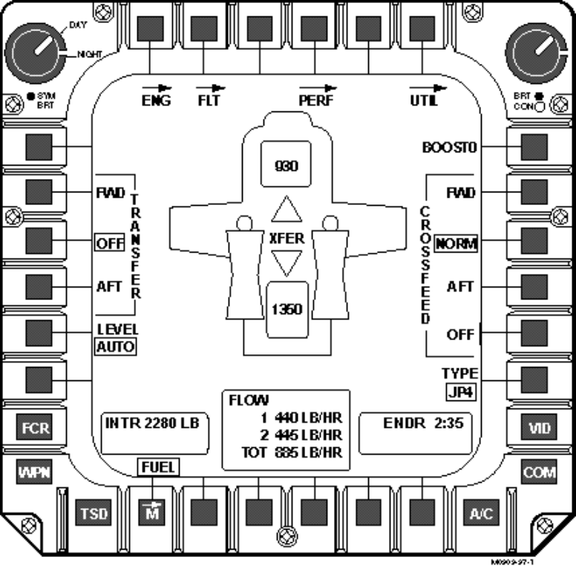
Figure 2-1. Format Consistency: Distinguishing Status Information from Control Options
Dialog Consistency
- Control procedures and dialog behavior should be consistent in form, means, and consequences from one transaction to another, from one task to another, and from one application to another, to support the crewmember in transitioning between tasks as well as multi-tasking. Ensure that control procedures within each dialog type are consistently implemented, and to the extent possible, across similar types of dialogs. Control assignments should be consistently applied throughout the AHCI system and system response time should be consistent for similar types of control inputs.
Example. Tuning a very high frequency (VHF) navigation radio is basically the same type of operation as tuning a ultra high frequency (UHF) or high frequency (HF) communications radio; therefore, the control actions for radio tuning should be similar. Also, if the crewmember can tune a frequency from two different “pages”, the manner in which the frequency data are displayed should be consistent.
Feedback Consistency
- The cockpit interface should have a reliable and consistent method of system response across cockpit applications. AHCI transactions made by the crewmember should produce a consistent perceptual response whether it be in visual, tactile, or auditory form.
Example. On the Army’s Longbow Apache, feedback to indicate that the cursor symbol has entered the active selection area is consistently indicated by bolding the display text (Little and Hannen, 1993).

System Compatibility for Task Management
This section provides compatibility guidelines for providing an intuitive and direct means for supporting the crewmember in accomplishing diverse tasks with a minimal amount of effort. Guidelines in this section support the crewmember in forming key relationships among data for transistioning between tasks, performing multiple tasks concurrently, and for acquiring and maintaining SA. For complex systems such as aviation applications, compatibility can be addressed at two levels to support the management of multiple tasks: 1) at the subsystem component level; and 2) at the system integration level. The following guidelines address both levels, but are primarily directed at the system integration level for promoting task management. Guidelines for promoting task management at the subsystem component level are presented in sections 3, 4 and 5 which address AHCI system components (i.e., dialogs, formats, and display/control devices).
Efficient Time-Sharing
- Displays and controls should be designed to promote efficient time-sharing when multiple tasks must be concurrently performed. Consider mapping the tasks to different human sensory modalities (e.g., visual and auditory) or to different processing codes (e.g., spatial and verbal) to allow for concurrent performance. Attention to two different tasks is more easily divided between the visual and auditory channels than between two auditory or two visual channels.
Note. The multiple-resource theory provides design guidance pertaining to the human’s ability to share mental resources across multiple tasks (Wickens, 1984). These are discussed within the framework of stimulus modality (visual or auditory), central processing (spatial or verbal), and response (manual or speech). Two tasks that share common resource demands will be time-shared less efficiently than tasks that use different resources (e.g., manual and speech) due to resource competition.
Exception. Research has indicated that two competing factors can influence time-sharing efficiency (Wickens, 1984): 1) greater differences in the task structural elements (e.g., two tasks that use digits and letters have been shown to be more easily time-shared than two tasks using all digits or letters); and 2) greater similarities between the rhythm or timing parameters of two tasks (e.g., tasks with similar control rhythms are better time-shared than tasks with different control rhythms).
Task Sequence Awareness
- The design should ensure that the crewmember is kept aware of the current position in a sequence of task activities, so that if interrupted, the crewmember can efficiently return and continue the sequence of task activity.
Example. Provide an indication of processing state. On the Army’s Apache helicopter, when a button’s operation is in progress, the label is shown in inverse video until the commanded change is actually implemented. The Apache’s menu architecture also provides a “bread crumb path” to let crewmembers know where they are and how they got there. This path provides steps to be retraced through the top level, second level, and third level pages.
Visual Momentum
- Provide perceptual landmarks or cues by presenting one display’s information in the context of the other so that the crewmember can easily locate task-relevant information to transition between displays/pages or integrate information across several displays/pages and still maintain a cognitive representation of the system (Sarter and Woods, 1996).
Example. Maintaining the same spatial arrangement of key information across different pages is one way visual momentum can be accomplished. MFD buttons that are shared across more than one MFD page should be presented in a consistent location on each page (e.g., if a target acquisition button is provided on more than one format, it should be provided in the same physical location).
Compatible with Task Requirements
- Displays, controls, and dialogs should be compatible with task requirements to promote an efficient means of accessing and acting upon task-relevant and critical information. As a minimum, displays, controls, and their associated dialogs should: 1) be optimized for task requirements; 2) be consistent with crewmember conventions and expectations; 3) facilitate the crewmember’s ability to quickly switch attention across multiple information sources; and 4) minimize the potential for crewmember error, especially in time-stressed and high workload conditions.
- Consider the following when designing for task compatibility: 1) the relationship between the displayed variables and their associated control responses (display-control compatibility); 2) the relationship between displayed variables and their cognitive mappings (display format compatibility); and 3) the relationship between control designs and their associated control actions (control compatibility) (Andre and Wickens, 1993).
Example. The direction and rate of movement of display indicators should be compatible with the operator’s internal representation of the movement direction and the associated control response. An upward movement of a control should result in an upward movement of the associated indicator.
Example. Continuously changing systems should be represented in analog format (rather than digital). Representing a continuously changing variable, such as altitude, in a digital format imposes an extra processing step that can increase processing time and influence accuracy.
- Consider the cognitive processing attributes of the task (i.e., spatial, verbal) for assigning formats (pictorial/sound localization and pitch, speech/print). Tasks that demand verbal working memory are generally more readily served by speech or print. Tasks that demand spatial working memory are generally more readily served by pictorial formats or sound localization and pitch (Wickens, 1984).
Note. Research has shown that tasks requiring a judgment or integration regarding the three axes of translation or orientation generally require the human’s spatial central processing codes. Tasks that require the use of language or discrete logical operations are considered to be verbal tasks.
Example. Determining the orientation of the aircraft with respect to other objects (e.g., other aircraft, ground) is an example of a spatial task.
Exception. Individual differences in spatial and verbal ability and their interaction with display formats may mitigate these effects. In such cases, the use of redundant formats should be used to provide the flexibility for different users to capitalize on the format they process best.
Compatible Display-Control Relationships
- Display-control relationships should be represented in terms that are evident and compatible with crewmember expectations and require a minimum amount of interpretation for implementing the required functions.
Task-Based Organizational Structure
- Information, controls, and options should be segregated into functional groups and organized on the basis of some logical principle. Major tasks and their associated display pages should provide the predominate structure to an aviation information system.
Example. Eight functional groupings (sights, weapons, video, aircraft, communications, navigation, aircraft survivability, and data management) have been identified for the design of the Longbow Apache information management system. Figure 2-2 shows how the Longbow Apache has organized functional information on the MFD (from Little and Hannen, 1993).
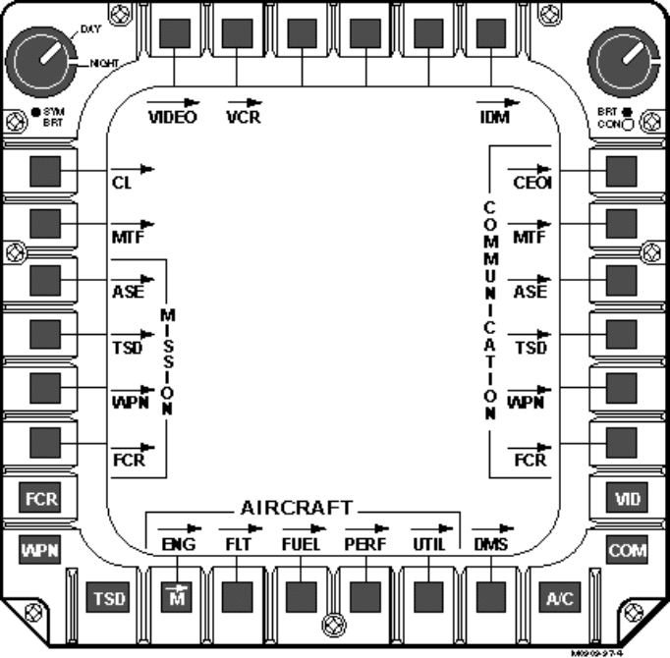
Figure 2-2. Organization by Functional Groupings

Information Control and System Configuration
Electronic formats afford the capability of configuring displays to effectively provide the types of information that will directly support task requirements as well as situational and system awareness. This configuration can be automatically set through the initial design of the system (e.g., prioritization of information) or by providing the crewmember with the capability to configure the system and displays (mode usage). In either case, the designer has ultimate responsibility for ensuring that the AHCI set-up and configuration allows for the management and access of vast quantities of cockpit information and is adaptable enough to accommodate the diverse demands of the task environment.
Flexibility in the Cockpit Interface
- Careful consideration should be given in determining the amount of flexibility designed into the cockpit interface. The amount of flexibility that is given to a crewmember for managing critical information should be limited, carefully implemented, and validated.
Note. Too much flexibility in the AHCI can lead to poor procedures and confusion, and may result in valuable time being wasted as crewmembers try to locate particular types of information that may be hidden in another display format/page or buried within a menu structure.
Information Assimilation and Integration
- The integrated AHCI system should promote the assimilation of a variety of image and non-image data from both on- and off-board sensors, the understanding of the relationships among them, the correlation of real-time and collateral data sets, and their integration within the context of a mission plan and a specific tactical environment. The designer should recognize the strengths and weaknesses of the various subsystems and integrate data from the various subsystems to create better information than can be provided by one system alone.
Direct Access of Information
- The essential information required for task accomplishment should be readily available, easily accessible, and prominently displayed. This includes information that is commonly used, frequently cross-checked, or time-critical. Conversely, the amount of non-essential information should be minimized or less prominently displayed.
Example. On the Longbow Apache helicopter, less important information is sometimes presented at a partial intensity to reduce display clutter without sacrificing SA. Figure 2-3 illustrates this use of partial intensity (from Little and Hannen, 1993).
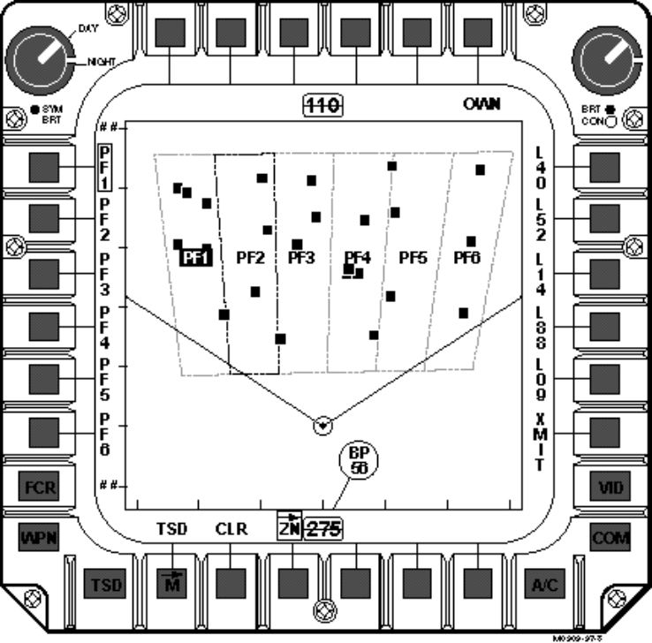
Figure 2-3. Use of Partial Intensity for Display of Non-Essential Information
Primary Flight and Critical Information
- As a minimum, the system should continuously inform the crewmember of the following critical information: primary flight information; the information essential to the accomplishment of the mission tasks; and currently selected system, subsystem, or display/control modes. Other information requirements should be based upon mission, task, and information analyses.
Example. Through function and task control analyses, 18 critical functions were identified for use on the Army’s Longbow Apache hands-on flight grip control design. By providing a design that promotes quick access to all these functions, the Longbow Apache utilizes a simple, straight-forward design. Each switch on the grip performs only one function - not multiple functions that are dependent on prior mode selections, such as selected radar mode. This design differs from the typical control grips of advanced aircraft that require the crewmember to remember the multiple functions associated with a single switch and the necessary conditions to enable each switch function (Little and Hannen, 1993).
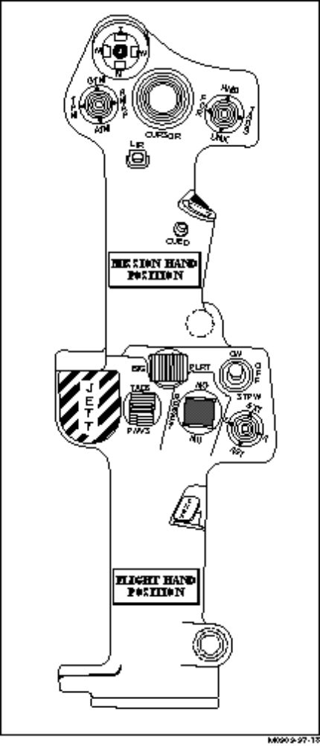
Figure 2-4. The Longbow Apache’s Collective Grip
Filtering Out Unneeded, Competing Information
- Unneeded and visually competing information (i.e., visual qualities that compete for the crewmember’s attention and inhibit focusing on a single informational element) should be temporarily removed through the use of filtering to reduce the amount of display clutter and to improve the crewmember’s ability to visually scan the display(s) and access the required information.
Example. Consider providing information on a display in a layered fashion such that groups of information can be added or removed from a display as relevant to the immediate information requirements. Information layering as a decluttering technique can be implemented manually through direct crewmember control or through some level of automation. An adequate number of information levels should be provided so that detail can be gradually added or removed.
Automatic Formatting
- Consider providing an automatic paging option to aid crewmembers in performing time-critical tasks, such as emergency tasks or threat detection. This option should also provide various thresholds, selectable by the crewmember.
Example. In the Army’s Longbow Apache, the selection of the Fire Control Radar (FCR) sight for target acquisition results in the automatic presentation of the FCR targeting page.
- Consider automatic information declutter for removing information that is not critical to flight operations or relevant for a particular task. If implemented, ensure that the crewmember is notified of automatic changes to the display.
Note. Caution must be exercised when incorporating automatic decluttering as a function of phase of flight or aircraft location since the information that the crewmember is currently using may be removed, or the automatic decluttering may surprise the crewmember. Consider using both manual and automatic declutter schemes to tailor the display information to the current mission phase or the selected sensor mode.
Example. On an electronic map display, an automatic decluttering option could involve the removal of some predetermined information when the display is zoomed out.
Incomplete, Missing, Uncertain, and Invalid Data
- Provide a means to indicate to the crewmember that data are missing, incomplete, uncertain, or invalid.
Example. On the Longbow Apache helicopter, if data are missing due to incomplete data transfer cartridge information or a fault during data transfer cartridge downloading, a question mark is presented in the data field. On the F/A-18’s Digital Display Indicator, the following is displayed (in addition to a voice alert) when vertical velocity, altitude, and/or glideslope sources are invalid in the takeoff and landing advisory system (TLAS).


Figure 2-5. An Example of the Representation of Invalid Data
Caution, Warning, and Advisory Data
- The system should automatically alert the crewmember to critical information that requires an immediate crewmember response, including threats, failures, and changes in automated systems. The system should also alert the crewmember to information that becomes critical within an integrated or pictorial display.
Example. Auditory alerts and voice warning aural messages have been effectively used to alert the crewmembers to critical aircraft health warning conditions. These can be used in conjunction with visual coding techniques, such as flash, color, and/or brightness coding. These coding techniques can also be effectively used for drawing the crewmember’s attention to critical information components of an integrated display.
- An efficient means should be provided for acknowledging CWA information, and removing it once it has been acknowledged or the error condition generating the alarm has been corrected. Procedures for acknowledgment and termination should not decrease the speed and accuracy of operator reaction to the alerting situation.
Example. Many aircraft have a press-to-reset Master Caution Light that illuminates to indicate that a malfunction or special condition exists. This press-to-reset capability promotes crewmember acknowledgment of the system alerts and informs the crewmember of a potentially hazardous condition that may need further investigation in other display areas.
Prioritization of Messages
- The crewmember should be provided with the capability to queue incoming messages by priority and time of receipt and to quickly view summary information of the messages. A message priority scheme should allow more critical messages to take top priority over the presentation of any message occurring below it on the priority list.
Note. If two or more incidents or malfunctions occur simultaneously, the message having the higher priority should be given first. The remaining messages should follow in order of priority.
Example. On the F-16 fixed wing fighter, all voice messages have priority over the low speed warning tone and the landing gear warning horn. Voice messages also have a priority sequence where “PULL UP” has the highest priority.

System Configuration
Tailorable Display Options
- The crewmember should be given some capability to control the amount, format, and complexity of displayed information to meet task requirements. This includes designating the display of interest, defining cockpit display configurations, selecting formats, and establishing default configurations.
Example. One way to design tailorability into displays is to provide the crewmember with the option for selecting the categories of information to be updated as a means to reduce display clutter. The Army’s Longbow Apache helicopter provides one-step tailoring of the selected categories of map symbols, including waypoints, hazards, engagement areas, control measures, planned targets and threats, enemy units, friendly units, sensor detected targets, and shot-at locations.
Pre-Mission Set-Up
- The use of pre-set templates and automatic set-up procedures should be maximized to reduce crewmember workload during time-compressed periods of flight.
Note. The system should allow mission-related data and functions to be established and loaded prior to the start of a mission, but not during real-time operation, through methods such as auto-filling databases or data entry templates.
Inflight Modification
- The crewmember should be given the capability for modifying data inflight to reflect changes as the mission progresses. The number of configuration options that can be presented to the crewmember for the inflight reconfiguration of display formats should be limited and immediately accessible.
Defaults
- The crewmember should be provided with an initial default configuration determined by the designer through careful analysis of the task requirements. The crewmember should be able to customize the display defaults in a system set-up menu. When changing a system parameter from the set-up menu, the default value should be displayed in the field being considered for change.
Automatic Update of Changed Data
- When displayed data are changing as a result of external events, the crewmember should be provided the option of having an automatic update of changed information and the capability to control its update rate.
Note. Update rates should be evaluated by user groups in tactical simulation scenarios to ensure that mission requirements are supported.
Accessing Other Crewmember’s Displays
- If the display management system provides the capability for a crewmember to access another crewmember’s display pages, provide a salient means for indicating whose display page is currently being viewed or active.
Note. This capability is provided for redundancy and for allowing one crewmember to configure another crewmember’s display for upcoming events.

Mode Management
Modes refer to “a manner of system behavior.” Although a system can have several mode states, only one mode state can be operational at any given time. Also, the same control action may cause different system responses, depending on which mode state is active. Modes can be activated either through some form of automation or via manual control by the crewmember (Degani et al., 1996). The use of modes in the AHCI can streamline and simplify the AHCI system, dramatically improve cockpit information management, and facilitate a more flexible AHCI structure in addressing the dynamic task demands of the crewmember. Ultimately, the effective implementation of modes can reduce crewmember workload and enable the crewmember to effectively perform concurrent tasks. On the other hand, if poorly implemented, mode usage can result in catastrophic effects that are caused when the crewmember either forgets or is confused regarding the current system mode, or is unable to easily transition from one mode state to another. Because modes can directly conflict with the principle of consistency, designers must carefully consider the trade-offs involved with their implementations.
There are various types of mode configurations that may be implemented in an aircraft cockpit environment. One type of mode configuration is at the automated subsystem, supervisory control level and is commonly referred to as a control mode. Control modes are used for engaging various control behaviors (e.g., autopilot hover hold mode) and require high-level system monitoring and control activities on the part of the crewmember. Another type of mode configuration is tied to configuring a group of display, control, and sensor subsystems to a particular operational mode (e.g., fighter air-to-air mode or air-to-ground mode). A lower level mode configuration is at the individual display or control unit level and is referred to as a format/data entry mode. For format/data entry mode configurations, display formats and their associated controls are tied to a particular format mode (e.g., Track-Up or North-Up display modes). The guidelines provided in this section address ways to effectively manage these various mode types within the aircraft’s cockpit information management system.
Organize Around Subsystems or Modes
- Consider organizing dialog structures around operational modes, with each mode functionality being accessible from a top-level.
Mode Awareness
- Facilitate a crewmember’s awareness of the current mode state and the potential interactions among modes, especially at critical points or during certain phases of flight.
System Status Indication
- Operational mode information should be provided at all times, including status and availability, either automatically or by request.
Example. The Longbow Apache’s two state controls show the first line as the control label, with the second line displaying the current state in a rectangular box beneath the label. Refer to the top diagram of 2-6. The bottom diagram shows the display for multi-state buttons. When a multi-state button is selected, all non-critical button labels are removed to reduce clutter and allow easy accessibility (Little and Hannen, 1993).
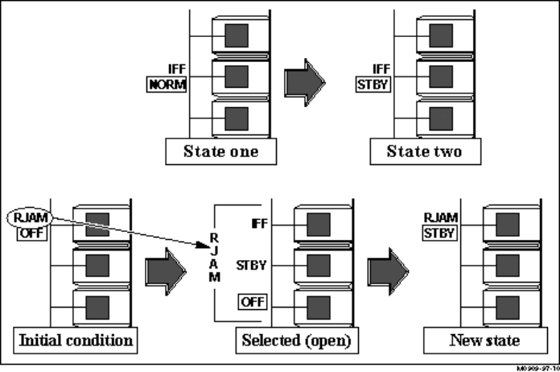
Figure 2-6. Example of Status Indication
Number of Modes
- Limit the number of modes for a given system to minimize the memory requirements on the part of the crewmember.
Transitioning Between Modes
- Enable the crewmember to easily switch between modes. Features and functions that are common between display modes should be as consistent as possible.
Note. Care should be taken when features or functions behave differently in different modes. A crewmember may perform an action that is appropriate in one mode but inappropriate in another mode. Visible cues should be used as necessary to prevent this type of error. If an error occurs, it must be easily reversible.
Example. The zoom functions should behave the same way in both North-Up and Track-Up display modes.
Mode Indicator
- Design display/control modes to be visually distinctive or provide some visual indication to make the current mode easily identifiable.
Example. A Track-Up mode may incorporate a fairly distinctive compass grid whereas a North-Up mode would provide no grid but incorporate a North-Up symbol. The use of different icons as cursors or presenting the mode type in a status bar are two commonly used methods for indicating current mode.
Mode Accessibility
- Make frequently used modes more accessible than infrequently used modes. Order modes by frequency of use and task suitability.
Example. In cycling through a menu option providing display modes, the most frequently accessed mode should be presented as the first menu option.

Designing for Crew Coordination
This section provides guidelines that support crew coordination, interaction, and resource management for mission accomplishment and flight safety. The user-centered approach for multiple crew aircraft must encompass a crew-centered philosophy which emphasizes total crew performance over individual performance (NASA Technical Memorandum 109171). Designing for crew coordination should be addressed prior to, or in parallel with, the development of individual components.
Design for Simultaneous Complex Task Performance
- When complex tasks must be performed simultaneously, design the human-to-system interaction for crew performance rather than for individual performance. This will reduce the number of situations in which performance will be degraded as a result of an individual crewmember performing simultaneous complex tasks, such as piloting the aircraft and acting on target acquisition data.
Example. Consider the situation where the pilot is flying nap-of-the-earth (NOE), spotting a target of opportunity, and designating it to the copilot/gunner (CP/G). The CP/G, who has been communicating and replanning the route, presses the line-of-sight acquire switch on the CP/G mission grip to slave the targeting system to the pilot’s line-of-sight and, with the target displayed on the MFD’s targeting page, engages the target. With this crew station design, the crew is able to work together and efficiently collect and act on the information required to successfully complete the mission (Holley and Busbridge, 1995).
Awareness of Responsibilities
- Sufficient information should be provided so that each crewmember remains aware of his/her responsibilities. This includes providing information regarding the allocation of various functions and tasks among the crewmembers and with automated systems.
Note. Heightening each crewmember’s level of awareness of responsibilities in the crew-system interface will alleviate the problems associated with “nobody minding the store” (a factor that has contributed to accidents associated with highly automated aircraft).
Visual Indication of Who Has Control
- When the crew can share functionality, with control being exclusively allocated to one or the other crewmember, provide an indication of who has control.
Facilitate Function Allocation Among Crewmembers and Automation
- The design should support the dynamic allocation of functions among crewmembers and automation systems.
Note. Separation of system function controls in the AHCI will enable the crew to work cooperatively and share task responsibilities, promoting overall system efficiency.
Multiple Access
- When more than one crewmember must have access to a display or control, the operation by one crewmember should not interfere with the operations of another unless mission survival is contingent upon preemption.
Cross-Checking
- Displays should be designed to allow one crewmember to monitor the activities of another crewmember, including data entry, mode selection, system management, and control tasks.
Tandem Display Configuration
- In the case of front and rear seat tandem cockpits, where either crewmember is assigned the role of controlling the aircraft, the displays should be provided similarly with regard to relative location and function.
Exception. If there are major role differences between the crewmembers, then the type of displays and their location in each of the two cockpits (front and rear) should be optimized for each of the assigned roles.
Side-by-Side Configuration
- If space allows, side-by-side configurations should provide duplicate display and control sets for high priority shared displays and controls or for shared controls that must be operated with the user’s preferred hand. Secondary shared displays should be centered between the crewmembers.
Exception. If there is inadequate space, center the high priority shared displays and controls between the crewmembers’ stations.
Mirrored Displays and Controls Across Crewstations
- The use of mirrored displays and controls should not be applied in tandem configurations and judiciously applied in side-by-side configurations.
Exception: Because the yoke partially restricted the crewmembers’ view of the primary flight displays (PFDs), mirror formats were the default configuration on the C-141 MFDs. This resulted in the PFD being presented on the outboard MFD at each of the pilot and copilot stations.
Display/Control Redundancy Across Crewstations
- Provide control/display redundancy across crewstations so that critical tasks can be accomplished by either crewmember. Redundancy should also be used to enable flexibility in crew operations and the division of tasks between the crewmembers based on the operational requirements of the environment. The performance of these critical tasks should be accomplished in the same manner by either crewmember.
Example. The crew station design for the Longbow Apache helicopter allows critical piloting tasks to be performed in the same fashion from identical control and display interfaces by either crewmember. The design enables the division of tasks between the crewmembers based on the operating environment. Both crewmembers have control of the FCR for target acquisition and the use of infrared (IR) sensors for night operations (Little and Hannen, 1993).
Independent Display/Control
- For crew cockpits, crewmembers should be provided a means to optimize the control and display selections necessary for their individual mission roles.
Example. On the Longbow Apache helicopter, the pilot and copilot MFDs are independent, permitting each crewmember to optimize the control and display selections necessary for his or her specific role during each mission phase. For instance, the pilot can view the air targeting mode of the FCR and the moving map display page to perform both air surveillance and enroute navigation. Meanwhile, the copilot can view the video cassette recorder page enabling the recording of the pilot’s selected sight while simultaneously viewing the weapons page, selecting the semi-active laser (SAL) missile laser codes, and powering up the radio frequency (RF) missiles (Little and Hannen, 1993).

Interacting with Automated Subsystems
This section provides the AHCI guidelines associated with crewmember interaction with and monitoring of automated subsystems, as well as the effective integration of automation with crewmember resources. Increases in aircraft capability, systems complexity, and the number of subsystem control tasks have necessitated that many aircraft operations be carried out under automatic control in order to avoid unacceptable workload. Guidelines presented in this section address three types of automation: 1) assessment automation, such as situation assessment and diagnosis; 2) control automation, such as auto-pilot and flight management systems; and 3) detection automation, such as sensor fusion and alert and warning systems.
The goal of this section is to improve the integration of computer and human resources and to provide an effective interface so that the crewmember can easily monitor the automation, assess the state of the automation, and intervene when necessary. When poorly implemented, automation has the potential of increasing crewmember workload during high task load conditions and decreasing crewmember workload during low task load conditions, both having potentially detrimental consequences. The disadvantages associated with automation include: over-reliance on system resources, the loss of system and mode state awareness, and the potential for an inadequate return to the control loop in the event of an emergency. An objective of the guidelines presented in this section is to mitigate these potential problems through proper design, although it is recognized that proper training and procedures play important roles.
Designs that promote good monitoring strategies can offset some of the disadvantages associated with automation. There are significant differences between the traditional scanning behaviors employed on conventional aircraft and the expectation-driven type of scanning used in modern “glass” cockpits. The latter scanning strategy is driven by specific questions crewmembers ask themselves in particular task contexts and is no longer based on a highly learned pattern of recurrent sampling of a given set of instruments. This strategy has important design implications because it increases the risk of a crewmember missing important pieces of information because parameters that are not expected to change may be neglected for a very long period of time.
Resource Allocation
- An automated function should be easier to operate than the manual function it replaces. Functions should be automated only when there is a good reason for doing so, such as improving a pilot’s capabilities or awareness. Functions should not be automated if doing so results in degraded SA, decreased pilot involvement, or reduced command ability.
Example. To reduce pilot workload in a high task load environment, repetitive and predictable tasks should be allocated to a computer. Tasks that are performed in an unpredictable environment require flexibility and adaptiveness and goal-setting, and therefore should be allocated to the human.
Simplicity
- Simplicity, clarity, and intuitiveness should be the cornerstone of automation in AHCI design. Automation should be designed to be simple to train, learn, and operate.
Automated Output Access
- As a minimum, automated systems should: provide sufficient information to keep the crewmember informed of its operating mode, intent, function, and output; inform the crewmember of automation failure; inform the crewmember if potentially unsafe modes are manually selected; not interfere with crewmember manual task performance; and allow for manual override.
Note. In most aircraft systems to date, the crewmember is informed only if there is a discrepancy between or among the units responsible for a particular function, or if there has been a failure of those units sufficient to disrupt or disable the performance of the function. In those cases, the crewmember is usually instructed to take over the control of that function. To be able to do so without delay, it is necessary that the crewmember be provided with information concerning the recent history of the operations, if these are not evident from the aircraft’s behavior or that of the system being controlled. It is thus necessary that the pilot be aware of both the function (or dysfunction) of the automated system and its output on an ongoing basis if the crewmember is to understand why complex automated systems are doing what they are doing.
Disruption of Task Performance
- Ensure that automation does not disrupt the performance of the task. Design control automation to be of the most help during times of relatively high task load and less help during times of relatively low task load.
Mode Feedback
- Provide a means to cue the crewmember to the current operating mode of the automation. Consider implementing an auditory alert for automation changes that require immediate attention.
Cross-Monitoring
- Each element of the system must have knowledge of each of the others elements’ intent. The intentions of the crewmember monitoring the system and the automated system being monitored must be known and communicated, so that role confusion does not occur.
Task Similarity
- Control automation should perform tasks in a manner that is similar to that employed by the crewmember.
Note. There are two advantages to this. First, crewmembers are more likely to accept and utilize automation that behaves in a manner with which they are familiar. Second, crewmembers will more likely recognize a departure from acceptable performance if the automation continues to perform but in an aberrant manner.
Automation Failure
- The crewmember should be informed of an automation failure; control automation should never be permitted to fail silently.
Automation Delimited in Authority
- Control automation should not be able to endanger an aircraft or make a difficult situation worse. It should not be able to cause an over-speed, a stall, or contact with the ground without explicit instructions from the pilot.
Note. The pilot should not be permitted to select a potentially unsafe automatic operating mode; automation should either foreclose the use of such modes or alert the pilot that they may be hazardous and why.
Manual Override
- Provide a manual override to those automation functions that could impair flight safety or mission accomplishment.
Crewmember Involvement
- Provide the crewmember with meaningful and relevant tasks to perform so that the crewmember is involved in the automated operation, regardless of the level of automation being employed.
Note. High levels of strategic automation have the potential to decrease crewmember involvement beyond desirable limits. Keeping crewmembers involved may require less automation rather than more, but involvement is critical to their ability to remain in command of an operation and their ability to reenter the loop in case of a failure.
Error Resistance and Tolerance
- Control automation should be designed for maximum error resistance and error tolerance. Automated systems and their associated displays should be as error resistant as is feasible. This may be accomplished by designing clear, simple displays and providing unambiguous responses to commands.
Control Automation Flexibility
- Control automation should provide the human operator with an appropriate range of control and management options. The range of control and automation must be flexible enough to accommodate the full range of crewmembers who may operate it, under the full range of operating conditions for which it was certified.
Comprehensible
- Automated systems must be comprehensible to the crewmembers and assist their understanding of potential mode interactions, especially those interactions which are infrequently encountered.
Crewmember in Command Role
- Flight management system and aviation system automation must ensure that the pilot cannot be removed from the command role. Responsibility for safe operation of an aircraft must remain with the pilot in command.
Note. Automation should never permit a situation in which “no one is in charge;” pilots must always be responsible for aircraft control, even if control has been delegated to the autopilot.
Example. One way to guard against the removal of the pilot from the command role is to design flight management systems so that the crewmember is shown the consequences of any clearance before accepting it. Another way is to ensure that the pilot must actively consent to any requested modification before it is executed.
Monitoring Capabilities
- Ensure that the crewmembers are able to monitor both the status of the automation and the status of the functions controlled by the automation. For automated subsystems that have “have nothing going on” for long periods of time, provide some type of indication that the automation is still monitoring the systems.
Note. While the “dark cockpit” concept (no annunciations as long as everything is normal) has distinct advantages in preventing information overload, no information can mean either that everything is normal or that the annunciator has failed. Some indictor must be provided to differentiate between these two possibilities.

Effective Use of Decision Aiding
This section addresses design criteria and issues for implementing decision aids for cockpit applications. Decision aids differ from automation in the sense that they assist rather than replace human decision making with the crewmember retaining the final role in all decisions. Decision aids are often used to facilitate crewmember decision making in uncertain, novel, or time-stressed situations by providing advice that is appropriate for supporting task activities. While information management, text, and graphic displays support the decision making process, they are not generally considered decision aids unless they are used to convey decision aid advice.
Guidelines provided in this section will refer to the implementation of both decision aids and expert systems applications, although only the term decision aids will be used in the text. The distinction between decision aids and expert systems is not a clear one, since both require cooperation between human and automated system components. Expert systems include many of the properties associated with decision aids, however they are generally more reliant on internal rules and algorithms (derived from subject matter experts) for the generation of advice. Also, expert systems may have relatively large knowledge bases and rule sets that respond to constant environmental factors, whereas decision aids place more burden on the crewmember.
When to Use Decision Aids
- Consider the following applications for employing decision aids: 1) for managing system complexity, assisting the crewmember in coping with information overload, and for focusing the crewmember’s attention; 2) for assisting the crewmember in accomplishing time-consuming activities more quickly; 3) when limited data result in uncertainty; and 4) for overcoming the human limitations that are associated with uncertainty, the emotional components of decision making, finite memory capacity, and systematic and cognitive biases.
Note. Use decision aids for assisting the crewmember in manipulating large amounts of data or visual representations, combining multiple criteria, allocating resources, managing detailed information, and selecting and deciding among alternatives.
Example. Time-consuming activities that may potentially benefit from decision aiding applications include diagnosing the current state of a system and performing mathematical calculations.
When Decision Aids Are Not Advisable
- Consider the following instances when decision aiding may not be advisable: 1) when solutions are obvious or when one alternative clearly dominates all other options, 2) when there is insufficient time to act upon a decision or when the crewmember is not authorized to make decisions, and 3) for cognitive tasks in which the human excels, including generalization and adapting to novel situations.
Cautionary Use
- Exercise caution when introducing decision aids that reduce the role of human judgment. Take into account crewmember attitudes and preferences regarding automation when planning the role and degree of authority the crewmember will have in overriding automated decisions.
Intelligent Adaptive Aiding
- Consider using intelligent adaptive aiding for monitoring trends (e.g., aircraft flight performance) and predicting future system behavior for highly predicable and dynamic situations.
Note. There are at least two major areas of concern to be addressed in developing adaptive interface technology: 1) determining the conditions under which selected adaptations to the interface should be made and 2) identifying specific modifications to be made to displays and controls to enhance performance (Hettinger, et al., 1996).
Meaningful Patterns
- Decision aids should automatically notify the crewmember of meaningful patterns or events. A decision aid should predict future data based on historical data and alert the crewmember when it predicts a future problem.
New Developments
- Ensure that the decision aid automatically alerts crewmembers to important new developments occurring in the database or as a result of predictive modeling.
Data for Making Judgments
- Decision aids should provide data for making judgments rather than commands that the crewmember must execute.
Electronic Checklists
- Consider the use of electronic checklists for reducing the potential for error.
Note. Depending on how they are implemented, electronic checklists have the potential to improve error resistance by performing checklists on command. They also have the potential to improve error tolerance by reminding crewmembers of items that need to be performed and by providing reminders of items not completed.
Feasible Alternatives
- If available, a decision aid should provide several feasible alternatives from which the crewmember can choose, and may display the alternatives in a recommended prioritization scheme based on an mission and task analyses.
Crewmember Control
- Provide the crewmember with control of the data that is used to make decisions. The decision aid should advocate crewmember participation in the decision process.
Awareness of Input Logic
- The crewmember should be provided with an understanding of the decision rules and logic that the decision aid algorithm is utilizing. Decision aids should not simply show the final decision without showing the course of the decision making or providing viable alternatives.
Note. An understanding of decision aid logic should be achieved through training.
Ease of Use
- Ensure that the decision aid can be easily used and provides beneficial information in a format that is readily understood and familiar to the crewmember. The decision aid should sufficiently adjust to crewmember task requirements.
Reduce Complexity
- The decision aid system should provide no more information than is essential and should avoid repeating already available information. Decision aid advice should be presented at the level of detail that is appropriate to the immediate task.

References
Advisory Group for Aerospace Research and Development (AGARD). (1995) Advisory Report 349, Flight Vehicle Integration Panel Working Group 21 on Glass Cockpit Operational Effectiveness. Neuilly-Sur-Seine, France.
Andre, A. & Wickens, C. (1992). Compatibility and Consistency in Display-Control Systems: Implications for Aircraft Decision Aid Design. Human Factors, 34 (6).
Avalle, M. (1995) An Integrated System for Air to Ground Operations. AGARD Conference Proceedings 563, Low Level and Nap-of-the-Earth Night Operations.
Braune, R., Infield, S., Harper, P., & Alter, K. (1993). Human-Centered Requirements for Advanced Commercial Transport Flight Decks. Proceedings of the 7th International Symposium on Aviation Psychology. The Ohio State University, Columbus, OH.
Corwin, W. (1995). Understanding Mode Annunciation: What is the Pilot’s Mental Model. Proceedings of the 8th International Symposium on Aviation Psychology. The Ohio State University, Columbus, OH.
Degani, A., Shafto, M., & Kirlik, A. (1996). Mode Usage in Automated Cockpits: Some Initial Observations, NASA report.
Hamilton, B. E. (1995). Helicopter Human Factors. In D. J. Garland, J. A. Wise, & V. D. Hopkin (Eds.), Handbook of Human Factors In Aviation Systems (DRAFT).
Hettinger, L., Cress, J., & Brickman, B. (1996). Adaptive Interfaces for Advanced Airborne Crew Stations. Proceedings of the 3rd Annual Symposium on Human Interaction with Complex Systems. Wright State University, Dayton, OH.
Hofer, E., Palen, L., & Possolo, A. (1994). Flight Deck Information Management: An Experimental Study of Functional Integration of Approach Data. Proceedings of the 7th International Symposium on Aviation Psychology. The Ohio State University, Columbus, OH.
Holley, C. D., & Busbridge, M. L. (1995). Evolution of the Venom Variant of the AH-1W Supercockpit. Proceedings of the 51st Annual American Helicopter Society Meeting, Fort Worth, TX.
Little, J. K., & Hannen, M. D. (1993). Longbow Apache Controls and Displays Management. At the American Helicopter Society Specialists Meeting. Fairfield County, CN.
Lind, J., & Burge, C. (1992). Human Factors Problems for Aircrew-Aircraft Interfaces: Where Should we Focus our Efforts? AGARD Conference Proceedings 521, Advanced Aircraft Interfaces: The Machine Side of the Man-Machine Interface.
Lovesey, D. E. (1992). Management of Avionics Data in the Cockpit. AGARD Conference Proceedings 521, Advanced Aircraft Interfaces: The Machine Side of the Man-Machine Interface.
Mulgund, S., & Zacharias, G. A. (1996). A Situation-Driven Adaptive Pilot-Vehicle Interface. Proceedings of the 3rd Annual Symposium on Human Interaction with Complex Systems. Wright State University, Dayton, OH.
National Aerospace and Space Administration (NASA), Ames Research Center. (1991). Human-Centered Aircraft Automation: A Concept and Guidelines. (Technical Memorandum 103885). Moffet Field, CA.
Sarter, N. B., & Woods, D. D. (1994). Pilot Interaction with Cockpit Automation II: An Experimental Study of the Pilot’s Mental and Awareness of the Flight Management and Guidance System. International Journal of Aviation Psychology, 4(1).
Sarter, N. B. (1995). Knowing When to Look Where: Attention Allocation on Advanced Automated Flight Decks. Proceedings of the 8th International Symposium on Aviation Psychology. The Ohio State University, Columbus, OH.
Sellen, A. J., Kutenbach, G. P., & Buxton, W. A. (1992). The Prevention of Mode Errors through Sensory Feedback. Human-Computer Interaction, 7.
Taylor, R. M., & Selcon, S. J. (1993). Operator and Automation Capability Analysis: Picking the Right Team. AGARD Conference Proceedings 520, Combat Automation for Airborne Weapon Systems: Man-Machine Interface Trends and Technologies.
Toms, M. L., Cavallaro, J. J., Cone, S. M. et al. (1996). Pilot-in-the-Loop Evaluation of the Approach Procedures Expert System (APES). Proceedings of the 3rd Annual Symposium on Human Interaction with Complex Systems. Wright State University, Dayton, OH.
Toms, M. L., & Kuperman, G. G. (1991). Sensor Fusion: A Human Factors Perspective (Technical Report No. AL-TR-91-0152). Armstrong Laboratory, Air Force Systems Command, WPAFB, OH.
U.S. Army. (1996). Aviation System of Systems Architecture (ASOSA), Framework for Computer, Communication, Electronics, and Power Management (AFCCEM), Volume 8, ASOSA Soldier/Aircrew Machine Interface (SAMI) Style Guide, Draft Version 1.3.
U.S. Army. (1997). U.S. Army Weapon Systems Human-Computer Interface Style Guide (WSHCI), Draft Version 2.
U.S. Department of Defense. (1996). Department of Defense Technical Architecture Framework for Information Management, Volume 8: Department of Defense HCI Style Guide (TAFIM), Version 3.0. Defense Information Systems Agency Center for Architecture.
U.S. Navy. (1997). Situational Awareness Guidelines (Technical Memorandum NAWCADPAX-96-268-TM). Naval Air Warfare Center Aircraft Division. Patuxent River, MD.
Weiner, E. L. (1988). Cockpit Automation. In E. Weiner & D. C. Nagel (Eds.), Human Factors in Aviation, San Diego. Academic Press.
Wickens, C. D. (1984). Engineering Psychology and Human Performance. Columbus, OH: Merrill Publishing Company.
Woods, D. D. (1984). Visual Momentum: A Concept to Improve the Cognitive Coupling of Person and Computer. International Journal of Man-Machine Studies, 21, 229-244.

Dialogs And Implementations
This section describes guidelines for the design of dialogs that allow the crewmember to communicate and interact with the aircraft computer systems. A dialog is a structured series of human-computer interface (HCI) transactions. For the purposes of this document, a dialog can be broadly defined as the basic method of interaction between the crewmember and the cockpit. Transactions are defined as user actions paired with system responses. The design of the interface dialog has a significant influence on the overall look and behavior of the aviation human-computer interface (AHCI), and on the effectiveness of the cockpit interface as a whole. Thus, selection and implementation of the dialogs are fundamental issues in the AHCI design process.
Since the cockpit environment imposes many unique requirements on the HCI, the dialogs implemented within the AHCI are not identical to those used for desktop HCI design. The following dialog types are typically used for cockpit applications: 1) menu selection, 2) graphical interaction, 3) alphanumeric data entry, and 4) direct system command. Menu selection involves the selection of an item or option from a displayed list. In cockpits, menus are commonly implemented on a multi-function display (MFD). Graphical interaction is a general dialog type that may include the control and manipulation of various graphic display elements. Alphanumeric data entry refers to the direct entry of alphabetic and numeric characters which is typically accomplished via a keypad. Finally, direct system command is a dialog unique to the cockpit domain, and refers to the crewmember’s direct command and real-time control of various subsystems which can be achieved via manual manipulation or verbal activation.
These dialog types are not exclusive and are often used in combination since different dialogs may be more appropriate for certain aspects of a function or task. The graphical interaction dialog, for instance, is more appropriate for navigation waypoint manipulation than for entry of a navigation radio frequency. A combination of dialogs is typically used to accomplish complex cockpit applications. For example, a menu may be used to present the crewmember with a list of sensors from which to choose. Once a particular sensor is selected, the menu dialog may lead the crewmember to a direct command dialog that allows the crewmember to directly slew the sensor.
Selection of a dialog type should be based on the dialog characteristics, the task requirements, and the operational environment. For example, a menu dialog with several levels would not be appropriate for a task which requires quick reaction time and minimal “head-down” time, such as designating a target. This task would be more directly accomplished through graphical manipulation. General dialog selection criteria are presented in the following paragraphs to assist the designer in selection of the dialog type that best matches the task and operational requirements.
Menu Selection. Menu selection dialogs are typically used for applications that involve a choice among a constrained set of alternative actions. As with any dialog application, menus have both advantages and disadvantages in terms of the AHCI. One advantage of menus is the minimization of the crewmember memory requirements. Another advantage of employing menu dialogs is that limited keystrokes or crewmember actions are required, which both expedites the user-to-computer transaction and reduces the chance for user error. Disadvantages for menu applications include the fact that menus take up valuable display “real-estate.” This can be a critical selection criteria given the limited display area available within most modern cockpits. Another disadvantage is the fact that menu dialogs are not practical for applications with numerous choices. When too many choices are implemented on a menu system, the menus can quickly become deep and complex. This is an especially important factor to consider in designing dialogs for cockpit applications since the multi-tasking operational environment and high workload can cause crewmembers to become lost and confused even when navigating through a fairly simple or shallow menu system. These advantages and disadvantages should be given careful consideration when designing menu systems for cockpit displays.
Graphical interaction. Graphical interaction dialogs allow the crewmember to interface with aviation systems by acting directly on graphically displayed objects, icons or symbols. This type of dialog is most appropriate for representing and manipulating relations in space or time. It is also appropriate for tasks where the crewmember action must be immediately observable. Graphical interaction can generally be characterized by the following: 1) there is a continuous representation of the object or symbol of interest, 2) system actions are initiated by a physical action by the crewmember such as key or switch depression, 3) the interaction may be performed in incremental reversible actions, and 4) there is immediate visual feedback from the system to the crewmember. Windows dialogs are also considered a form of graphical interaction, whereby the crewmember is able to interact through the selection of “soft keys” located within dialog windows that are overlaid on the display area. Windows can also be used in cockpit applications as a means for displaying system messages and alerts.
Alphanumeric data entry. Alphanumeric data entry dialogs are appropriate when: 1) the data to be entered is open-ended and cannot be confined to a distinct set of choices; or 2) the data can be confined to specific choices, but these choices are too numerous or cumbersome to be implemented as menu options. When the specific data cannot be constrained, the data entry task should be implemented as an unprompted (free text) data entry dialog. Unprompted data entry is defined as data entry that is not confined to specific data fields or data types. Prompted data entry involves entry of specific data items that are identified by unique data fields and labels. Both types of data entry have been implemented in the cockpit environment.
Direct system command. Direct system command dialogs are appropriate when the crewmember requires real-time control of a subsystem. This dialog type is characterized by the crewmember’s ability to command a subsystem directly without the use of menus or explicit alphanumeric data entry. Slewing a sensor via a cursor slew key, or commanding the system to master weapon arming via an up-front control (UFC) switch are both examples of direct system command.
Guidelines for each of these dialog types are presented in the following sections. More detailed definitions of these dialogs and the current conventions for their use in cockpit applications are also discussed.

General Guidelines
This section presents high-level guidelines for designing dialogs for cockpit applications. These guidelines are applicable to any of the four cockpit application dialog types identified above.
Dialog Compatible to Task Requirements
- The dialog type and its associated control logic should be compatible with the task requirements and the operational domain.
Example. Lengthy data entry tasks may be more appropriate to pre-mission activities, while direct system commands via pushbuttons may be the appropriate dialog type for higher workload phases of a mission.
Logical Transaction Sequences
- When designing a sequence of related transactions for an information handling task within the cockpit, perform a task and information analysis to ensure that the transactions constitute a logical unit or subtask from the crewmember’s perspective, and to determine what control options the crewmember will need at any point in the transaction.
Note. A task and information analysis should be considered whenever the AHCI is being designed or modified, and should definitely be performed whenever the task being added or modified is critical to system operation. A task and information analysis will ensure that the proposed transaction sequences are appropriate to the task and the crewmember’s capabilities. This will also ensure that the workload remains within manageable limits when the new transactions are implemented.
Flexible Sequence Control
- The AHCI should provide flexible sequence control so that the crewmember can avoid unnecessary steps and easily recover from an error while accomplishing tasks related to data entry, data display, and data transmission.
Definition. Sequence control is defined as the process that governs crewmember actions and the associated system logic that initiates, interrupts, or terminates transactions.
Minimal Crewmember Control Actions and Data Entry
- Control actions should be simple, particularly for time-critical tasks requiring fast crewmember response; control logic should permit the completion of a transaction sequence with the minimum number of actions or inputs.
- Use selection lists, default values, “hot keys,” or other methods to minimize data entry and to speed the execution of frequently used and critical actions.
Example. It may be advantageous to allow the crewmember to select certain waypoints or areas of interest in logical groups.
Example. The function keys and pushbuttons implemented on many aircraft UFCs are examples of common “hot key” practices.
Minimal Memory Load
- The dialog types implemented within the AHCI should require minimal memorization on the part of the crewmembers. All information required for a specific task or action should be available to the crewmember at the time the action is to be performed.
Example. To reduce crewmember memory requirements, use icons that represent objects or processes familiar to the crewmember, or provide prompts to guide the crewmember through an interactive process.
Example. When a crewmember must select control options from a discrete list of alternatives, display the list at the time the selection must be made, rather than requiring the crewmember to remember all of the alternatives.
User-Paced Control
- Allow crewmembers to pace the control entries, rather than requiring the crewmembers to keep pace with computer processing or external events. This will allow control entries to be made in accordance with the crewmember’s current needs in the time available, and allow the crewmember to remain in control of the system interaction.
Note. This is applicable to tasks such as mission data entry activities that may be completed during a pre-mission set-up, or during relatively calm phases of a mission. However, there are times when the cockpit activities are heavily paced and controlled by external events such as during air-to-air or air-to-ground engagements. The AHCI design for tasks associated with these mission phases may not be appropriate for user-pacing and may actually require some form of automation or decision aiding to assist the crewmember.
- Provide the crewmember with the capability to control, interrupt, or terminate system processes. When this is not possible, ensure that the application or system informs the crewmember of a change in status.
Consistent Sequence of Control Actions
- The sequence control actions required for various transactions with the AHCI should be consistent in form and consequences; employ similar means to accomplish similar objectives from one transaction to the next and from one task to another throughout the user interface.
Example. Do not require the crewmember to take different control actions to perform similar tasks such as entering navigation waypoints and communication radio channel frequencies into the mission computer.
Redundancy
- For some applications, consider providing redundant methods of control so the crewmember can select the control method that is most efficient for a given task.
Example. Employ both hands-on throttle and stick (HOTAS) controls as well as MFD pushbuttons to allow the crewmember to “step” through weapons selection.
Feedback for Crewmember Actions
- Provide the crewmember with feedback for menu selections, data entries, graphical selections, control actions, direct system commands, or other inputs to indicate that the action has been accepted, is being processed, or has not been accepted. For every action by the crewmember there should be some apparent reaction from the system. Also provide feedback to indicate when the transaction is complete and that it is appropriate to go on to the next task. This feedback should be informative and presented in a timely manner appropriate to the task.
Note. System response time is dependent upon the function or task being accomplished. Maximum response times can range from 0.1 second for response to a key depression, to 10.0 seconds for complex queries or file updates. If the system response time will exceed 15 seconds, the crewmember should be given a message indicating that the system is responding. Refer to MIL-STD-1472E for maximum response times for other tasks.
Example. For direct system command dialogs this feedback may be an obvious change in system performance (e.g., a change in radar mode) or may be a confirmation message that the system command was received.
Example. For menu selection dialogs the feedback may be a change in the display based on the menu options selected (e.g., a new menu level is displayed) or a change in the actual menu options themselves (e.g., highlighting or outlining a selected item).
Example. Data entry dialogs may present feedback to the crewmember via a visible change in the appearance of the data entry field, a change in the system affected by the data entry process (e.g., a change in a communication radio frequency), or some other type of visible feedback including a confirmation message. Feedback could also be presented in these manners for system initiated query transactions.
Example. Graphical manipulation typically presents feedback to the crewmember by a visible change in the appearance of the object being manipulated. This may include a change in the position of the displayed object, a change in the color, or a change in the highlighting of the object. An example of this type of feedback is the difference in appearance between designated and undesignated targets on a tactical situation display.
Feedback for System Functioning and Process Completion
- Provide the crewmember with some form of feedback to indicate normal system operation when system functioning requires the crewmember to stand by.
Example. The system may provide some type of feedback, (e.g., a countdown clock) to indicate that a missile is being armed.
- Present a positive indication to the crewmember concerning the outcome of the process and requirements for subsequent crewmember action when a control process or sequence is completed or aborted by the system.
Note. This is especially important when the processing associated with a crewmember request or action is lengthy.
Indication of System Mode
- When the system has multiple modes of operation, provide a means to cue the crewmember to the current system operating mode.
Feedback for Function/Item Availability
- A cockpit function should provide the crewmember with an indication of its availability. The appearance of a menu item or graphical object should indicate to the crewmember whether or not the item/object is currently available or if it is temporarily unavailable due to extended processing.
Example. If a menu item or graphical selection is not currently available (e.g., due to the current mode) its appearance should indicate its non-availability by shading, graying out, or some other convention. The Longbow Apache separates non-selectable options from adjacent bezel buttons by a barrier (Little and Hannen, 1993).

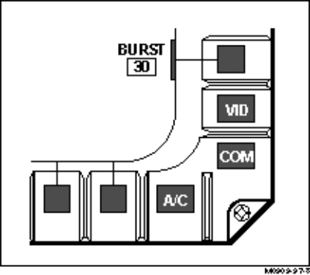
Figure 3-1. Separation of a Non-Selectable Option
Error Handling and Feedback
- The AHCI should be designed to provide simple error handling through system error-checking and easy correction of identified errors. Ensure that the system provides a clear indication and explanation of the error conditions.
Definition. An error condition, in this context, is defined as: 1) any crewmember input error; or 2) any system error impeding the completion of a requested transaction.
Informative and Timely Error Messages
- Error messages should be brief but informative, stating specifically what the cause of the error is and suggesting corrective actions. The AHCI should provide error feedback to the crewmember as quickly as possible.
Note. Refer to MIL-STD-1472E for appropriate system response times.
Consistent Error Message Location
- Where possible, error messages should be displayed in a consistent manner within and across dialog types.
Removing Error Messages
- A displayed error message should be removed immediately after the error has been corrected.
Confirmation of Destructive Entries
- Ensure that the crewmember can confirm control entries that may be destructive, cause extensive changes in databases or system operations, or cannot otherwise be undone. Do not provide a potentially destructive action as the default in a list of options.
Undo Function
- Consider providing the capability to reverse or undo the effects of the last computer transaction, and where appropriate, previous transactions.

Menu Systems
This section provides guidelines for designing cockpit menu systems. These guidelines cover topics related to the structure and mechanization of cockpit menu systems including menu structure, menu navigation, and feedback. Various menu types are also defined in this section and the types currently implemented within military cockpits are identified. Guidelines for designing the format of menu page displays are presented in the Information Presentation and Formatting section of this style guide.

Definitions and Current Conventions
This section describes menu dialogs and the current conventions for their use in cockpit applications. Menus are typically used for applications that involve a choice among a constrained set of alternatives. They are sometimes used in conjunction with other dialog types depending on the application. For example, a menu may be used to present the crewmember with a list of mission data variables from which to choose. Once the variable is selected, the menu dialog may lead the crewmember to a data entry dialog that allows entry of mission specific data. Menus can be implemented with various control types such as pushbuttons, cursor control devices, or keyboards. Current cockpit conventions for menu dialogs include MFD applications (e.g., weapons stores management and selection), UFC implementations (e.g., radio frequency selection and entry, and mission computer applications (e.g., navigation waypoint selection and entry).
The most common form of the menu dialog within military cockpits is the form used on MFDs. These menus are different from the menus found on traditional desk top computer systems in both appearance and function. One reason for this difference is that the menu selections are often arranged around the pushbuttons located on the perimeter of the MFD. These menus are also generally more broad and shallow in structure than the narrow and deep structure found in desk top menus. The advantages of this type of menu design include a reduction in the number of keystrokes required and direct access to various menu options or functions. These advantages are important in the dynamic environment of military aircraft.
Menus are also found on UFCs in many modern cockpits. These menus are limited by the display size of the UFC and are also different in form and function than traditional desk top menus. These menus are generally very simple in form and often use a pointing or positioning control device to position a cursor or set of symbols (e.g., asterisks) in order to select menu options.
Menus are also often implemented on the mission computers. These menus may be more complex than those implemented on MFDs or UFCs in that the mission computer menus may be deeper, have more options, and may branch to multiple pages. This complexity is appropriate for the mission computer since much of the interaction between the crewmember and the mission computer is during the non-flying pre-mission or post-mission segments. The crewmembers are less likely to be distracted during these times by external (operational) events and are therefore also less likely to be confused or become lost in a somewhat complex menu system. Although mission computer menus may be more complex than other menus within the cockpit, they are still relatively simple and are also often arranged around the line select keys or option select buttons that are on the mission computer display hardware itself.
The guidelines provided in the following sections apply to specific menu implementations that will most likely be found in military cockpits. These guidelines are based on research in aviation menu systems and on existing menu system guidelines. Those guidelines based on existing menu guidelines have been tailored to the aviation style menus discussed above. This tailoring was necessary since most current menu system guidelines refer to desk top, “windows” style menus systems. While these “windows” style menus may be appropriate for analyst workstations (in the case of an Airborne Warning and Control Systems (AWACS) aircraft) or maintenance applications that occur on the ground, it has been assumed that this style of menu will have limited application in the cockpit.
Specific types of menus currently implemented on MFDs, UFCs, and mission computers within military aircraft are defined and discussed in the following section.
Displayed Menu Options. This is the menu style that is similar to a traditional “windows” style menu. All options associated with a particular menu are displayed to the crewmember at one time. Typically, when the menu system is presented on an MFD, the options are arranged around the perimeter of the MFD, next to the bezel buttons. For other display types, including mission computer displays or UFCs, the menu options may be arranged as a vertical list. These menu options may or may not be part of a hierarchical menu system. When menu options are displayed on a display unit with a limited display surface, such as those associated with UFCs, the options may be displayed on multiple pages. This type of display requires the crewmember to scroll through multiple pages to view all menu options.
Example. Figure 3-2 shows different radar modes selected from display menus. When the groundmap (GM) option is selected, another radar mode menu is displayed. Selecting the range-while-search (RWS) option from this menu brings up the range-while-search mode display.
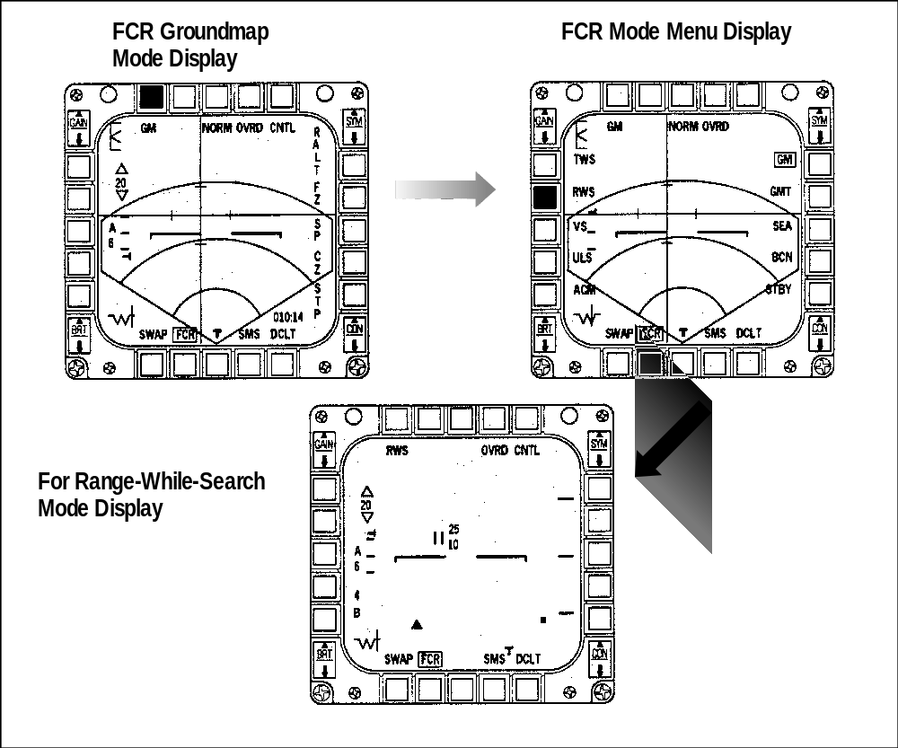
Figure 3-2. Option Selection via Menu
Rotary Menus. Another type of menu system that is commonly implemented on MFDs is the rotary menu. The rotary menu cycles through the available options upon crewmember request. The available options may be displayed one at a time as the rotary cycles, or may be displayed simultaneously with the currently active option highlighted in some way with each selection of the rotary. The rotary menu is often arranged around the MFD bezel buttons. In this arrangement, depression of the button associated with the rotary menu will display the next option in the list or highlight the next option if all options are displayed.
Example. Figure 3-3 shows how various radar displays are selected by repeatedly depressing the same bezel button, whose label changes as the crewmember cycles through the rotary.
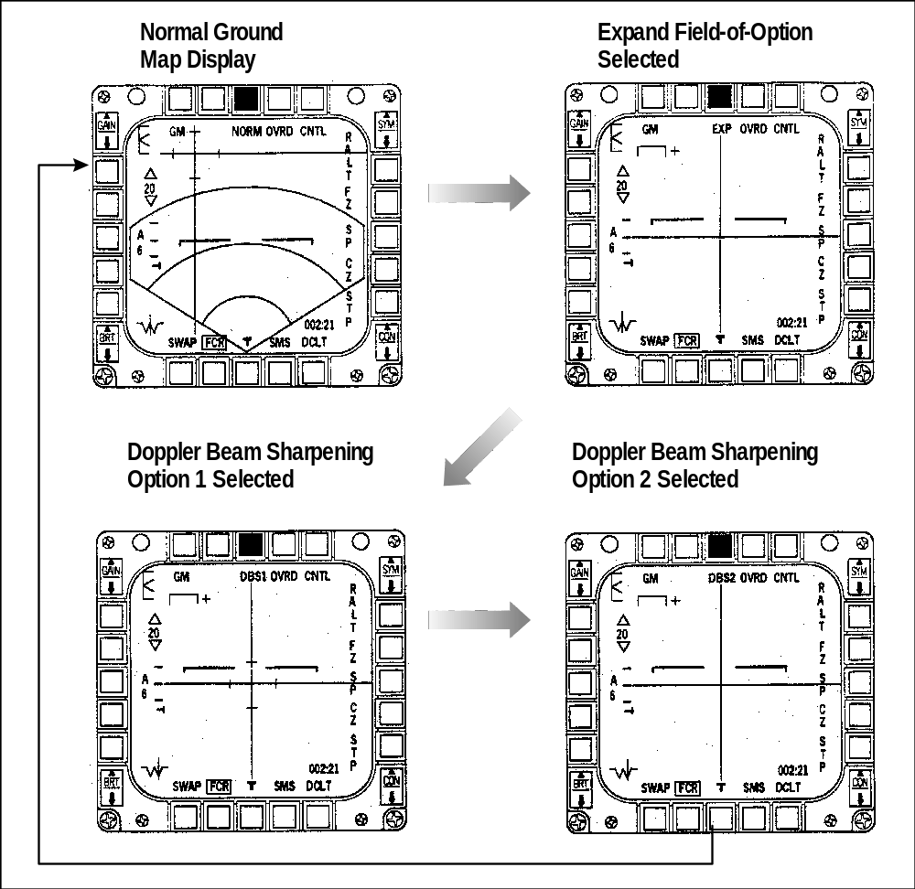
Figure 3-3. Option Selection via Rotary
Increment/Decrement Menus. The increment/decrement menu is another type of menu system found on cockpit displays. This type of menu is best suited for changing or selecting numerical values. When implemented on a MFD, the current value is generally displayed and one bezel button is designated for incrementing and one bezel button is designated for decrementing the value. Depression of a button increments or decrements the current value and the new value is typically displayed.
Example. Figure 3-4 shows a radar range being adjusted via increment and decrement selections.
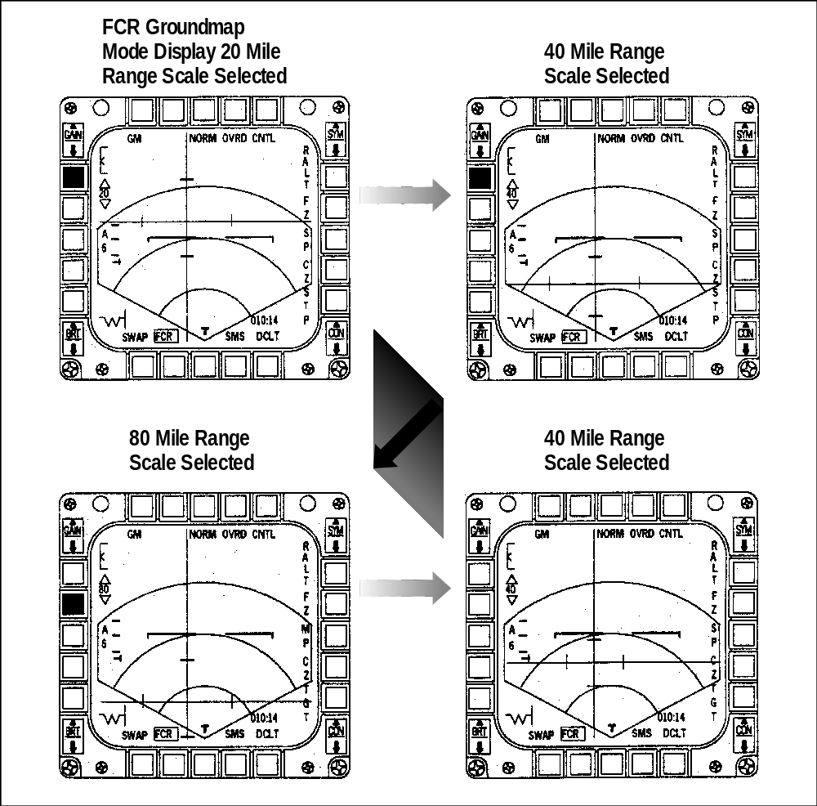
Figure 3-4. Increment/Decrement Menu Selection

Menu Option Selection Methods
Bezel Buttons/Programmable Pushbuttons. Bezel buttons, or programmable pushbuttons, are one method used for selecting menu options when the menu is implemented on the MFD. Arranging the menu options around the bezel buttons on the perimeter of the MFD allows for the simultaneous display of menu options as well as the tactical and status information necessary for crewmember tasks. Refer to section 5.2 for guidelines regarding cockpit programmable pushbuttons.
Cursor Control Keys. Some type of cursor control key is typically employed in the cockpit as a redundant method of menu option selection. This cursor control may be implemented on the HOTAS, or may be implemented via arrow keys on a dedicated keyboard or keypad. When implemented on the HOTAS, the cursor control key or switch usually “steps” through the menu options with each activation, while a second type of action makes the explicit control entry. Arrow keys are typically multi-directional keys that consist of a pair of one-dimensional control devices, with one set of arrow keys controlling the horizontal cursor movement and the other set controlling the vertical cursor movement. This allows the crewmember to navigate through the menu in all required directions (usually, only up-and-down and side-to-side movements are necessary for menu navigation). Refer to section 5.2 for guidelines regarding cursor control keys.
Voice Command System. Voice command and control is still being investigated within the laboratory, and has only been flight tested on a limited number of aircraft outside of the laboratory in the United States. It is currently being used, however, on foreign aircraft including the EF-2000 and the Rafale combat aircraft. Voice is typically used for managing information when the crewmember must remain head-up and hands-on. Voice technology has the potential for reducing crewmember workload by using voice commands to create a shortcut method for bypassing multiple sequential menu selections to access critical menu pages on the MFD. Some examples of voice command technology currently being implemented in military aircraft include, radio channel selection and frequency change, waypoint selection and route manipulation, display format selection and moding, tactical information read-out, target selection and sensor moding, and data link interaction. Refer to section 5.2 for guidelines regarding voice command systems.
Light Pen. Light pens have been implemented on a limited basis for use in military aircraft and may be appropriate for some menu applications. For example, the Navy E-2 aircraft is currently equipped with light pens. While light pens may be suitable for certain applications including special purpose workstations such as those found on command and control aircraft, caution should be taken when implementing these devices for cockpit applications where turbulence, vibration, and g-forces are a concern. Refer to section 5.2 for guidelines regarding the use of light pens in cockpit applications..
Touch Screens. Touch screen technology has recently been developed as an input device for head down displays. Touch screens may consists of a frame of infrared (IR) sensors which is applied around the display surface. These sensors detect the presence of a finger on the surface. Other touch screen designs use resistive, capacitive, or surface acoustic wave technology to locate the finger on the display surface. Each of these technologies have advantages and disadvantages. Major shortcomings common to most touch screen designs include the lack of adequate tactile feedback and the difficulty for the crewmember to accurately position the finger on the display surface in a highly dynamic environment while wearing gloves. For these reasons, touch screens have not been widely adopted for cockpit use to date. Refer to section 5.2 for guidelines regarding touch screens.

Menu Structure
Structure Based on Task and Information Analysis
- Design the cockpit menu structure and organization based upon a mission level human factors engineering task and information analysis.
- Consider organizing menus around subsystems or operational modes, with each subsystem or mode functionality accessible from a top-level menu option. Within these modes, menu display pages should be organized by a set of activities or group of functions that the crewmember must perform to complete a mission task or subtask.
Example. Military aircraft may have different menus and menu options for air-to-air and air-to-ground modes; either operational mode menu is typically available from the other mode’s top-level menu.
Example. The menu structure for the SuperCobra helicopter is organized around its basic system functions (e.g., Caution/Warning/Advisory (CWA), System (SYS), Communications (COM), Flight (FLT), Map, Defensive (DEF), Targeting (TGT), and Weapons (WPN) functions. Each of these functions is accessible from a top-level MFD menu, as well as lower-level menus (Holley and Busbridge, 1995).

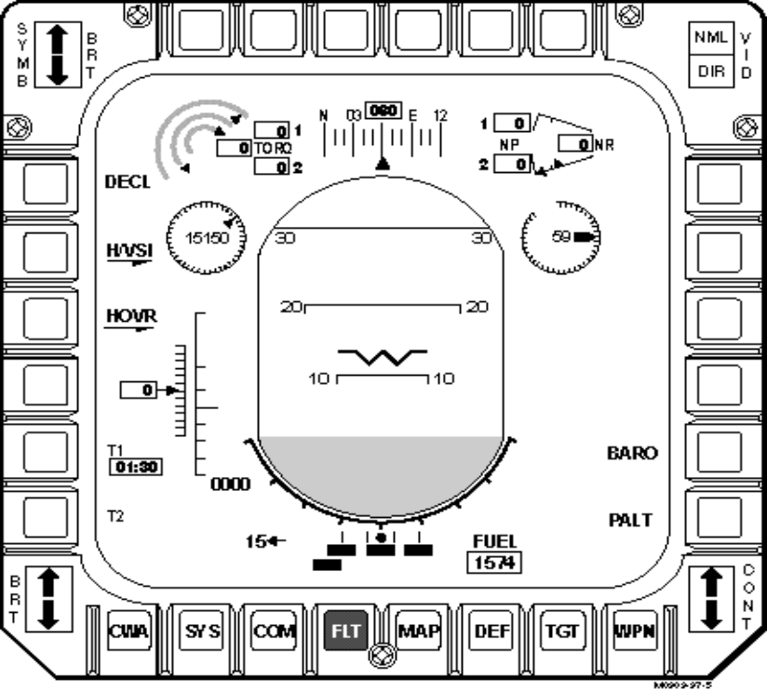
Figure 3-5. SuperCobra Menu Structure
- High-level or routine data and controls should be accessible from the top-level of the menu structure.
Tree Structure Appropriate to Cockpit Application
- Limit the number of menu levels so that the menu tree structure is broad and shallow rather than narrow and deep, as crewmembers can easily become lost in deep levels especially during critical tasks within the operational environment. It is generally recommended that cockpit menu applications be no deeper than three levels.
- Within each level, keep the number of menu selections to the absolute minimum to reduce menu-selection time. Keep the number of top-level options relatively large, with a smaller number of options at the lower levels.
Note. The crewmember is more likely to become lost in the lower-level menus. Typically, no more than five to nine options are considered optimal, depending on the level.
Consistency Within Levels
- Ensure that menu designs and their associated option selection logic are consistent within the different levels of the menu structure.
Accessibility of Important Options
- Design menu pages to permit immediate crewmember access to critical or frequently selected options.
Note. This can usually be achieved fairly easily if the menu is implemented on an MFD and uses the associated pushbuttons for selecting options. Since MFDs can be equipped with up to 20-24 pushbuttons (bezel buttons), several of them can be reserved for access to critical functions.
Menu Types and Appropriate Implementations
- Rotary Menu: Consider using a rotary menu when there are relatively few options from which to choose.
Example. The current convention for the F-16 fixed wing fighter is to use a rotary menu if there are four or fewer options.
- Increment/Decrement Menu: Consider using an increment/decrement menu when there is a constrained set of numerical values from which to choose.
- Multi-Level (Hierarchical) Menu: Consider using a hierarchical menu structure when there is a relatively large number of menu options, and they can not all be displayed at once due to space limitations or clutter concerns.
Menu Type Distinction
- When different menu types (e.g., rotary, hierarchical) are used within the same cockpit application, there should be a unique indication for each menu type that denotes the type of menu and the actions required of the crewmember.
Example. Hierarchical menu options that branch to a lower level could indicate this via an arrowhead or three ellipses following the option label.
Example. Rotary menu options may be designated by a unique border.
Example. Increment/decrement menu options could be identified by upward and downward pointing arrows, indicating the increment and decrement options.
Command Versus Status Menu Options
- Ensure that there is a clear indication to the crewmember as to whether the menu option is a command option or status display option.
Definition. Command options reflect the setting that the system will be in upon crewmember selection. Status options reflect the current setting of the system.

Menu Navigation
Indicate Current Position in Menu Structure
- When hierarchical menus are used, provide some type of indication of the crewmember’s current position in the menu structure.
Example. For MFD menu displays, this can be accomplished by highlighting the option adjacent to the bezel button that corresponds to the currently displayed menu page.
Distinct Navigation/Control Options
- Design the menu options that accomplish control entries to be distinguishable from options that branch to other menu pages.
- Provide a visual indication when a menu option will take the crewmember to a lower level menu page.
Note. Upon option selection, the crewmember must be cognizant of the navigation implications (e.g., will another menu page be displayed, or will the information on the current display be updated). Clear and distinct option labels will expedite menu navigation.
System-Level Menu Page
- Provide a system-level menu page of basic options as the top-level in a hierarchical menu structure.
Note. When the menu is implemented on a MFD using the associated pushbuttons (bezel buttons), this guideline may be met by consistently grouping and organizing the system-level options around one set of pushbuttons. These options may or may not be available to the crewmember at all times. This system-level menu page will act as a home base to which the crewmember can always return as a consistent starting point for control entries.
Return to Higher Level Menus
- Require the crewmember to take only one simple control action to return to the next higher or system-level menu page.
Minimal Steps/“Switch Hits” in Sequential Menu Selection
- When crewmembers must “step” through a sequence of menus to make a selection, design the menu structure to minimize the number of “steps” or “switch hits” required.
Consistency Across Transactions
- Ensure that the navigation methods are consistent across various menu structures.
Feedback for Menu Navigation
- Provide some immediate indication to the crewmember that a menu option has been selected. Also, provide a visual distinction between selected and non-selected menu options to identify currently active selections.
Note. This can be accomplished by highlighting or underlining the item via color coding, or by creating a border around selected options. When the menu options are associated with MFD bezel buttons, one current design convention is for the display surface adjacent to the bezel button to momentarily flash upon selection.
Dual Activation for Cursor Selection
- When a cursor control key is used for menu selection, provide a dual activation capability, where the first action designates the selected option and a separate, second action executes the selected control entry.
Example. One action of the cursor control switch “steps” through the menu selections and highlights the selection, and a second action activates the currently highlighted selection.
Cursor Position Default
- When menu selection is to be made via a cursor control key, ensure that the system places the pointer automatically in a consistent position within the menu that is compatible with crewmember expectations.
Note. Technical Architecture Framework for Information Management (TAFIM) has recommended that the cursor be automatically placed at the first listed option, however, there are also applications where it would be more appropriate to place the cursor in the position that it was in when the crewmember last accessed the function. The designer should analyze the task to determine the cursor position most appropriate to the task.

Graphical Interaction
This section provides guidelines for the design of graphical interaction dialogs for cockpit applications. These guidelines cover topics related to the mechanization of graphical interaction functions including display manipulation, element selection, cursor/icon design, display zooming, panning, and windowing. Guidelines for designing the format of graphical displays and windows are provided in the Information Presentation and Formatting section of this style guide.

Definitions and Current Conventions
This section describes the graphic interaction dialog and the current conventions for its use in cockpit applications. Graphic displays are typically used to represent relations in space or time. In the cockpit, these graphics can show spatial, temporal, or other (e.g., target type) relations among aviation system data by applying special formatting techniques to the display elements. Graphical interaction is a dialog type that allows the crewmembers to interface with the aviation systems by acting directly on graphically displayed objects or symbols. The crewmembers typically act on the graphic symbols via pointing devices that may include hands-on controls (i.e., HOTAS), trackballs, and cursor control keys. Examples of current cockpit applications of graphic interaction include manipulating navigation waypoints and designating areas of interest on a map display, manipulating data on a tactical situation display, and designating targets on a head-up display (HUD).

Graphical Element Selection Methods
Cursor Control/Slewing Key. A cursor control/slewing key is typically a three-axis control where the X-Y axes control slewing of the cursor and the third axis executes the explicit control entry (designation) after element selection. This implementation is often used in cockpits where a trackball is not practical due to space limitations, an incompatible operational environment, or for conditions in which the crewmember must maintain hands-on control. In military combat aircraft, the cursor control key is often implemented on the HOTAS. The properties of this type of cursor control key are comparable to a joystick control which has been shown to provide the capability for rapid cursor positioning but may provide less accuracy than a trackball. Refer to section 5.2 for guidelines regarding cursor control keys.
Trackball. Although not as common as the HOTAS cursor control, a trackball may be used for element selection in cockpits with adequate control space, such as in transport aircraft cockpits. Trackballs have been found to be preferred over the joystick and multi-directional keys for cursor positioning in aircraft applications. Trackballs have also been demonstrated in the flight environment through extensive application in anti-submarine warfare as well as on command and control aircraft. Refer to section 5.2 for guidelines regarding the use of trackballs in the cockpit.
Multi-Directional Keys. Multi-directional keys consist of a pair of one-dimensional control devices, with one set of directional keys applied to control the horizontal cursor movement and the other set for the vertical control of the cursor movement. This allows the crewmember to move the cursor in all directions for element selection. Multi-directional keys have been shown to be adequate for one dimensional positioning and menu selection but are inadequate for rapid 2-D movement. Refer to section 5.2 for guidelines regarding multi-directional keys.
Voice Command System. Voice command and control is still being investigated and tested in laboratory environments, and has only been implemented on a limited number of aircraft. Voice is typically used to manage information when the crewmember must remain head-up and maintain hands-on control. Voice technology has the potential for aiding the crewmember in the command and manipulation of graphics. For example, voice control could be used for target selection during combat when the crewmember may be heavily involved in flight maneuvers. Other examples of graphic manipulation using voice command technology currently being implemented in military aircraft include waypoint selection and route manipulation. Refer to section 5.2 for guidelines regarding voice command systems.
Light Pen. Light pens have been implemented on a limited basis for use in military aircraft and may be appropriate for some graphical selection applications. For example, the Navy E-2 aircraft is currently equipped with light pens. Care should be taken, however, when using light pens for graphical selections in the cockpit. Vibration in the airborne environment can cause a certain degree of instability of the light pen and lead to erroneous selections. Although light pens may be suitable for certain applications including special purpose workstations such as those found on command and control aircraft, caution should be taken when implementing these devices for cockpit applications. Refer to section 5.2 for guidelines regarding the use of light pens in the cockpit.

Graphic Manipulation
Provision for Graphic Manipulation
- When manipulating graphic data, provide the capability for the crewmember to resize, copy, move, rotate, reverse (mirror image), and delete selected elements or symbols on the display as appropriate to the task. These capabilities should be extended to grouped objects.
Note. These capabilities may enhance the crewmember’s ability to manipulate waypoints or other symbols of interest on a map display for route manipulation or display decluttering.
Click-and-Point Considerations
- Use a click-and-point technique rather than a click-and-drag technique for the insertion or manipulation of graphical lines (e.g., route lines) or objects. Click-and-point is less time-consuming and more efficient, especially in turbulent or high vibration operating environments.
Control/Display Ratio
- Ensure that the control/display ratio provided for graphical interaction is appropriate for the specific manipulation task and is consistent with crewmember expectations. Use a low control/display ratio for graphical interactions that require fine adjustments of the graphical display and a high control/display ratio for graphical interactions that require only gross adjustments of the graphical display. This will allow the crewmember to accomplish the required adjustment more quickly.
Definition. The control/display ratio is defined as the ratio of the unit of control movement to the unit of display movement.
Variable Control/Display Ratio
- If the graphical interactions for a specific task or group of tasks will require both fine and gross adjustment to the graphical display, provide a variable control/display ratio that can be controlled by the crewmember, or that adjusts automatically as appropriate to the task.
Limit Need for Multiple Entry Devices
- Design the graphical interaction tasks so that control actions and element selections are accomplished by the same input device, minimizing the need to shift from one entry device to another.
Example. When crewmember input involves frequent pointing on a display surface, other actions such as display control should also be accomplished by the same pointing device.

Element Selection and Cursor/Icon Mechanization
Element Selection
- Provide the crewmember with a means for designating and selecting displayed graphical elements. Ensure that it is clear to the crewmember which graphical elements are selectable and how the elements are to be selected. Also, provide feedback to the crewmember to indicate when an element has been selected and that it will be the object of the next action.
Note. When elements are selectable and especially when they may be selected by different methods (e.g., HOTAS and trackball), it is important to ensure that the selection options are clear to the crewmember. Selection is often indicated by highlighting the selected element.
- When an element is selected, ensure that it moves to the foreground to guarantee that it is not obscured.
Element Selection Area
- Ensure the selection area for graphical elements is large enough to enable the crewmember to easily select the elements under all operational conditions.
Example. The selection area must be large enough so that the crewmember can accurately position the cursor under operational flight conditions such as vibration and sustained accelerations.
Selection Sensitivity to Vibration
- When objects are selected using a pointing device, ensure the selection method is not sensitive to the inherent vibration of the aircraft.
Note. This will reduce the chances of the crewmember inadvertently selecting an object. One method for accomplishing this is to provide a “snap-to” feature that will highlight or select the nearest selectable object.
Confirming Selection
- For most graphic applications, pointing and selection should be a dual action; first positioning a cursor at a desired position, and then confirming that position to the computer.
Selectability within Groups
- Where appropriate to the task requirements, enable the crewmember to select a single object or symbol within a densely packed group.
Grouping of Elements
- Consider allowing the crewmember to select and group graphic elements that can be edited or manipulated in common.
Example. Allow the crewmember to select a group of waypoints and remove them from the display with one action in an effort to declutter the display.
Distinctive Point Designation
- Design the cursor for easy positioning under all operational conditions, and include a distinctive point designation feature such as cross hairs or a v-shaped component to the cursor symbol. This distinctive point designation should indicate the precise location where an operation will occur.
Non-Obscuring Cursor
- Design the cursor so that it is not obscured and does not completely obscure any other character displayed in the position designated by the cursor. Also, ensure that the cursor/pointer does not move beyond the outer boundaries of the screen or disappear from sight while being manipulated.
Stable Cursor
- Ensure that the displayed cursor will be stable and remain where it is placed until moved by the crewmember to another position.
Cursor/Pointer Shapes
- Consider using different pointer shapes to represent specific functions or operations.
Example. The cursor may take on a unique shape such as a hand, when panning a display.
Icon Usage
- Consider using icons to start an application or action, or to provide additional data or detail. Ensure that the icon can be used in all expected operational conditionals and while wearing night vision devices.
Definition. Icons are pictorial symbols that represent objects, concepts, processes, applications, or data.
Icon Function Representation
- Icons should represent a single function. The function associated with an icon should be obvious to the crewmember by its unique shape. Consider the use of mirrored shapes to represent opposite functions or modes.
Selectable Icon Area
- Ensure the area of the icon that enables the assigned action allows selection under all expected operational conditions (vibration, turbulence, sustained accelerations), and encompasses the entire area of the icon and its label, where labels are used.

Display Zooming
Provision for Zooming
- Provide the crewmember with the capability to move away from or toward the displayed graphical area (zoom) to obtain a larger view or greater detail.
Symbol Legibility while Zooming
- Ensure that the zooming capability does not prevent the crewmember from reading symbols, labels, or other graphically displayed features in all operational environments.
Display Detail and Zooming
- The level of detail (i.e., the number of symbols, labels, and other graphical features) should be modified to match the degree of zooming used (i.e., more detail should be displayed for close-up views and less for large-area perspectives).
Declutter while Zooming
- The zooming capability should be designed so that the display system collapses symbols into fewer summary symbols to declutter the display.
Discrete Versus Continuous Zooming
- Select the zooming capability, either discrete or continuous, based on the crewmember’s specific task requirements and operational environment.
Return to Normal
- Provide the capability for a quick (e.g. one step) return to the normal or original display size when zooming.
Constant Effect of Manipulation
- Ensure that framing functions perform integrally so that zooming will affect all displayed data in the same way.
Centering on a Given Position
- When a zooming option is provided, a method should also be provided that allows the crewmember to select a given position on the display page as the center for the zooming operation.
Return to Default Configuration
- If graphical display pages can be customized through zooming or decluttering, a method should be provided for the crewmember to return to the default display configuration.

Display Panning
Provision for Panning
- Provide the crewmember with the capability to view all areas beyond a display frame by providing a fixed “window” or frame that can be moved in any direction.
Note. The distinction between panning and scrolling is made based on the crewmember’s perception of the moving graphic area. Panning refers to moving a fixed frame over the scene, whereas scrolling refers to moving the scene beneath a fixed frame. The preferred method of presenting display graphics that extend beyond a display frame is for the control to act as a frame. For example, as the frame moves up, new areas of the graphic display would appear at the top and other areas of the graphic display would disappear at the bottom (Smith and Mosier, 1986).
Discrete Versus Continuous Panning
- Select the panning capability, either discrete or continuous, based on the crewmember’s specific task requirements.
Note. Continuous panning is preferable to discrete panning for most tasks, but discrete may be used if the crewmember cannot pan smoothly or needs to rapidly “jump” to specific locations or areas of interest.
Consistent Display Framing
- Ensure that display framing is consistently implemented for panning operations throughout the interface design so the crewmember can either conceive the display frame as a window moving over a fixed array of data, or conceive the data as moving behind a fixed display frame.
Indication of Position
- During panning operations, provide some graphic indication of the current position relative to the overall display.
Return to Starting Point
- During panning operations, provide a means for rapidly returning to the origin.
Constant Effect of Manipulation
- Ensure that framing functions perform integrally so that panning will affect all displayed data in the same way.
Centering on a Given Position
- When a panning option is provided, a method should also be provided that allows the crewmember to select a given position on the display page as the center of the panning operation.
Return to Default Configuration
- If graphical display pages can be customized through panning, a method should be provided for the crewmember to return to the default display configuration.

Updating of Graphical Displays
Control of Update
- Consider allowing the crewmember to control how often the graphical display is updated when non-continuous data/information is automatically incorporated into the display (e.g., sensor updates). However, the update rate should have a default value to ensure that it meets minimum mission requirements. As appropriate, allow the crewmember to select categories of information that will be automatically updated.
Update Rate Matched to User Abilities/Needs
- Ensure that the rate of display update matches the perceptual abilities and needs of the crewmember to permit successful visual integration of the changing patterns.
Display Freeze
- The crewmember should be given the capability of freezing the display to prevent further updates to enable the crewmember to analyze the displayed data.
Freeze Notification
- If the crewmember is allowed to freeze the display, provide an indication to the crewmember when the automatic display updating has been suspended and also when the automatic updating has been resumed.
Resume Options
- If the crewmember is allowed to freeze the display, provide an option to either resume at the current time or at the time that updating was suspended.

Window Design
Window dialogs should be carefully considered for use in aircraft cockpit applications. Not only do window dialogs have the potential for making the cockpit interface more cumbersome and confusing to use, they also have the potential for overwriting critical flight/mission data resulting in impaired flight safety or mission conduct. This is especially true in a highly dynamic, time-compressed operational environment. Thus, window dialogs should have limited application within the cockpit, and be employed for preflight mission set-up tasks or for use in redundant or non-critical information displays. The advantages of using windows as a dialog must outweigh their disadvantages, and there should be compelling reasons for their use over other dialog types.
Fixed Window
- Windows for cockpit applications should be designed so that they are fixed regions and can not be resized, moved, or multi-layered requiring forward and backward movement.
Dialog Box Mechanization
- Dialog box design should: 1) contain all selectable functions for that dialog; 2) include OK and CANCEL buttons to accept or reject action(s), with OK located to the left of CANCEL; and 3) include a highlighted default option to represent the most frequently selected or most appropriate option for the current tasking.
Opening a Window with a Multifunction Key
- Ensure that the multifunction key that opens a window retains its visual indication of the activation (e.g., highlighting), to provide window context to the crewmember.
- The window that is opened with a multifunction key should appear close to the multifunction key that opened it (adapted from Weapon Systems Human-Computer Interface (WSHCI) Style Guide, 1997).

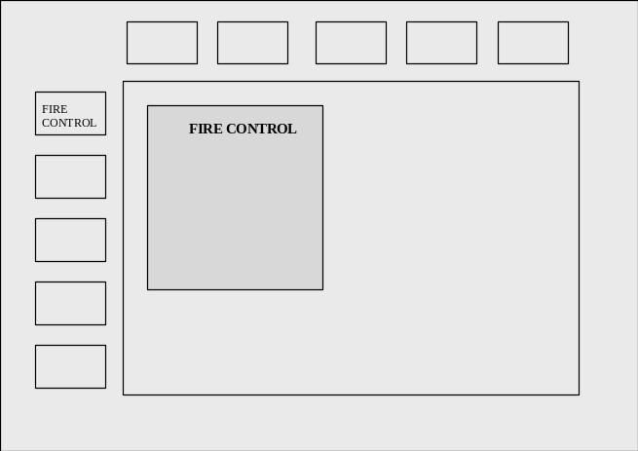
Figure 3-6. Window Opened with Multifunction Key
Preservation of Overwritten Background Information
- Ensure that when a window is opened on top of existing information on the screen, the existing or “background” information is not lost.
Closing a Primary Window
- Ensure that closing a primary window causes all sub-windows associated with that window to close.
Menu Overlap of Critical Screen Information
- Pull-down or pop-up menu windows should not overlap critical screen information, such as message alert areas, flight, and mission information.
Context Sensitive Windowing Hierarchy
- Provide the crewmember with a navigational route through the window hierarchy, whereby the flow through the hierarchical structure is a logical representation of the sequential processes for accomplishing the task.
Single Selection Pop-Up Windows
- Consider using a single selection pop-up window when the crewmember must select only one option from a list. Selecting the option through a single control activation, such as an ENTER key, will cause the option to be implemented and the window to close (adapted from WSHCI Style Guide, 1997).

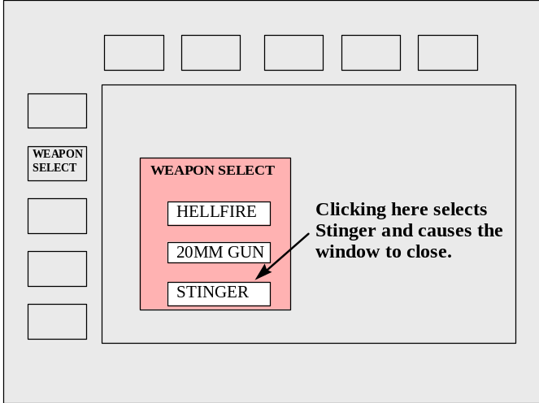
Figure 3-7. Single Selection Pop-Up Window
Current and Default Selection Highlighting
- Ensure that for single selection pop-up windows, the current or default selection is highlighted when the window opens (adapted from WSHCI Style Guide, 1997).
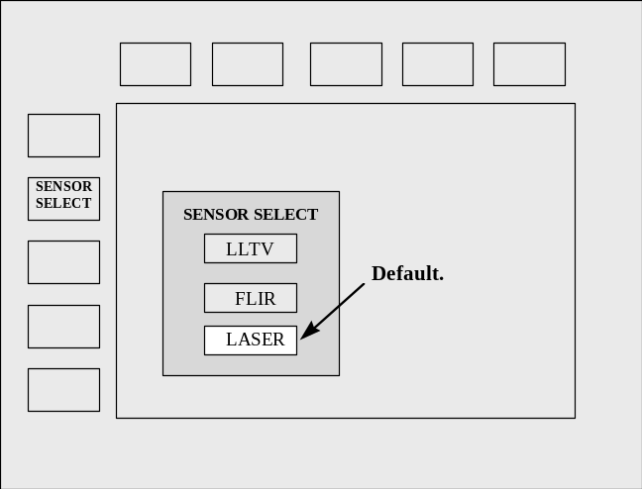
Figure 3-8. Default Selection Highlighted
Multiple Selection Pop-Up Window
- Allow for multiple selections in a pop-up window when the crewmember must select more than one option from a list.

Alphanumeric Data Entry
This section provides guidelines for the design of alphanumeric data entry dialogs for cockpit applications. These guidelines cover topics related to the mechanization of data entry dialogs including prompted and unprompted data entry dialog design, error management, and feedback. Guidelines for designing the format of alphanumeric data entry displays are provided in the Information Presentation and Formats section (section 4) of this style guide. Current cockpit tasks and applications that are typically implemented via alphanumeric data entry are also discussed.

Definitions and Current Conventions
This section describes alphanumeric data entry dialogs, including prompted data entry and unprompted (free text) data entry, and discusses the current conventions for their use in cockpit applications. Prompted data entry involves the entry of specific data items that are identified by unique data fields and labels. In these displays, the crewmember may only enter data in predefined areas or data fields. Unprompted data entry is defined as data entry that is not confined to specific data fields or data types. The crewmember is allowed to enter any data, in any form, on the display. This dialog is often used for alphabetic or word entry. Both types of data entry may be performed in the cockpit. Free text entry may be accomplished via a keypad integrated with an UFC, as in the Comanche rotary wing aircraft. Prompted data entry is typically accomplished from the UFC keypad or directly at the mission computer display, as in the C-17 fixed wing aircraft. When data entry is performed at the UFC keypad, the data is generally displayed on a small scratchpad display associated with the UFC.
Some examples of data entry currently performed in the cockpit: 1) entering navigation data including waypoints and Inertial Navigation System (INS) data; 2) entering communication information including radio frequencies and Identify Friend or Foe (IFF) modes; 3) entering flight mission data including warning limits (e.g., BINGO fuel, low altitude) and formation flight parameters; and 4) entering target acquisition parameters.

Data Entry Methods
Keypad/Keyboard. Keyboards or keypads are typically used for the entry of long strings of alphanumeric data. Typical examples of cockpit data entered via a keyboard include navigation routes and communication channel frequencies. Space limitations require that keyboards implemented in the cockpits be miniaturized. This miniaturization, combined with cockpit vibration and gloved operation, will affect the crewmember’s data entry capability. This should be considered when designing data entry functions for cockpit applications. Refer to section 5.2 for guidelines regarding keyboards.
Bezel Buttons/Pushbuttons. Bezel buttons or programmable pushbuttons may be used for the entry of limited numeric data. This is accomplished by assigning one digit to each bezel button as required, thus essentially using the bezel buttons and the associated MFD as a limited numeric keypad. These programmable pushbuttons can also be referred to as Option Select Buttons (OSBs). Refer to section 5.2 for guidelines regarding programmable pushbuttons.
Example. As shown in figure 3-9, this type of data entry is implemented on an advanced fighter aircraft to facilitate the entry of weapons stores inventory data.
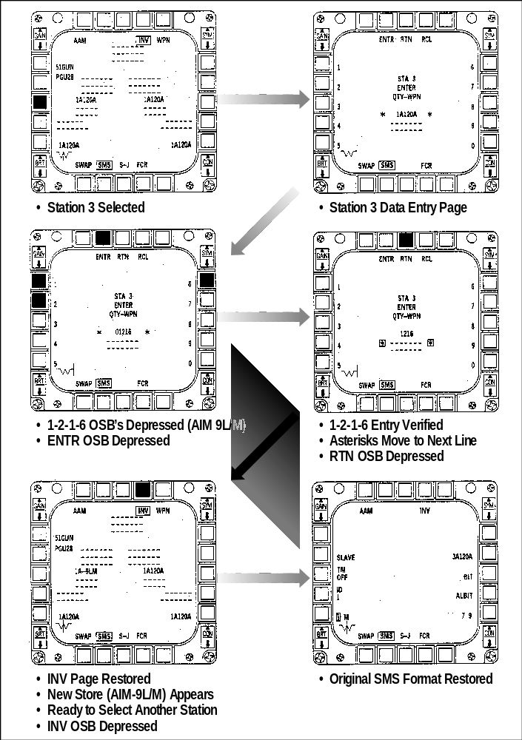
Figure 3-9. Entry of Numeric Data via Option Select Buttons
Voice Command System. Voice command and control is still being investigated in laboratory evaluations, and has only been flight tested on a limited number of aircraft in the United States. Voice technology has the potential for aiding the crewmember by allowing voice data entry while the crewmember remains head-up and hands-on. Voice input may be best suited to data entry of limited strings of alphanumerics. Entering long strings of alphanumerics may be faster and more reliable on a keyboard than with current state-of-the-art voice command systems. The designer must carefully consider the capabilities of the crewmember and the voice command system as well as mission requirements when considering voice input for data entry. Refer to section 5.2 for guidelines regarding voice command systems.

General Alphanumeric Data Entry
Data Entered Only Once
- Ensure that the crewmember is required to enter any particular data only once, and that the system can access the data if needed thereafter for any task.
Single Method for Entering Data
- Design the data entry function and associated displays so that the crewmember is not required to shift between multiple methods of data entry.
Example. Do not require the crewmember to shift between data entry via the keypad and the HOTAS.
Consistent Method for Data Change
- Ensure that the method used for changing data is employed consistently throughout the data entry functions.
Note. Data may be changed in one of two ways; by overwriting the existing data or by deleting it and inserting new data. The overwriting method of data entry is typical of how the data is modified via the UFC on many aircraft.
Exception. The Army’s Comanche helicopter employs both overwrite and insert capabilities within its UFC.
Clear Indication of Overwrite Mode
- Provide a clear indication to the crewmember when new data entered will overwrite the display of existing data.
Example. The crewmember should know if an existing communication frequency will be overwritten when a new frequency is entered.
Crewmember Paced Data Entry
- Allow crewmembers to pace their data entry, rather than having the pace controlled by system processing or external events.
Explicit Enter Action
- Require the crewmember to take an explicit action to initiate the processing of entered data. Processing should not be initiated as a result of some other action.
Example. When entering data via the UFC on the F-16, the crewmember must select the ENTER key to enter the data into the avionics system.
Explicit Cancel Action
- Require the crewmember to take an explicit action in order to cancel a data transaction. Data cancellations should not be accomplished as a result of some other action.
Note. If the crewmember must stop data entry from the UFC to attend to another task, partially entered data should not be lost.
Keep Data Item Short
- For coded data, keep the data entries short so that the length of an individual item will not exceed 5-7 characters.
Abbreviations
- When defining abbreviations, follow simple abbreviation conventions and ensure that the crewmembers understand those conventions. Also, ensure that the abbreviations used in data entry are sufficiently distinctive in order to avoid crewmember confusion.
- Where appropriate, allow the optional abbreviation of lengthy data items to minimize data entry keying.
Minimal Shift Keying
- Design data entry transactions to minimize the need for shift keying.
Decimal Point/Leading Zero Optional
- Allow optional entry or omission of: 1) a decimal point at the end of an integer; or 2) leading zeros.
Convenient Cursor Movement
- Ensure that the crewmember has a convenient method for cursor control. When position designation is required in a task emphasizing keyed data entry, provide cursor control by some device integral to the keyboard.
Example. When the crewmember is entering data via the UFC keypad, allow cursor placement to be accomplished via keys integral to the UFCs.
- If a cursor must be positioned sequentially in predefined areas such as displayed data entry fields, ensure that this can be accomplished by simple crewmember action.
Example. The crewmember should be able to move the cursor using the ENTER or arrow keys.
Compatible Control of Cursor Movement
- Ensure that control actions for cursor positioning are compatible with movements of the displayed cursor in terms of control function and labeling.
Example. When the cursor is controlled by a key action, a key labeled with a left-pointing arrow should move the cursor leftward on the display.
Pointing Device-to-Cursor Movement Ratio
- Pointing device-to-cursor movement ratio should be close to 1:1. Where appropriate, consider allowing the crewmember to select the movement ratio.
Explicit Actuation of Cursor Designation
- A separate explicit action, distinct from cursor position, should be required for the actual entry of a designated position.
Prohibit Cursor Movement to Non-Updatable Fields
- Prohibit the cursor from being positioned in any fields that the crewmember is not allowed to update.
Consistent Cursor Placement
- On the initial appearance of a data entry display, ensure that the cursor will appear automatically at some consistent and useful location.
Data Entry Independent of Cursor Placement
- Ensure that an ENTER action for multiple data items results in entry of all items, regardless of where the cursor is placed on the display.
Example. A crewmember may choose to move the cursor back to a previous field to correct earlier entries. The cursor should ignore cursor placement and update all new entries upon ENTER action.
Non-Obscuring Cursor
- The cursor should not obscure the character displayed in the position it designates.
Stroke by Stroke Feedback
- Provide displayed feedback for all crewmember actions during data entry; display keyed entries stroke by stroke.
Fast Response
- Ensure that the system will acknowledge data entry actions rapidly, so that the crewmember is not slowed or paced by delays in system response.
Note. It is recommended that for normal operations, delays in feedback should not exceed 0.2 seconds.
Processing Delay Feedback
- Where system conditions will result in a processing delay, ensure that the system acknowledges crewmember data entry and provides an indication of the delay to the crewmember.
Feedback for Transaction Completion
- Ensure that the system will acknowledge the completion of a data entry transaction with a confirmation message for successful transactions or an error message for unsuccessful ones.
Error Correction for Characters and Fields
- Ensure that the crewmember can easily correct errors on a character-by-character and field-by-field basis.
Error Messages
- Ensure that the system provides understandable error messages to the crewmember when an unacceptable value is entered in a data field.
Cursor Placement Following Error
- Where appropriate, mark the location of a detected error by positioning the cursor on the erroneous entry.
Displaying Erroneous Entries
- When an error is detected, continue to display the erroneous entry as well as an error message until corrections are made.
Crewmember Editing of Entry Errors
- Following error detection, require the crewmember to re-enter only the portion of the data/command entry that is not correct.

Prompted Data Entry
This section provides guidelines for the design of a data entry dialog using labeled display fields as prompts. Most of the data entry tasks performed at the cockpit UFCs or mission computer, such as communication/navigation data entry functions, are primarily prompted data entry tasks of this type.
Defaults
- If default values are used in data entry fields, display them automatically in the appropriate fields.
- When the crewmember replaces a default value in a data entry field, ensure that the default settings or values are not permanently changed.
Combined Entry of Related Data
- In a form-filling dialog, when the crewmember is entering logically related items, the system should require just one explicit entry action at the end of the transaction sequence rather than the separate entry of each item.
Flexible Interrupt
- When multiple data items are entered as a single transaction, as in form-filling, allow the crewmember to review or cancel any changes before taking a final ENTER action.
Data Entered in Familiar Units
- Ensure that the crewmember is able to enter data in familiar units.
Note. When required, the system should perform any required conversions (e.g., between geographic, geodetic, and Military Grid Reference System coordinates).
Minimal Cursor Positioning
- Where possible, minimize the crewmember actions required for cursor movement from one data field to the next.
Example. Pressing the ENTER button to enter data in one data field should send the cursor to the next data field to be filled.
Automatic Cursor Placement
- When a data entry display is presented, the system should automatically place the cursor at the beginning of the first data entry field.

Unprompted Data Entry (Free Text)
This section provides guidelines for the design of data entry dialogs that allow free text entry. The Army’s rotary wing Comanche is one example of a cockpit which has an integrated free text entry and display.
Adequate Display Capacity
- Ensure that the display capacity is adequate to support efficient performance of text entry/editing tasks.
Note. Cockpit displays used for text entry are typically small in order to conserve space. While maintaining a small display size, it is important to ensure that the required data entry tasks can be performed.
Editing Capabilities During Text Entry
- Allow the crewmember to perform some simple editing during text entry without having to invoke a separate edit mode.
Free Cursor Movement
- For free text entry and editing, allow the crewmember to move the cursor freely over the displayed text to designate and edit items.
Automatic Word Wrapping
- For entry and editing of unformatted text, provide an automatic word wrap feature that starts a new text line when the text reaches the right margin of the display.
Note. This will allow the crewmember to enter text freely without having to consider the text format.
Crewmember Confirmation
- If a DELETE function is available to the crewmember as a feature of the free text editing, the system should require the crewmember to confirm the DELETE action before processing it.

Direct SYSTEM Command
This section provides guidelines for the design and implementation of direct system command dialogs. Definitions and examples of current direct command implementation within the military cockpit are also provided.

Definitions and Current Conventions
This section defines the direct system command dialog and describes the current cockpit conventions for its use. Direct system command is defined as allowing the crewmember to control a subsystem directly without the use of menus or explicit alphanumeric data entry. Subsystem control can be either discrete or continuous control. Direct system commands are typically accomplished via hands-on controls (i.e., HOTAS) or pushbuttons implemented on the UFC. Voice command and control is also currently being explored as a method to directly control subsystems. An example of continuous control of a subsystem via hands-on controls is the real-time slewing of a sensor to support target designation. Another example of direct system command implementation in the cockpit is the UFCs provided in many rotary-wing and fixed-wing combat aircraft. These controls provide the crewmember with direct, discrete control of various subsystem settings including communication presets, navigation system selections, master mode selections, and master weapon arming.

Direct Command Methods
Hands-on Controls. Hands-on controls are typically used for real-time control of aircraft subsystems that the crewmember must control while maintaining hands-on. Subsystems that may be controlled via the HOTAS include sensor slewing, weapons selection, target designation, and weapons release. Refer to section 5.2 for guidelines regarding HOTAS controls.
Pushbuttons. Pushbutton controls, especially those implemented on the UFC, are typically used for critical functions that must be made quickly or for frequently required control entries. An example of a critical function that is often controlled via UFC is the master mode command. Another example of subsystem command via UFC is the communication channel presets. Commanding the communication subsystem via UFC pushbuttons allows the crewmember to make frequent channel changes with relatively few actions. Refer to section 5.2 for guidelines regarding cockpit pushbuttons.
Voice Command System. Voice command and control is still being investigated within in laboratory evaluations, and has only been flight tested on a limited number of aircraft in the United States. While still considered as an emerging technology, voice command does offer some unique implementations for direct subsystem command. It is best suited for direct command tasks that require only limited control entries and that may be required when the crewmember must remain head-up and hands-on. Examples of voice commands currently being investigated and tested include sensor moding, target selection, radio channel selection and frequency change, and route manipulation. Refer to section 5.2 for guidelines regarding voice command systems.

Direct System Command Guidelines
Predictive Information Prior to System Command
- The crewmember should be provided with some indication of the results of a given control or mode action before the action is finalized. In other words, make sure that the crewmember is informed of the consequences of any proposed actions.
Example. Before the crewmember zooms in a sensor’s coverage, the system may display a window showing the field of coverage upon zooming in.
System Response Feedback
- The system should acknowledge every direct system command control entry immediately; for every crewmember action there should be some apparent reaction from the system. When the direct system command control activation does not result in an immediately observable response, the crewmember should be given some indication of system acknowledgment.
Feedback for Head-Up Operations
- Since hands-on controls and voice command may be used for direct system command when the crewmember must remain head-up and maintain hands-on control, consider providing auditory feedback in response to these commands.

References
Advisory Group for Aerospace Research and Development (AGARD). (1995) Advisory Report 349, Flight Vehicle Integration Panel Working Group 21 on Glass Cockpit Operational Effectiveness. Neuilly-Sur-Seine, France.
Bowen, C. D. (1995) Theater Battle Management (TBM) Human Computer Interface (HCI) Specification, Version 1.1. (MP95B0000035). Mitre Corporation.
Goins, R. T. (1993). Integrated Cockpit/Avionics for Transports, Pilot-Vehicle Interface Trade Studies (Draft AFMC Wright Laboratory Technical Report, Contract F33615-92-C-3803). McDonnell Douglas Corporation, Burbank, CA.
Hamilton, B. E. (1995). Helicopter Human Factors. In D. J. Garland, J. A. Wise, & V. D. Hopkin (Eds.), Handbook of Human Factors In Aviation Systems (DRAFT).
Helander, Martin. (1991). Handbook of Human-Computer Interaction. Amsterdam: Elsevier Science Publishers.
Holley, C. D., & Busbridge, M. L. (1995). Evolution of the Venom Variant of the AH-1W Supercockpit. Proceedings of the 51st Annual American Helicopter Society Meeting, Fort Worth, TX.
Little, J. K., & Hannen, M. D. (1993). Longbow Apache Controls and Displays Management. At the American Helicopter Society Specialists Meeting. Fairfield County, CN.
Mayhew, D. J. (1992). Principles and Guidelines in Software User Interface Design. New Jersey: Prentice Hall.
Smith, S. L., & Mosier, J. N. (1986). Guidelines for Designing User Interface Software. (Technical Report No. ESD-TR-86-278). Mitre Corporation. Bedford, MA.
U.S. Air Force. (1994). F-16 C/D Avionics and Nonnuclear Weapons Delivery Manual (Technical Order 1F-16C-34-1-1).
U.S. Army. (1996). Aviation System of Systems Architecture (ASOSA), Framework for Computer, Communication, Electronics, and Power Management (AFCCEM), Volume 8, ASOSA Soldier/Aircrew Machine Interface (SAMI) Style Guide, Draft Version 1.3.
U.S. Army. (1997). U.S. Army Weapon Systems Human-Computer Interface Style Guide (WSHCI), Draft Version 2.
U.S. Department of Defense. (1996). Department of Defense Technical Architecture Framework for Information Management, Volume 8: Department of Defense HCI Style Guide (TAFIM), Version 3.0. Defense Information Systems Agency Center for Architecture.
U.S. Department of Defense. (1996). Department of Defense Design Criteria Standard, Human Engineering, MIL-STD-1472E.
U.S. Department of Transportation, Federal Aviation Administration. (1996). Human Factors Design Guide, Final Report. FAA Technical Center, Atlantic City International Airport, NJ.
U.S. Navy. (1997). Situational Awareness Guidelines (Technical Memorandum NAWCADPAX-96-268-TM). Naval Air Warfare Center Aircraft Division. Patuxent River, MD.

Information presentation and formatting
This section presents guidelines for cockpit display formats. The term “format” refers to the way in which information is represented, organized, and presented to the crewmember. Proper format design will aid the crewmember in assimilating the information presented. For cockpit applications, display formats can be either visual or auditory in nature. Visual formats include alphanumerics, menus, graphics, pictures, images, or a combination of these. Auditory formats include both voice and tone presentations. This section presents guidelines for each of these format types including selection criteria for their proper implementation.
Visual formats should be visually, conceptually, and linguistically clear and understandable. The formats should also be compatible with crewmember expectations. Compatibility can be achieved by using familiar concepts, terminology, and task flow. It is critical that the format design of cockpit displays be compatible with task and function requirements. The crewmember must be able to perform required tasks in a direct and obvious manner. Formats that are designed with a predictable task flow will facilitate crewmember performance.
The crewmember should be able to rely on an interface that remains consistent, to the extent possible, in general appearance and behavior across system functions and applications. The basic principle of functional format design is to keep the interface as simple as possible and provide all the functionality required by the crewmember to perform the required tasks.
Within the cockpit, the audio channel is used for many different tasks including verbal communication, warnings, system messages, answers to crewmember queries, and threat identification. Auditory presentations can take the form of verbal messages (either digitized or synthesized voice), or some kind of sound or tone. Auditory signals are advantageous in many situations since they can alert the pilot faster than visual displays, and are independent of eye fixation and head position. Auditory perception is also less effected by high g-loads than visual perception. Another advantage of auditory signals and voice messages is that they do not take up valuable display space.
Auditory displays, however, have some inherent disadvantages. The human’s input channel via the ear is not very reliable. In certain situations, a sound or voice may be perceived but does not reach the level of cognition. This failure to process auditory inputs may happen during phases of high workload. However, designers often assume that auditory displays are most advantageous during periods of high workload. The designer should carefully weigh the advantages and disadvantages of auditory displays, and compare them to implementing visual displays for the same function.
The following table shows which type of functions are suitable for auditory presentation and which are suitable for visual presentation. The designer should use this guide when assigning a particular function to either a visual or auditory display.
Table 4-1. Auditory Versus Visual Presentation
Use Auditory Presentation If: | Use Visual Presentation If:
The message is simple | The message is complex
The message is short | The message is long
The message will not be referred to later | The message will be referred to later
The message deals with events in time | The message deals with location in space
The message calls for immediate attention | The message does not call for immediate action
The visual system of the crewmember is overburdened | The crewmember’s auditory system is overburdened
The receiving location is too bright or dark adaptation integrity is necessary | The receiving location is too noisy

The interface format must also conform to standards and requirements established for the specific platform to be designed. The designer should review these documents before starting the design process. The AHCI Style Guide can also be used to develop system requirements if none exist. The design process should allow for trade-offs in the design to accommodate crewmember needs and provide a means for user feedback into the design trade-off process. While cockpit format design may differ to varying degrees for different platforms and mission objectives, there are elements common to many applications. The basic philosophy and issues to be considered in the design of typical cockpit applications are presented in the following sections.
Flight Display Formats. All aircraft cockpits are equipped with indicators for airspeed, altitude, attitude, heading, engine/rotor tachometer, and engine and fuel status. Most combat aircraft currently display flight information both in a head-down format as well as a head-up format, using either a head-up display (HUD) or a helmet-mounted display (HMD). Traditionally, the head-down display of flight information was provided through electromechanical displays. However, electronic displays are replacing electromechanical displays for the display of flight information. Regardless of the display medium, the information is typically arranged in the traditional “T” pattern with the airspeed indicator on the left, the altitude indicator on the right, and the attitude indicator in the center. Many electronic implementations of flight displays mimic their electromechanical counterparts. In other implementations, different types of flight information are integrated within a single “primary flight display” format. While this approach can save cockpit real estate, the display of the information may not be optimum. In addition to traditional flight instruments, crews rely on a variety of sensor technologies to aid in flight control for special situations. These may include radar altimeters, terrain following radar, night vision goggles, and Forward-Looking Infrared (FLIR) systems. The requirements for the display of data from these sources must also be considered in the overall design of flight display formats. Detailed information regarding flight display formats can be found in MIL-STD-1787, Aircraft Display Symbology.
Navigation/Tactical Situation Display Formats. The specific navigation information provided in the cockpit and the display format varies with aircraft platform. Basic navigation information includes aircraft position, course and course deviation indicators, range and bearing indicators, heading, and landing data. This information is supplied by various systems including Internal Navigation System (INS), Global Positioning System (GPS), and ground-based navigation aids (e.g., Tactical Air Navigation (TACAN) and Instrument Landing System (ILS)). Command steering information is also provided in some form on nearly all platforms, but its presentation varies widely with its intended usage. Examples of command steering include route steering guidance, air-to-ground attack steering cues, flight directors, terrain following steering commands, and formation flight steering guidance.
All aircraft provide basic Horizontal Situation Indicator (HSI) information either in an electromechanical or electronic format. As with primary flight displays, electronic formats will eventually replace electromechanical instruments for display of HSI information. Landing information, such as glideslope, localizer, and flight director information, is often presented both head down, and head-up, in those cases where an aircraft is equipped with a HUD.
Electronic map and situation displays are becoming more prevalent in modern cockpits. Many of these are currently provided in a symbolic “stick map” format. However, full color navigation charts with overlaid symbology to represent routes, waypoints, and other important information will be more widely used in the future. These formats may also serve as the foundation for presenting other tactical and spatial information from on- and off-board sources, such as real/near-real-time intelligence information, target ID and location, and mission updates.
A variety of data entry and system configuration tasks are involved with the navigation function, including entering/editing waypoints, configuring displays for presenting navigation aid information, and tuning navigation radios. As electronic cockpits become more sophisticated, and as GPS receives widespread use, the specific nature of these tasks may change or become more automated. For example, the use of GPS may reduce the reliance on ground-based navigation aids, and improved graphics capabilities in the cockpit may simplify the entering and editing of route information. Map displays also provide a range of configuration options that include: 1) data filters, 2) orientation, 3) selectable range scales, 3) zoom modes and 4) declutter modes. Relevant aviation human-computer interface (AHCI) display issues include display formatting techniques for both dedicated and integrated displays, and appropriate interface formats for data entry and display configuration.
Communication/Data Communication Display Formats. Communication is critical to all aircraft types for flight and battlefield operations coordination and for relaying reconnaissance and targeting information. Data communication, as used here, refers to data link and other systems (e.g., Real-Time Information in the Cockpit (RTIC) systems) that can provide high volumes of national intelligence information, in real- or near-real-time, directly to the aircrew.
Crewmembers typically interface with the communication systems via dedicated control panels or integrated control display units. Rotary-wing aircraft typically display this information on a control display unit. Crews use these interfaces to accomplish a variety of communication functions, including selecting radios, tuning radios, and configuring Identification Friend or Foe (IFF) systems. Some aircraft are equipped with digital displays that allow the presentation of data-linked textual messages. Textual messages are typically prioritized for display. Some current aircraft, such as the Apache helicopter, also provide the capability for crewmembers to compose and transmit textual messages off-board.
The provision of real-time tactical information will have an increasing importance in future tactical arenas. The visual presentation of messages appears to be preferred when the message is very complex. This type of data communication is gradually replacing voice communication, especially in rotary-wing aircraft, where the need for real-time tactical information transfer between the helicopter and ground-based troops is critical. As RTIC technology is integrated into various platforms, the use of graphics formats to display charts, route updates, threat data, sensor imagery, and digitized photographs will become more prevalent.
Due to the number, variety, and potential complexity of communication systems in the cockpit, their management can result in considerable workload for the pilot. Consideration needs to be given to integrating various communications systems to allow easy configuration and access. Some specific design issues include: functional and sequential grouping of displays, display formatting, minimizing clutter, and highlighting of critical information.
Caution/Warning/Advisory Formats. Caution/Warning/Advisory (CWA) information is required in all aircraft cockpits. The information typically includes visual warning and caution displays (master warning and caution), voice message information regarding warning conditions, and aural tones for warning and caution conditions. Most aircraft use annunciator lights to present CWA information. Aircraft equipped with electronic displays may also present textual messages in the cockpit. These messages may appear on multifunction displays (MFDs) or on a separate electronic scrolling fault list. Visual warning and caution displays are generally divided into three categories and are color coded depending on their category (warning - red, caution - amber, advisory - green). Aural tones are typically associated with a master caution/warning condition. Voice messages are generally reserved for critical warning conditions. Trends are toward decision-aiding systems to assist the pilot in making corrective actions for emergency responses.
Consideration needs to be given to prioritization, integration, and phraseology of visual CWA information and auditory presentation of CWA information. Specific formatting design issues involve: redundancy, positioning of displayed information, color coding, and highlighting.
Weapon Systems Formats. Accurate weapon delivery requires real-time information from a variety of sources and displays. This information includes sensor system information, weapons stores and status information, and basic flight and navigation data. While the information requirements are similar for rotary and fixed-wing aircraft, the actual presentation format of the information and the methods used for weapon aiming and delivery are different.
In newer rotary-wing combat aircraft, the pilot or copilot/gunner is provided with a weapons situation display and a weapons stores display on the MFD. These displays are used to track targets, select the weapons, and control turret guns. Weapon aiming symbology is typically presented on the HMD. Some newer attack helicopters such as the Apache are equipped with an Integrated Helmet and Display Sighting System (IHADSS) that provides basic flight information, weapon aiming symbology, and night vision imaging information for pilotage and target acquisition. The pilot is generally required to maneuver the aircraft in order to bring the target within the weapon envelope as displayed on the HMD.
Modern fixed-wing combat aircraft are equipped with MFDs that provide the pilot with the information required for weapon delivery. The MFD formats usually include a stores management display used to verify weapon selection, status and operating mode, and a radar or tactical situation display which presents target identification and tracking information. In addition to the MFD formats, the pilot is provided with critical weapon aiming and system status information on the HUD. Data presented on the HUD includes target symbology, weapon mode and status, attack steering cues, and basic navigation data. As with attack helicopters, the fighter pilot is usually required to maneuver the aircraft to position the aiming cues/symbols displayed on the HUD over the displayed target.
In all combat aircraft, the management of sensors is an integral task associated with the weapon delivery function. Combat aircraft typically have a fire control radar (FCR) that is used for target location and identification, and other various sensors used for navigation and/or targeting such as the FLIR, or the Low Altitude and Targeting Infrared for Night (LANTIRN) system. The data from these sensor systems is critical information for the pilot/copilot and is therefore typically given significant priority for display within the cockpit. Information gathered from these sensors and displayed in the cockpit may include target location, target tracking information, and ground mapping data. Data from sensors may be presented in raw form, as imagery or video, or in a “processed” form, such as synthetically generated symbology. In addition to the sensor imagery or video, display formats may also include symbology and alphanumeric readouts.
Symbology is used to present information such as targets, range scale, radar antenna data, and beacon symbols, while alphanumeric data is used to present information such as scale values, target airspeed, target altitudes, etc. Most sensor information is displayed on MFDs. However, targeting information from sensors is normally presented both head-down on an MFD, and head-up on the HUD or HMD. AHCI display formats for sensor data display should be designed to effectively integrate and present data from different sources. These formats must also be designed to facilitate sensor management and configuration. Sensor data displays should present data so that the crewmember is aware of current modes and any required crewmember actions. Configuration and mode selection of sensors is usually accomplished through the MFD menu system. However, real-time sensor control, such as slewing and target designation, is usually accomplished with hands-on controls.
Stores management, another integral task associated with weapon delivery, is typically accomplished through the MFD interface and dedicated controls. Stores management displays provide information regarding current weapon loading on the aircraft, weapons remaining, weapon status, the weapon delivery mode, and selected weapons release parameters. The stores display formats typically include an inventory page, an emergency or selective weapon jettison page, and other page formats based on the particular combat or weapon mode. Most weapons stores displays are currently alphanumeric but a graphic display format could be used to present this same information.
System Status Display Formats. Military aircraft are equipped with a variety of displays and display types that provide system and subsystem status. These status displays are sometimes referred to as “aircraft health displays” and may include engine status, fuel status, and other subsystem status to which the crewmember must be kept apprised. Traditionally, these displays were electro-mechanical, round-dial gauges or digital readout displays. When these displays are implemented electronically within an MFD or dedicated display, information may be presented in a combination of graphical and alphanumeric displays. Designers may decide to maintain the same basic look of the electro-mechanical instruments when presenting information on an MFD. For example, oil pressure and temperature information may be presented on circular dials “drawn” on the MFD. An alternative to depicting traditional electro-mechanical status displays is to present all engine status information as numeric readouts integrated within one or two electronic displays. It is typical to provide one electronic display for engine information and one for fuel information.
The designer should be aware that system status parameters do not change frequently. Therefore, the display format should be designed to facilitate crewmember detection of critical changes in the system status. One method for achieving this is the use of color coding. As multiple color MFDs become more prevalent within military aircraft, color coding may become a viable option for subsystem status displays. Color coding may be used in status displays to depict normal ranges as well as minimum and maximum limits. For example, green may be used to depict normal, yellow to depict caution, and red to depict warning ranges for scale displays.
Defensive Systems Management. Defensive systems management functions involve the monitoring of threat displays and the management of various countermeasure systems, including chaff, flares, and electronic countermeasure systems. Radar threat warning information is typically presented to the pilot as a combination of auditory tones, indicator lights, and dedicated electronic displays. The indicator lights present threat warning information as well as system status to the pilot by illuminating upon certain conditions. The dedicated electronic display typically provides graphic or symbolic representations of signal type (e.g., surface-to-air missile (SAM) type), signal strength, and signal bearing. In some aircraft, this information may be presented on integrated tactical situation displays. Threat data may also be relayed to the aircrew through traditional communication systems. As RTIC systems become more prevalent, high volumes of real-time and near-real-time threat information will be available to the crewmember in a graphic form.
One of the most important considerations in the design of threat warning and countermeasure management AHCIs is the task environment in which they are used. The management of countermeasures is a critical function that usually must be accomplished during the most demanding phases of the mission. Their interfaces must therefore be seamlessly integrated with those for target acquisition, sensor management, weapon delivery, and other functions accomplished during critical phases. Other important display formatting considerations include the content and coding of visual and auditory displays, and the presentation of feedback to the aircrew.
This section of the style guide is divided into two main parts: 1) Presentation and Formatting of Visual Information guidelines (4.1); and 2) Presentation and Formatting of Auditory Information guidelines (4.2). In the visual format section, general visual display guidelines that apply to all visual displays, such as format design, organization, and clutter guidelines are presented first. Guidelines that apply to a particular type of visual display (i.e., graphics) are presented next. Visual display format guidelines specific to HUD and HMD applications are also discussed. The auditory format section presents selection criteria for voice and tonal formats and then presents guidelines for each type.

Presentation and Formatting of Visual Information
Visual presentation formats should be compatible with the crewmember functions and task requirements. The crewmember must be able to perform the required tasks in a direct and obvious manner. Task flow should be predictable by the crewmember and easy to follow. Information should be presented in such a way as to enable the crewmember to accurately detect, acquire, interpret, and use the information, while placing minimum demands on the crewmembers’ perceptual, memory, and cognitive capabilities, under all expected operational conditions. An interface and format design that is easily learned and understood is critical to efficient crewmember and task performance. Display coding should be in accordance with accepted crewmember conventions and should enhance the overall format design. Care should be taken in the design of special format displays including graphical and imagery displays so that the display format facilitates the detection and interpretation of critical information. The following guidelines will aid the designer in developing visual display formats.

Format Selection and Design
Format Compatibility
- To facilitate task accomplishment and task flow in a multi-tasking environment, the designer should select the format type based on the task and function requirements. The format must be compatible with task requirements.
Note. Table 4-2 summarizes the display formats recommended for various task requirements and provides comments related to the implementation of the format. As a general rule, the following format assignments apply within the cockpit environment.
Table 4-2. Visual Display Format Types
Format Type | Recommended Usage/Task Requirements | Comments
Menu Format | Selecting among constrained set of alternatives | Menu types may include hierarchical, rotary, and increment/decrement.
Alphanumeric Format | Task is primarily textual and involves reading, scanning, or monitoring textual data | Alphanumeric formats include standard text display and data-entry displays. Uses include providing lengthy lists of textual information (radio frequencies), messages, status data, etc.
Graphic Format | Showing relations in space or time; integrating information from diverse sources; displaying geographic data; rapid scanning and comparing or monitoring of data | Graphic formats include pictures, configurations, schematics, maps, and situation displays. As a rule, complex formats and artistic embellishments which detract from the intended purpose of the graphic should not be used.
Imagery Display | Providing video images from various sensors | Imagery formats include video images from one sensor or a combination of different sensors presented in a single display format.

Frame of Reference Compatibility
- Information should be presented in a form that is compatible with the crewmember’s frame of reference for the task being performed.
Example. An inside-out view that presents a moving horizon is an example of frame of reference compatibility.
Integrated Format Usage
- When the crewmember is required to assess the relation among different data elements, or when multiple types of information are relevant to a single task, the data should be provided in an integrated format rather than partitioned into separate windows or display pages.
Example. When the crewmember needs specific data displayed concurrently to make judgments on the tactical situation, provide those data in an integrated, “tactical situation” display, rather than displaying the different types of data in separate windows or displays.
Example. A Primary Flight Display (PFD) presents different information relevant to the task of flying the aircraft.
Integrated Format Design
- Graphic symbols used on an integrated display should not interfere with each other and hinder the detection and comprehension of information.
Note. Symbols that are appropriate for one display type may not be appropriate when displayed with other types of information or symbols on an integrated display.
- Critical information should not be obscured by other, less important data. The designer should develop a symbol priority scheme such that more important graphic symbols are given higher priority for display and will not be overwritten by lower priority symbols.
- When alphanumeric data is overlaid on graphic data, careful consideration should be given to the background color and clutter to ensure that the overlaid data are easily legible under all operational conditions. Similarly, when alphanumeric and graphic data is overlaid on video imagery data, ensure that the overall display color and clutter does not interfere with data comprehension.
- Integrated displays should be designed to alert the crewmember when information within the display becomes critical.
- Careful consideration should be given to display clutter issues when designing and coding integrated displays. (Refer to section 4.1.3 for more detailed guidelines regarding display clutter).
- Data items should be selected so that their designs or coding mechanisms do not “compete” with each other and interfere with information comprehension.
Example. The improper use of highlighting or coding of information may distract the crewmember and interfere with his/her ability to identify and comprehend critical information.
- Multiple indications of a single threat obtained from multiple sources should be integrated and presented with a single symbol.
Display of Trend Information
- Format and display information to enable the crewmember to easily acquire historical trend information for those tasks that require some estimate of this information for task accomplishment. Generally, historical trend information is better provided with analog presentations rather than with digital representations.
Note. Predictive, computer-aided displays are a direct means of providing this type of information.
Analog Versus Digital Display Format
- Consider using analog formats when the task requires the crewmember to perceive rate-of-change information or to estimate the magnitude of the variable when it is rapidly changing. Also consider using analog formats for displaying information which is analog, or for displaying information for which the crewmember typically maintains an analog mental representation (Wickens, 1984).
Example. Altitude, temperature, and direction are physically analog quantities. Analog formats for display of these data would be most compatible with the crewmember’s mental representation of these quantities.
- Consider using digital formats when the task requires the crewmember to read the absolute value of an indicator with high precision (Wickens, 1984).
Command Versus Status Display Format
- Command display formats should be distinctly different from status display formats. Command displays should be augmented with status information for verification.
Definition. Command displays present information that the crewmember should follow, such as the Attitude Director Indicator (ADI), whereas status displays present information regarding system status.

Content/Organization of Display Information
Content of Display Information
- The content of displayed information should be that which is best suited for the crewmember at any given point in time: The quantity of information displayed to a crewmember should be limited to that which is necessary for the performance of specific actions, maintaining situational awareness (SA), or decision making. The precision of the information displayed should be at the level necessary for the accomplishment of crewmember actions or decision making.
Consistent Format
- Display formats should have a consistent structure and layout evident to the crewmember so that display features are always presented in the same way across display pages that support similar functions. Where appropriate, data fields such as headers and message areas should be consistent in wording and location on similar display pages.
Note. Obviously, not all cockpit display pages will have similar formats. For example, a radar display does not have many features that are similar to a weapons stores display. However, consistency should be maintained whenever possible across similar displays or displays with similar functions, such as those data entry displays used for entering communication frequencies and those used for entering navigation waypoints. Also, consistency should be maintained for similar features of different displays and display types. For example, even when displays have different appearances and functions, the crewmember prompts should appear consistent in form and location whenever possible.
- Common elements within a given format type (e.g., alphanumeric formats, graphical and map formats, menu formats) or between similar formats should be consistently depicted and located.
Example. Threat symbols should be the same on a tactical situation display format as on another map format or as a menu item icon.
Usable Form Consistent with Crewmember Conventions
- Display data in the most directly usable form so that the crewmember is not required to transpose, compute, interpolate, or mentally translate data into usable units or number bases. Also, display information only as accurately as the crewmember’s decision and control actions require. Where appropriate, units should be selectable to accommodate task requirements.
Example. Altitude expressed in metric units may be a more useable form than feet, particularly for foreign operations. Another example is the expression of barometric pressure in millibars versus inches.
- Display data in a format that is consistent with crewmember conventions and that uses familiar wording or task-oriented jargon.
Example. Mimicking electro-mechanical format designs on electronic displays, such as the ADI and HSI displays, can help to maintain accepted crewmember conventions.
- Ensure that each data display page provides the needed context so that the crewmember does not have to rely on memory to interpret new data.
Prominent Display/Protection of Essential Information
- Essential information required for task accomplishment should be predominately displayed at the forefront of the crewmember’s awareness and the amount of non-essential information should be minimized.
- Ensure that key display data, such as critical information, warnings or other messages, cannot be overwritten.
Example. Primary flight information should not be removable and should never be overwritten by other information.
Distinctive Display Categories
- Make the different categories of a display format distinctive from one another. There should be a clear differentiation between different types of data such as display titles, menu options, status information, and control options.
Example. The MFDs implemented on the Longbow Apache make a clear distinction between status information, which is displayed in windows with rounded corners, and option selections, which are displayed in windows with square corners (Little and Hannen, 1993).

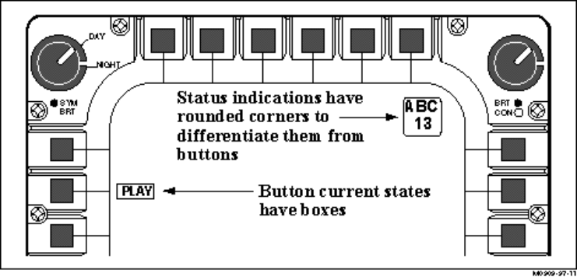
Figure 4-1. Proposed Apache Display Conventions
Layout/Organization of Information
- The layout of information within a page should follow some logical, organizing principle that crewmembers can recognize and apply. Data should be grouped on the basis of this principle, considering the trade-offs derived from a task and information analysis. Groups of data should be distinctively displayed using blank space, surrounding lines, or different intensity levels as appropriate. Ensure that the location of recurring functional groups and individual items is consistent across MFD pages and displays.
Note. Breaking large portions of text into small, meaningful groups will minimize the amount of information to be attended to at one time. Closely packed data are difficult to locate and difficult to read. Blank space can therefore be beneficial in separating different groups of data. Related data items within a group, however, should be displayed near one another to minimize eye movement time in scanning those data.
Organization Methods
- When some displayed data items are critical to task performance, consider displaying those items in the primary viewing area of the crewmember.
- If crewmembers must analyze data to discern similarities, differences, trends, or relationships, structure the display page format to facilitate data comparison.
- When displayed data are used in some spatial or temporal order, consider grouping those data by sequence of use to preserve that order.
- When some data items are used more frequently that others, consider grouping those items at the top of the display.
- When various types of data are associated with particular functions, consider grouping the data to illustrate their functional relationships.
Meaningful Integrated Units
- Large amounts of data should be integrated into a few meaningful units that will allow for easy interpretation under compressed time constraints.
Example. One way this can be accomplished is through pictorial formats that allow the crewmember to easily determine trends and make decisions that require the integration of information from multiple sources.
Display Title at Top
- Where appropriate, display pages should have a title or header at the top of the display that concisely describes the contents or purpose of the display. The title should be separate and distinguishable from the body of the display.
Exception. MFD menu displays that present bezel button selections around the perimeter of the display including the top edge usually do not have titles displayed, but instead typically highlight the option selection label that reflects the current display (Holley and Busbridge, 1995).

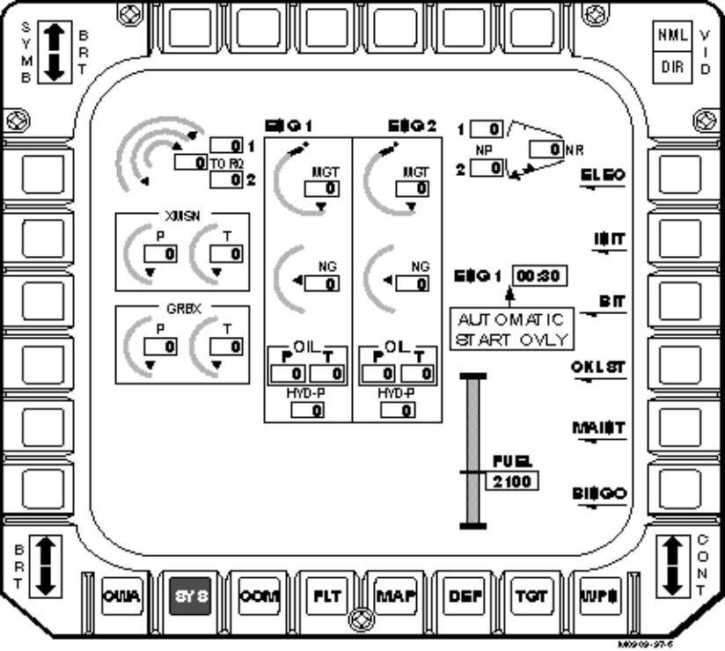
Figure 4-2. Bezel Button Labels Function as Menu Titles
Reserved Areas
- Messages, warnings, and crewmember prompts should appear consistently in the same location throughout the various cockpit display pages. The areas in which these items are displayed should be reserved for this purpose.
Note. Some sources have recommended that the space at the bottom of the display pages be reserved for messages and critical warnings. While this may not be practical or possible for all display pages, consistency of location for these messages between display pages of similar types should be maintained.
Use of Multiple Display Pages
- When a display contains too much data for presentation in a single page, the information should be partitioned into multiple pages. When data must be partitioned, consider the type of data to be displayed, and display functionally related data items together on one page. The crewmember should be informed when the data extends beyond one page.
Display Clutter
- Displays should be as uncluttered as possible. Information should be presented simply and in a well organized manner with the display appearing free of clutter.
Note. Display clutter can directly affect a crewmember’s visual search in accessing task-relevant or critical information within and across displays, especially when under the stress of combat environments or while experiencing high workload. In military aircraft cockpit systems, a large amount of visual information must be compressed into a relatively small field of view, creating a very real potential for display clutter. Major sources of display clutter include the number of elements to be searched, the number of confusing objects in a display, and their spatial proximity.
Minimize Display Density
- Minimize the display density on a display by prioritizing and limiting information to be displayed. Density must be minimized for the display of critical information. Prioritize the information so that the most important or critical information is displayed at all times and less important or critical information can be displayed upon crewmember request.
Definition. Display density is the ratio of characters/symbols to blank space.
- Display density should not exceed 50%, and preferably should be less than 25%. Displays consisting largely of alphanumerics generally should not exceed 25% density. Displays composed largely of graphics may be more dense.
- The unused area of a display page should be distributed to separate logical groups and categories of data.
Display of Unnecessary/Old Data
- To help alleviate display clutter, unnecessary borders should not be used on the display. Scales should not be cluttered with more marks than necessary for precision. Old data points should be removed after some fixed period of time, and interim information should be removed from the display once it is no longer needed.
Declutter Scheme
- The designer should develop a hierarchy of information needs and incorporate this hierarchy into a compatible declutter capability.
Removal of Features/Minimizing to Declutter
- As a decluttering technique, the designer should consider the total removal of a display feature.
Note. This method is commonly used in cockpit applications where symbols or labels may override critical display features (e.g., high elevation points on a digital terrain map).
- The designer may also consider minimizing symbols and removing labels instead of totally removing a display feature.
Note. Research has shown that the partial removal of features by minimizing symbols and removing labels is as effective as total removal. This method has potential for electronic map displays.
- If information is removed or minimized, a visual cue indicating that more information is available should be provided.
Display Sequencing
- Display sequencing may be used to reduce clutter, to reproduce temporal changes in the display, and to aid in visualizing database changes in the battlefield situation.
Crewmember Control of Display Data (Declutter Capability)
- Where possible, allow crewmembers to control the amount, format, and complexity of displayed data as necessary to meet task requirements.
- Whenever possible, provide the crewmember with a means for reducing clutter while preserving essential information.

Display Coding
This section contains display coding guidelines for visual display applications. Display coding refers to the distinctive methods used to highlight different categories of displayed data to attract crewmember attention. There are various coding methods that may be appropriate for cockpit applications. These include: 1) shape coding; 2) alphanumeric coding; 3) line coding; 4) size coding; 5) brightness coding; 6) blink or flash coding; and 7) color coding. Each of these coding methods is more appropriate for certain cockpit applications than for others. The designer must consider the task requirements, the operational environment, and crewmember conventions to determine the coding method most suitable to a given display or display element. Table 4-3 summarizes the appropriate use and limitations of the various coding methods typically employed in cockpit displays. The remainder of this section presents general coding guidelines that apply to all display coding, as well as guidelines specific to each coding type. Color coding guidelines are presented last.
Table 4-3. Display Coding Methods
Coding Method | Recommended Usage | Limitations
Shape | Discriminate between different categories of data on graphic displays | No more than 15 shapes should be used.
Alphanumeric | Auxiliary coding method where primary presentation method is not alphanumeric (e.g., graphics) | Code should be limited to 4 or 5 characters.
Line | Auxiliary coding method for graphic displays | No more than 4 different line types and 3 line widths should be used.
Size | Auxiliary coding method for alphanumeric or geometric shapes | Although 5 sizes may be distinguishable, generally only 3 sizes should be used, and only when displays are not crowded.
Brightness | Discrimination between two categories of data | Although 4 brightness levels may be distinguishable, should only be used as a two-valued code (i.e., bright and dim).
Blink/Flash | Indicate emergency or urgent need for attention | Use sparingly. Although 3 or 4 blink rates may be distinguishable, it is best implemented as a two-level code.
Color | Rapid discrimination between several discrete categories of data | 11-12 different colors may be distinguishable, but color coding should typically be limited to 5 different colors.

General Coding
Coding Congruency
- When coding display elements (e.g., graphical objects, alphanumerics), consider the semantic dimensions of that element so that coding does not interfere with the required response.
Example. Color coding the word “GO” as red may result in a response conflict on the part of the crewmember, since red is typically interpreted as “STOP” or “CAUTION”.
Meaningful/Consistent Coding
- Use meaningful codes that are familiar to the crewmembers and conform to their general expectations; do not use arbitrary codes. Maintain consistent meanings for symbols and other codes, from one display to another.
Note. Ensure that any codes implemented do not reduce legibility or increase transmission time.
Visual Display Coding Applications
- Contrasting features such as inverse video, color, or other distinctive coding should be provided to highlight important or time-critical data requiring crewmember attention. It is especially important to highlight critical data items that are displayed infrequently. Also highlighting should be removed when it no longer has meaning.
- Provide display coding in applications where a crewmember must rapidly distinguish among different categories of displayed data, particularly when those data are distributed in an irregular way on the display.
- Provide visual cues, such as color, shading, or patterns, when crewmembers must detect changes in a display. When more detailed information is required, provide exact numbers.
Example. The blue and brown color coding on the ADI is an example where the crewmember can determine attitude changes based on the amount of blue versus brown showing on the display. Exact attitude information is also provided via pitch lines and numbers, but the color coding allows the crewmember to quickly ascertain changes in attitude.
Special Symbols
- Consider using special symbols, such as asterisks, arrows, etc., to draw attention to selected items in alphanumeric displays. When special symbols are used to signal critical conditions, use these symbols for this purpose only.
Shape Coding
- Different geometric shapes may be used to help crewmembers discriminate different categories of data on graphic displays. When shapes are used, ensure that the different shapes are assigned based on established standards or conventional meanings, and that the number of different shapes does not exceed 15.
Note. For aviation standard symbols, refer to the following symbology standards and guidance documents: MIL-STD 1787, Aircraft Display Symbology or MIL-STD 2525A, Common Warfighting Symbology.
Alphanumeric Coding
- Consider using alphanumeric coding as a redundant method of coding for display applications such as graphics where the basic data presentation is not alphanumeric.
- When arbitrary alphanumeric codes are used and must be recalled by the crewmembers, the codes should be no more than five characters long.
- Alphanumeric codes should consists of all upper or lower case letters. The codes should not contain a mixture of both upper and lower case. Consistency should be maintained throughout the coding scheme.
- When the coding scheme contains both letters and numbers, the letters should be grouped together and the numbers should be grouped together.
Example. The code AB3 should be used rather than the code A3B.
Line Coding
- For graphic displays, consider using auxiliary methods of line coding, including variation in line type, line width, line length, and line direction. Variations in line length are appropriate for applications involving spatial categorization in a single dimension, such as velocity or distance. Variations in line direction are appropriate for applications involving spatial categorization in two dimensions. When line coding is used, ensure that the number of different lines used does not exceed six.
Example. Differences in routing may be displayed using variations in line type, such that a temporary route may be presented as a dashed line and the permanent route may be presented as a solid line.
Example. The length and angle of a displayed vector might be used to indicate speed and heading, respectively.
Size Coding
- For alphanumeric and graphic displays, consider using size coding, such as varying the size of displayed alphanumerics and graphics. When size coding is used, a larger symbol should be at least 1.5 times the height of the next smaller symbol. However, careful consideration should be given to display overcrowding when determining appropriate size coding.
Example. For perspective displays, objects that represent items that are physically closer may be presented as larger objects.
Note. Since display clutter is a major concern in many cockpit displays, size coding should be used only minimally.
Brightness Coding
- Consider coding with differences in brightness for applications that require discrimination between two categories of displayed items. When used for coding, brightness should be treated as a two-valued code, bright and dim. The brightness levels used should be separated by at least a 2:1 ratio.
Brightness Inversion
- Consider using brightness inversion coding (reverse video) for highlighting critical items that require crewmember attention.
Flash Coding
- Consider flash coding for items that require an urgent need for crewmember attention, such as mission-critical events or emergency conditions. However, flash coding should be used sparingly to avoid crewmember distraction and annoyance. When flash coding is used, it is best to use it only as a two-level code, i.e. either flashing or non-flashing.
Note. If used sparingly, flashing symbols are effective in calling a user’s attention to displayed items of unusual significance. However, flashing characters may have somewhat reduced legibility, and may cause visual fatigue if used too much.
Example. New threats may be momentarily highlighted on a tactical situation display to attract the crewmember’s attention to the most current tactical information.
- When a crewmember must read displayed text that is flash coded, an extra symbol such as an asterisk should be added to mark the item, and the marker symbol should be flashed rather than the text itself flashing. Text should not be flashed.
- The rate of flashing should be in the range of three to five flashes per second, with equal on and off durations. If two rates are used, one should be slower than two flashes per second.
- Ensure that the crewmember can acknowledge flash coded information and suppress the flashing.

Color Coding
With proper usage, color can be a very effective discriminator. However, the improper use of color coding can degrade performance and may even introduce clutter. There are many factors that affect the use of color in electronic displays. Both brightness and the level of ambient illumination can affect how colors are perceived, both in brightness and hue. For example, bright ambient light desaturates display colors, leading to degraded color identification and discrimination. It may shift the eye’s adaptation, also reducing the ability to discriminate color. In essence, identically colored objects can be perceived as being dissimilar under different lighting conditions. The color of a background may also affect how the color of a foreground object is perceived. More importantly, the color contrast between the foreground and the background can affect overall visibility and readability of color displays. The designer must be aware of these factors and must use care when implementing color in a cockpit display.
The following definitions may be helpful in understanding the color guidelines contained in this section.
Definitions.
Achromatic. Colorless; lights that have no definite hue.
Brightness. The perceptual (psychological) correlate of intensity that ranges from dark to bright.
Chromatic. Highly colored.
Discrimination. The degree to which a human visual system can sense differences in the physical characteristics of an image.
Hue. The psychological attribute of color sensation associated with the physical property of visible wavelengths.
Legibility. Ability to identify an alphanumeric character or symbol. A criterion of image quality.
Luminance. The amount of light reflected or emitted by a surface, measured in FootLamberts (fl).
Luminance Contrast. Ratio of the foreground brightness compared to the background brightness.
Monochromatic. Consisting of one color or hue.
Recognition. Ability to recognize or interpret the meaning or association of an image.
Saturation. The degree to which a hue differs from a gray of the same lightness.
Color Coding Applications
- Color may be used to attach specific meaning to tactical information presented in the form of text or symbology.
- Color may be used to direct the crewmember’s attention to the most important or time-critical information on the screen.
- Color may be used to enable a crewmember to rapidly differentiate among several types of information, especially when the information is dispersed on the display or contains complex computer-generated symbology.
- Color may be used to increase the amount of information portrayed on a graphic display by adding color in addition to shape.
- Color may be used to indicate changes in the status of graphical data.
Redundant Display Coding
- Do not code solely by color. Make color coding redundant with some other display feature, such as symbology or actual text content, or with another coding method such as size. Color coding should be the secondary code, not the primary.
Consistency
- Color should be standardized and applied consistently across all cockpit applications to ensure that the crewmember can make the proper interpretations. Color coding should also be consistent with the relationship of the label color and the color associations of the words in the label.
Example. The word “ENEMY” should be color-coded red rather than green.
Conservative Use of Color
- Color coding should be implemented conservatively, using relatively few colors to designate critical categories of displayed data and only where it will help crewmember performance. When overused, color may impede rather than enhance performance.
Note. Research has shown that humans can easily discriminate only eight or nine highly saturated colors. For this reason, it has been recommended that the number of different colors used in a display not exceed seven. This may be accomplished effectively by using four standard colors and reserving others for occasional use such as in map displays.
Color Coding Compatible with Night Vision Imaging System
- Ensure that color coding is compatible with Night Vision Imaging System (NVIS) and related equipment. Refer to Joint Service Specification Guide (JSSG) - 1776 for more detailed guidance on NVIS compatibility.
Color Coding Logically Related Information
- Logically related information should be colored with similar hues.
Color Coding in Small Areas
- Where possible avoid color coding small areas of a display page, such as small geographical features, if the crewmember must discriminate between the colors in these areas. Small, color coded areas are subject to loss and bleeding of colors. Use achromatic colors (i.e., black or white) if coding must be done in small areas.
Symbol Size
- Ensure that color coded symbols subtend a minimum of 20 minutes of visual arc.
- Consider that color coding may not be an appropriate coding mechanism for small graphical objects or symbols.
Note: Blue/green differences are hard to distinguish with symbol sizes smaller than about 8.5 milliradians and red/green are difficult to distinguish with symbol sizes smaller than about 4.5 milliradians.
Symbol Brightness
- Color coded symbols should have a minimum brightness of 3.43 cd/m² (1 fl).
Luminance Contrast
- Ensure that the contrast is high between the text or graphical object and its background to enhance screen readability. Using pure white or black as a background color is not recommended. Unsaturated hues provide the best background contrast.
Example. Magenta and cyan are unsaturated hues that are typically used in cockpit displays, especially on map display pages.
- Generally, the color of a foreground should differ from its background by a minimum of 100 E (Commission International d’Eclairage (CIE) Yu’v’) distances. Minimum luminance contrast ratios are required for specific tasks. For discrimination and legibility, acceptable ratios of foreground-to-background luminance contrast typically range from 6:1 to 10:1.
Note. The following luminance equation can be used for contrast determination (*intensities have been normalized from 0.0 to 1.0):
Y = .30*Red + .59*Green + .11*Blue
Table 4-4. Normalized Standard Color Luminance (Y)
 | Red | Green | Blue | Luminance (Y)
Black | 0.0 | 0.0 | 0.0 | 0.00
White | 1.0 | 1.0 | 1.0 | 1.00
Red | 1.0 | 0.0 | 0.0 | 0.30
Green | 0.0 | 1.0 | 0.0 | 0.59
Blue | 0.0 | 0.0 | 1.0 | 0.11
Cyan | 0.0 | 1.0 | 1.0 | 0.70
Magenta | 1.0 | 0.0 | 1.0 | 0.41
Orange | 1.0 | 0.5 | 0.0 | 0.60
Yellow | 1.0 | 1.0 | 0.0 | 0.89

Note. The following are luminance contrast ratios generally recommended for various conditions:
Table 4-5. Recommended Luminance Contrast Ratios
Condition | Ratio of Foreground-to-Background
Bright ambient illumination | > 7:1
Dark ambient illumination | 3:1 through 5:1
To attract attention | > 7:1
To sharpen edges | > 7:1
Continuous reading | 3:1 through 5:1
Camouflage images or smooth edges | < 3:1

Easily Discriminable Colors
- For color coding of discrete categories of data, select colors that are easily discriminable from one another in all expected operational environments. This can be accomplished by selecting colors that are as widely spaced along the visible color spectrum as possible.
Example. The following colors, listed by their wavelengths in millimicrons, are spaced widely enough for easy discrimination from one another:
Table 4-6. Recommended Color Wavelengths
Color | Wavelength (millimicrons)
Red | 700
Orange | 600
Yellow | 570
Yellow-green | 535
Green | 500
Blue-green | 493
Blue | 470

Unique Assignment/Color Conventions
- Ensure that each color represents only one category of displayed data and that these color categories are compatible with accepted conventions and crewmember expectations.
Note. The following color conventions are typically used for designing military color coding:
Green: Non-alert, forces or situation at acceptable condition, system operational, obstacles on map graphics.
Blue: Friendly forces symbology, advisory.
Red: Alert, forces or situation at critical condition, system failure, warning, enemy symbology (flashing red should be used only to indicate emergency conditions requiring immediate action to avert personnel injury or equipment damage).
Yellow: Forces or situation at marginal condition, caution, degraded operation, Nuclear, Biological, Chemical (NBC) areas on map graphics.
Black: Friendly forces symbology.
Magenta: Pilot selectable options, such as airspeed and altitude command markers.
White: Inactive, no data.
Note: All colors chosen should conform, if possible, to the color conventions specified in Department of Defense (DOD) documents, such as Army FM 101-5-1: Operational Terms and Symbols (U.S. Department of the Army); U.S. Army FM 21-26, Map Reading and Land Navigation (1987); Defense Intelligence Agency (DIA) Standard Military Graphics Symbols Manual (DIAM 65-x) (Draft 1990); and North Atlantic Treaty Organization (NATO) Standardization Agreement 2019, Military Symbols for Land Based Systems (1990) published by the U.S. Navy.
Note. When an NVIS will be used to read color coded displays, the following color coding should be implemented for military displays:
Warning: NVIS Red (Class B) or NVIS Yellow (Class A)
Caution: NVIS Yellow (Class B) or NVIS Green (Class A)
Advisory: NVIS Green (Class A)
Refer to JSSG-1776 for more detailed guidance regarding color selection and NVIS compatibility.
Use of Green, Yellow, and Red
- When green, yellow, and red are used, they should be used in combination with other cues, such as brightness and saturation, to enhance their discriminability.
Use of Blue
- Blue is most effective as a background color for tasks that are performed at close distances, and should not be used for the foreground color, especially when fine detail resolution is required.
- Avoid using saturated blue for small lines or dots when the background is dark. Since the eye is relatively insensitive to blue, blue lines or dots will be very difficult to resolve.
Highlighting Data
- Consider using white to highlight data that requires particular attention. For text, white highlighting should be used with dark letters when the background is dark. Do not, however, use white excessively as a highlighter since it can create a glaring brightness that may interfere with display legibility.
- When the background is light, dark highlighting should be used with white letters.
Pairing of Colors
- Avoid simultaneous use of highly saturated, spectrally extreme color pairs on a display screen. Such pairs include red and blue, yellow and purple, or magenta and green.
- To emphasize different information in displays, consider using contrasting colors such as red and green or blue and yellow. However, ensure that the color choice is consistent with crewmember conventions and expectations.
- To convey similarity of information in displays, consider using similar colors such as orange and yellow or blue and violet.
Color Selection and Ambient Illumination
- Consider using green for display coloring when the operational environment contains a broad range of intermediate luminances.
- Consider using red for display coloring when the operational environment will have high ambient lighting. Do not use red in low lighting environments.
Brightness Color Coding
- To emphasize important or critical information by means of color, use a color that is brighter than adjacent color coded information. Ensure that the choice of colors is consistent with the crewmember’s expectations for the information being coded.
Tonal Color Coding
- When relative rather than absolute values of a variable are important, display gradual color changes of a single color as a tonal code to show the relative values of a single variable.
Definition. Tonal coding is coding based on different shades of the same hue or different patterns or textures.
- Where different areas of a map are coded by texture patterns or tonal variation, order the assigned code values so that the darkest and lightest shades correspond to the extreme values of the coded variable.
Note. It has been recommended that the lightest shade should correspond to the smallest value, and the darkest shade should correspond to the highest value.

Menu Formats
Display Of All Options
- Ensure that the menu pages implemented within the cockpit present all the options required to support the crewmember’s specific transaction or task.
- Locate less frequently used or potentially destructive options at the end of a menu structure.
Indication of Unavailable Menu Options
- If unavailable menu options must be displayed on a menu, provide an indication of their inactive status such as dimming or graying out.
Note. Current design conventions indicate that menu options are typically removed from the display when they become inactive. This reduces display clutter and also may decrease menu navigation time. Research has indicated that experienced users perform faster when non-available items are removed from a menu.
Menu Distinct from Other Displayed Information
- Ensure that menu options are distinct from other information presented on the same display.
Note. This is especially important when designing menu pages for MFDs since there is typically a large amount of other information such as status or tactical information displayed in addition to the menu options. Making these options distinct can be accomplished by presenting them in a consistent location on the display and by consistently incorporating some distinguishing feature(s) to indicate their menu properties.
Example. The MFDs implemented on the Longbow Apache make a clear distinction between status information, which is displayed in windows with rounded corners and option selections, which are displayed in windows with square corners (Little and Hannen, 1993).
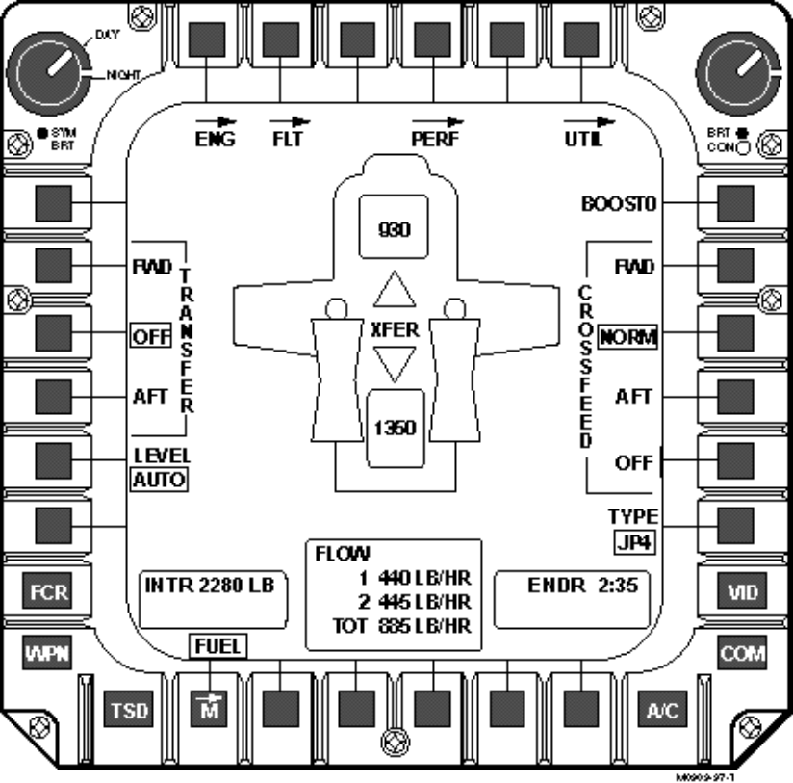
Figure 4-3. Square Corner Options Distinct from Rounded Corner Status Windows
Menu Option/Title Labeling
- Menu options and titles should use a key word or abbreviation that is distinct from other option or title labels, that is familiar to the crewmember, and that coveys the exact meaning of the option or menu page. Pushbutton labels, such as those used on MFDs, should indicate the function, current status, and consequence of selection.
Note. Menus used in cockpit displays, especially those implemented on an MFD, often use simple one-word labels for menu options. This helps to reduce display clutter and may also reduce menu navigation time. When the menu option branches to another menu page on the MFD, the pushbutton label also doubles as a menu title. Traditional menu titles that appear at the top of the display may be found on the dedicated displays associated with up-front controls (UFCs) and mission computer displays that contain multiple menu pages.
Ordering/Grouping of Menu Options
- Menu options should be displayed in a logical order and the menu page format should be designed to indicate logically related groups of options, rather than an undifferentiated string of alternatives.
- If there is no apparent logical order to the menu options or there is a small number of options, the options should be presented in sequential or arranged according to the frequency of use.
Note. When MFD menus are used, there is an inherent grouping available to the designers since the pushbuttons are divided into four groups, one on each of the four sides of the display. Current menu implementations have tended to organize the menu options around these four groupings. For instance, all menu options associated with display formats may be grouped at the bottom of the display or options associated with sensor modes may be grouped at the top of the display. These options would be available to the crewmember at all times, regardless of the current operating mode. Menu options unique to a specific operating mode or format may be arranged along either side of the MFD.
Example. The MFD menu page on the Longbow Apache is designed so that the options are grouped in three main categories, one on each side of the display (Little and Hannen, 1993).

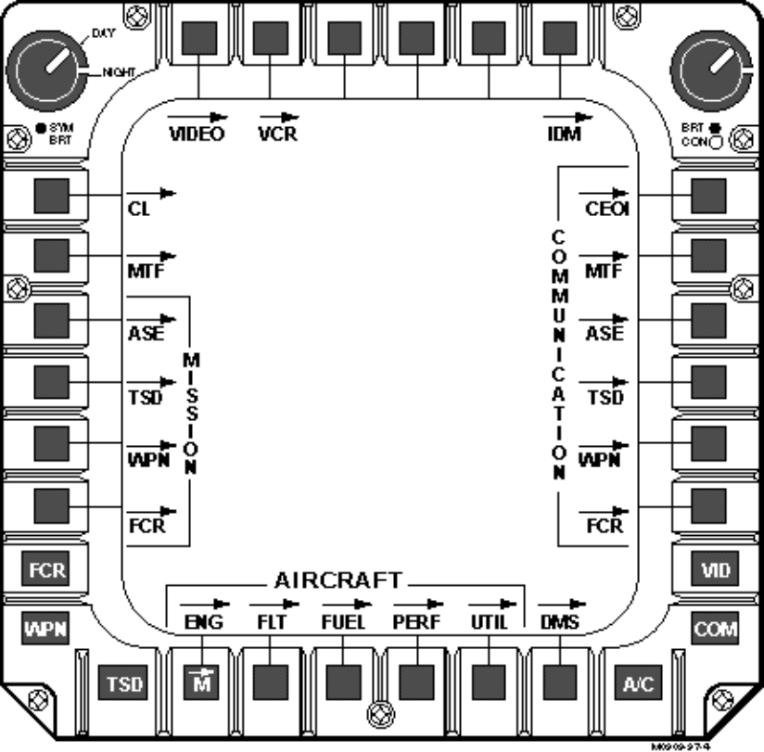
Figure 4-4. MFD Top-Level Menu Arrangement

Alphanumeric Formats
This section presents display format guidelines for alphanumeric displays. Alphanumeric formatting is used in presenting textual and numeric data to the crewmember, such as status information, guidance, and warning messages. This section is divided into three sections. The first section presents general format guidelines applicable to all displays of alphanumeric data. The remaining two sections present guidelines for text displays and data entry displays, respectively.

General Guidelines
Capitalization
- When capitalization is used on display pages, ensure that the capitalization does not impair word recognition or reduce readability, or severely limit the space between text lines.
Character Size
- Alphanumeric characters should subtend a minimum of 15 minutes of visual arc. Refer to AFGS-87213, Displays, Airborne, Electronically/Optically Generated for detailed information regarding character size.
Note. The designer must determine the maximum viewing distance from the display, then calculate the minimum size of the object using the following formula:

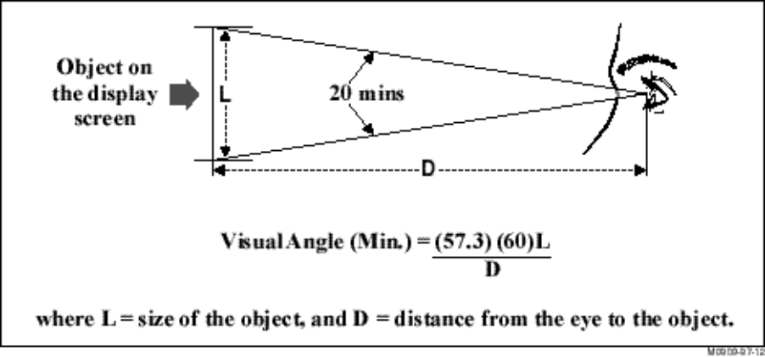
Figure 4-5. Visual Angle Subtended
- Ensure that the minimum height of displayed characters is 1/200 of viewing distance.
- Character width should be 50-100 percent of character height.
- A minimum character stroke width is 10-12.5 percent of character height.
Character Spacing
- Ensure spacing between characters is 20-50 percent of character height. Spacing between lines should be equal to character height.
Note. It has been recommended that a minimum of one character space should be left blank above and below critical information with a minimum of two character spaces left blank before and after.
Use of Abbreviations
- When abbreviations are used, ensure that those chosen are distinctive, commonly recognized by the crewmembers, and that they are used consistently.
Note. Any abbreviations used should conform to appropriate standards, such as: AR310-50 (U.S. Department of the Army 1985a), MIL-STD 12D (DOD 1981), MIL-STD 411E (DOD 1991), and MIL-STD 783D (DOD 1984).

Text Displays
Font
- Design fonts to facilitate the legibility of alphanumeric characters. Consider the character height-to-width ratio and strokewidth when designing fonts for cockpit displays, since these factors directly affect legibility.
Note. In general, legibility is a function of the height-to-width ratio, strokewidth, basic vertical orientation of the characters, and the lack of extraneous detail such as serifs.
Presentation of Information in Series
- In cases where a series or list of information must be presented, display the series vertically, not horizontally.
Conventional Text Display
- Ensure that displays of textual data, messages, or instructions generally follow design conventions for printed text.
Textual Screen Density
- Ensure that screen density for text displays does not exceed 60 percent of available character spaces.
Definition. Screen density is defined here as the ratio of characters to blank spaces.
Conventional Use of Mixed Case
- Display continuous text conventionally in mixed upper and lower case.
Consistent Spacing
- Maintain consistent spacing between the words of displayed text.
Scrolling of Data
- Where possible, display text information statically on the screen rather than constantly scrolling it across the screen.
Clarity of Wording
- In designing text displays, especially those designed for crewmember guidance, strive for simplicity and clarity of wording. Use affirmative statements or command language rather than negative statements for user guidance and command prompts.

Data Entry Displays
Standard Symbol for Prompting
- Use a standard symbol to indicate that a crewmember input is expected and reserve the symbol for that purpose.
Visually Distinctive Data Fields
- Provide clear visual definition of data fields, so that the data are distinct from labels and other display features.
Logical Order of Data Fields
- Design the prompted data field displays so that data items are ordered in the sequence in which the crewmember is likely to access them.
Data Field Labeling
- Identify each data field with a displayed label. These labels should be close enough to be associated with their proper data fields, but should be separated from data fields by at least one space.
Descriptive and Distinctive Wording of Labels
- For data field labels, use descriptive wording or standard predefined terms and codes/abbreviations that are familiar to the crewmember. Also ensure that data field labels are distinctive from other data so that they are not readily confused with data entries, control options, or other displayed information.
Consistent Labeling
- Ensure that labels are formatted and worded consistently, so that the same data item is given the same label if it appears in different displays, and so that the same label is used to indicate the same kind of data entry.
- Ensure that the ordering and layout of corresponding data fields is consistent within a display as well as across displays.
Example. The label may always be to the left of the field, or may always be above the field, as long as the format is consistent.
Note. This may be difficult to accomplish, especially on small displays where space is limited, such as the data entry display associated with some UFCs. It is important however, that the crewmember understand where data entries are to be made for each associated label.
Compatible with Data Entry
- When forms are used for data entry as well as for data display, ensure that the format for data display is compatible with whatever format is used for data entry; use the same item labels and ordering for both.
Optional Field Labels
- Optional data fields should be labeled or coded in a readily apparent manner.
Data Format Cueing in Labels
- Include additional cueing in a field label when it would be helpful to the crewmember. This information should be included only if there is display space available and when the information provided does not interfere with other data displayed.
Example. Date (mm/dd/yy):
Labeling Units of Measurement
- When a measurement unit is consistently associated with a particular data field, include that unit as part of the field label rather than requiring the crewmember to enter it.

Graphical/Pictorial Formats
This section presents guidelines for graphical format design. Included in this section are three topic areas: General Guidelines for Graphic Design, Guidelines for Pictorial/Configural Displays, and Guidelines for Map/Situation Displays. Graphical representations have been shown to be an effective formatting technique for depicting spatial relationships among information, as well as for providing a means for the crewmember to quickly acquire and assimilate information. By using a readily recognizable pattern in which interrelationships are clearly identifiable, graphical formats can assist in the interpretation of information required for decision making responses. If designed properly, graphical formats can assist the crewmember in formulating a “picture” of system state and facilitate the integration of information for tasks where variables interact.

General Guidelines
Usage
- Consider using graphical formats for the following: 1) for showing relations in space or time; 2) for integrating information from diverse sources into a single display; 3) for displaying geographic data (i.e., direction and distance relations among physical locations); and 4) for quickly scanning and comparing related sets of data or monitoring changing data.
Situational Awareness
- Graphic displays should be designed to ensure that information is provided to support the crewmember’s SA for the tasks being performed.
Highlighting Critical Data
- When a crewmember’s attention must be directed to a portion of a graphic display showing critical or abnormal data, that feature should be highlighted with some distinctive means of data coding.
Text Annotation/Labeling
- Labeling of graphical elements and symbols should always be presented in the horizontal, upright position and located in a consistent position with respect to its associated graphic element or symbol (Resource Document for the Design of Electronic Instrument Approach Procedure Displays, 1995).
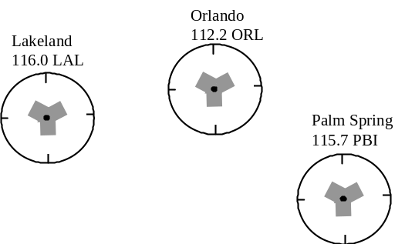
Figure 4-6. Consistent Labeling Convention
Exception. Labels that are associated with or embedded in a line may require rotation with the line because of the potential of overlapping. A rule may be required to switch the orientation of the text when the line rotates 180 degrees so that the text does not appear upside down.
Graphical Element Representation
- Graphic symbols should have established meanings that are consistently applied and should look as much like the objects or processes they represent as possible.
Note. Where appropriate, the designer should use accepted aviation symbology. For aviation standard symbols, refer to the following: MIL-STD 1787, Aircraft Display Symbology; U.S. Army FM 21-26, Map Reading and Land Navigation (1987); Defense Intelligence Agency (DIA) Standard Military Graphics Symbols Manual (DIAM 65-x) (Draft 1990); North Atlantic Treaty Organization (NATO) Standardization Agreement 2019, Military Symbols for Land Based Systems (1990) published by the U.S. Navy; and, Mil-Std 2525, Common Warfighting Symbology.
Note. When new graphic symbols are developed, the symbol sets should be tested with a representative user group familiar with the particular platform or application with which the symbols are being used.
- Graphical elements should be familiar to the crewmember, conform to established conventions, and should be appropriate to the task being performed.
- Where possible, minimize and simplify symbol movement to avoid distraction.
Symbol Size
- Complex shapes and symbology should subtend a minimum of 20 minutes of arc. Symbology should be appropriately sized upward for vibrating environments. Refer to AFGS-87213, Mil-Std 1787, and Mil-Std 2525A for detailed guidance regarding appropriate symbol size.
Scaling
- Scales should be designed employing conventional scaling practices that are appropriate to the platform type and mission.
- If graphic data must be compared across different scales, the scales should be designed to allow the crewmember to easily interpret and compare data.
- Scales should be constructed with tick marks at standard intervals, and intervening tick marks to aid visual interpolation.
Unobtrusive Grids
- When grid lines are displayed, ensure that they do not look like data and do not obscure data elements.
Stable Reference for Changing Data
- When graphic data are changing and displays are automatically updated, provide some stable display elements (e.g., coordinates, geographic boundaries, etc.).

Pictorial and Configural Formats
This section presents guidelines for graphical design that are specific to pictorial and configural formats. Pictorial formats typically refer to graphical depictions that relate to the crewmember’s mental model of a real-world situation, capitalizing on the inherent advantages of graphical representation (e.g., easy to assimilate for cognitive processing). Common cockpit applications include the display of weapons stores, engine status, and fuel management. Configural formats are generally more symbolic in nature, depicting system variables as dimensions of a configural object. Configural formats take advantage of an object’s multi-dimensional and inter-related perceptual properties as well as the salient features that emerge when system variables interact. Although configural formats have been shown to be useful in the laboratory environment, their application in the cockpit environment has been very limited to date.
Configural Formats/Emergent Features
- Consider a configurable format design only for those tasks that require the integration of correlated information.
Note. Configural formats have shown to be effective in laboratory environments.
- Consider using emergent properties that result when the dimensions of a configural object change for providing salient visual cues for information integration tasks. Information should not be integrated such that an emergent feature develops that does not support the tasks or interferes with task performance.
Example. The figure below shows an example of a configural display and its emergent property - the distorted hexagonal shape. The shaded hexagon illustrates the system variables when at a normal or optimum state (adapted from Wickens, 1984).
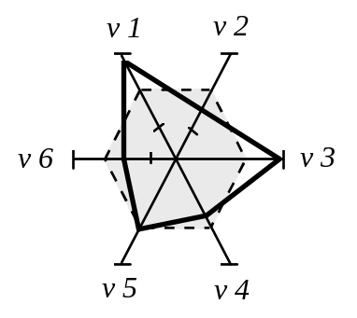
Figure 4-7. Configural Format and the Use of Emergent Features
Pictorial Formats Usage
- Consider using pictorial displays in applications where it is necessary to show accurately detailed representations of real objects or processes.
Note. The computer can be used to synthesize pictorial displays from stored data.
Display Animation
- Consider adding animation to the pictorial displays to aid crewmember understanding of complex relationships between system variables.
Schematics Usage
- Consider using schematics or diagrams when the crewmember requires information concerning the relationships among objects but does not require a high level of detail.
Complex Formats
- Complex formats and artistic embellishments (pictures, shading colors, decorative items) which detract from the intended purpose of the graphic should be avoided.
Alerting for Critical Information within an Integrated Format
- Graphical displays that provide simultaneous or integrated information should advise or alert the crewmember to information that becomes critical within the display.
Pictorial Realism
- Pictorial displays should be as much an approximation of the real-world situation as possible, providing a direct association between the pictorial format and the information being represented.
Analog Compatibility of Orientation
- Careful consideration should be given to the orientation, ordering, and movement of display elements to be compatible with the ordering of the mental representation. Display compatibility should not be violated in shape, direction, or movement.
Example. An example of display incompatibility would be if a circular altimeter represents the linear concept of altitude or a linear display representing compass heading. Similarly, the altimeter should present high altitudes at the top of the scale and low altitudes at the bottom. However, for moving scale displays, this could violate movement compatibility, such that a movement downward would indicate an increase in altitude.

Map Formats
Consistent Orientation
- When several different maps are displayed (or switched between), a consistent orientation should be used so that the top of each map will always represent the same direction.
Note. This orientation may be either North-Up or Track-Up, depending on the task being performed.
Large Geographic Areas
- When maps represent large geographic areas, a consistent method, such as latitude/longitude grids, should be used to represent the earth’s curvature on the flat display surface.
Labeling of Features on a Map
- Significant features of a map should be labeled directly in the display (e.g., highest elevation point), when it can be done without cluttering the display.
Functional Color Coding
- Color coding should provide a specific meaning to the crewmember. These specific meanings should be used in accordance with appropriate standards. Refer to section 4.1.4.2 for additional color coding guidelines.
Note. Standards include U.S. Army FM 21-26, Map Reading and Land Navigation (1987); Defense Intelligence Agency (DIA) Standard Military Graphics Symbols Manual (DIAM 65-x) (Draft 1990); and, North Atlantic Treaty Organization (NATO) Standardization Agreement 2019, Military Symbols for Land Based Systems (1990) published by the U.S. Navy.
- Map colors should resemble their paper map counterparts as much as possible to promote a positive transfer of training.
Example. The hydrography should be represented in blue, vegetation in green, aeronautical information in purple, etc.
Note. There are limits to this transfer, however, as cathode ray tubes (CRTs) and liquid crystal displays (LCDs) yield a smaller color space than surface colors.
Tonal Coding
- Consider using tonal codes (different shades of one color) or textural patterns for area coding when different areas of a map must be defined, or when the geographic distribution of a particular variable must be indicated.
- Consider using tonal codes or textural patterns where crewmembers must make relative judgments for different colored areas of a display, such as in displaying differences in terrain elevation. Consider employing redundant tonal codes rather than spectral codes (different colors).
- Where different areas of a map are coded by texture patterns or tonal variation, order the assigned redundant code values so that the darkest and lightest shades correspond to the extreme values of the coded variable.
Color Discriminability and Ambient Conditions
- The map colors should be reliably identified on an absolute basis (discriminable) and should be able to withstand the extremes in environmental conditions to which the display will be subjected.
Note. The designer should consider all ambient conditions of the platform and display hardware type, particularly when using tonal codes. Even if shades are discriminable under certain conditions, shades may wash out in extremely bright conditions (CRTs) or when viewed off axis (LCDs). Refer to section 5, Display and Control Devices, for more detailed information on the hardware issues associated with the use of color.
Highlighting
- If one area of a map represents data of particular significance, that area should be highlighted in some way to attract the crewmember’s attention.
Overlaying Considerations
- When overlaying point and linear map features “on top of” area features in the background, the designer should consider the following perceptual anomalies for discriminating map features against the background:
Color Contrast. Color contrast occurs when the perceived color of the foreground shifts toward the color complement of the background.
Example. A gray symbol displayed on a green background will tend to take on a reddish tint, since red is the color complement of green.
Brightness Contrast. Brightness contrast occurs when the same map symbol appears darker when displayed on a bright background and lighter when displayed on a dim background.
Saturation Contrast. Saturation contrast occurs when the foreground appears more saturated when surrounded by a desaturated background (e.g., pink) or more washed out when surrounded by a more saturated background (e.g., red).
- Colors chosen for overlaid symbology or point symbols (e.g., waypoints, tactical symbols) should have sufficient chromatic and luminance contrast so as to not blend in with contour lines and other map backgrounds on which they may be placed.
Note. Point symbol contrast may be improved by outlining the symbol in a contrasting color from the background rather than insetting it directly into background terrain.
Overlay Priorities
- When display data can be obscured by other moving objects on the display, a display object priority scheme must be defined and implemented.
Example. The aircraft symbol should have priority over all other objects. Objects with continuous lines such as flight path and grids may be given lower priority as they still may be seen despite having other objects overlaying them.
Linear Features
- Linear feature colors should be readily identifiable and should have sufficient contrast to ensure adequate contrast from the map’s background, since the shape coding of linear features (e.g., contour lines, roads, streams, railway lines, and bridges) is limited and will comprise critical navigational cues.
Available Coverage Indicator
- Consider providing an inset or window that shows the maximum available map coverage.
Example. One type of coverage indicator would be a graphic square on the inset map that indicates the area of the map currently being displayed. In the most useful form, this inset would be interactive and used to set parameters for calling up a screen map display.
Indication of Position When Panning
- During panning operations, provide some graphic indication of current position relative to the overall operational areas. Refer to section 3.3, Graphical Interactions, for guidelines that address the implementation of panning functions.
Example. An inset map may be used with a symbol or code to indicate which part of the larger picture is being displayed.
Symbol Legibility While Zooming
- Ensure that the zooming capability does not prevent the crewmember from reading symbols, labels, or other graphically displayed features. Refer to section 3.3, Graphical Interactions, for guidelines that address the implementation of zooming functions.
Display Detail and Zooming
- The level of detail should be modified to match the degree of zooming used (i.e., more detail should be displayed for close-up views and less for large-area perspectives).
Exception. Alphanumeric and symbol sizes should not change as a result of zooming. However, this may cause some overlap problems as the display is zoomed out. When implementing this type of zoom, ensure that some method is used (such as removal of detail or abbreviation of information) so that overlap does not occur.
Declutter while Zooming
- When the crewmember is zooming out to enlarge the display area, the display system should collapse symbols into fewer summary symbols to declutter the display.
Example. Contour lines may change from 500 feet separations to 1000 feet separations. Close obstacles may be combined into one group of obstacles displaying the highest obstacle elevation.
Zoom Scale Indicator
- When changing scales through zooming, an indicator should be provided that continually shows the current scale.
Indicating Data Change
- When changes in mapped data are significant for a crewmember’s task, consider auxiliary elements to indicate those changes.
Grid Overlay
- A user-selectable grid overlay should be provided that is keyed to the coordinate system of the map.
Note. This may not be appropriate for all cockpit applications. When a grid overlay is used, the crewmember should be able to easily turn the grid on and off. Additionally, coordinate keying of the overlays must be clearly specified and easily operated by the crewmember.
Dedicated Message or Information Area
- Consider a dedicated “information area” in a consistent location on the display for legend and display status information so that crewmembers will have explicit expectations as to where to look for such information.
Example. This information area may include map scale, cursor location, and map coverage. The bottom or top of the screen is commonly accepted as an “information” or “status” area. See Figure 4-8, adapted from Hanafi, et al., 1996.

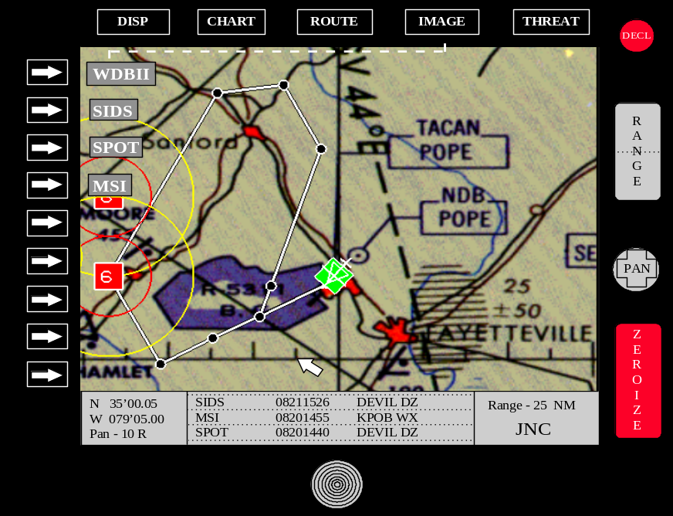
Figure 4-8. Dedicated Status Area
Switching Between Frames of Reference
- When switching between frames of reference (e.g., from North-Up to Track-Up), visual cues should be provided that will enable the crewmember to easily relocate the same information.
Distance/Azimuth Calculations
- Where appropriate, provide a distance/azimuth function that calculates the distance (range) and azimuth (bearing) between any two selectable points or symbols. The distance calculation should be presented in selectable units (feet, meters, miles, or kilometers). Azimuth should be presented in degrees from true north.
Position Determination
- Consider providing a function that calculates the position of a selected point.
Note. The position should be presented in a selectable coordinate system (e.g., Universal Transverse, Mercator, latitude/longitude, or Military Grid Reference System). It is also recommended that the calculation results be provided textually in user-specified units of measure, such as latitude and longitude, distance (kilometers or nautical miles), and azimuth (in degrees from true north).
Return to Default Configuration
- If map views can be customized through features such as zooming or declutter, a fast and easy way should be provided for the crewmember to return to a default map configuration.
Limited Methods for Displaying Terrain
- The number of different methods of displaying terrain should be limited. If several display options are provided, crewmembers should be given the capability to customize the display and remove some of the terrain representations.
Terrain Awareness
- Smooth contour lines may be preferable to spot elevation for terrain awareness (Kuchar and Hansman, 1992).
Example. International Civil Aviation Organization (ICAO) recommends 500, 1000, or 2000 feet between contour lines. Designers should consider spacing based on rate of change of terrain - steep terrain may require 1000 feet or 2000 feet spacing, while gradual terrain may require 500 feet or 1000 feet spacing.
Note. Contour spacing should be evaluated for potential clutter and the ease with which the labels can be read. Designers may want to consider changing the spacing based on zoom level - zoomed out views may use greater spacing than zoomed in views.
- Terrain elevation levels should be large enough and sufficiently separated for ease of reading.
Memory Aids
- Consider providing crewmembers with the capability to highlight specific information on a map to act as memory aids or reminders.
Example. An electronic map may allow the crewmember to highlight the information associated with a navigational aid when entering the frequency into the navigational system.
Note. If the crewmember is interrupted before completing a subtask, the highlighted information serves as a reminder to help him/her quickly relocate.
Symbol Selection
- Provide the crewmember with a consistent method for selecting a graphical map symbol to obtain additional information.
Example. When the cursor is on a threat or waypoint (closest to, if snap-to is activated), the selected symbol would be highlighted and a text box would appear in a consistent location for displaying additional information such as latitude/longitude.
Planview Formats
- Consider using a planview or 2-dimensional (2-D) format when the task only requires information on two axes.
Note. Planview display formats are typically very effective for the display of information along two dimensions, but must rely on some abstract coding or alphanumeric labeling method for representing information in the third dimension. Thus, cognitive processing requirements may be greater when performing tasks that require integrating information across the three dimensions.
Perspective Formats
- Consider using a 3-dimensional (3-D) perspective format for depicting the relative locations of elements of interest (e.g., other aircraft, threats) with respect to ownship position in three dimensional space.
Note. Perspective displays provide a view that is more consistent with a pilot’s out-the-window scene, thus presenting all three dimensions in an intuitive format.
Example. The 3-D perspective display has been shown to be useful in a cockpit display of traffic information (CDTI) for presenting altitude and vector information of other aircraft in the surrounding area. The Pathway-in-the-Sky 3-D perspective depiction for flight navigation guidance has been effectively demonstrated in laboratory simulation testing. Figure 4-9 shows the Pathway-in-the-Sky representation for inflight navigation (adapted from Reising, 1989).

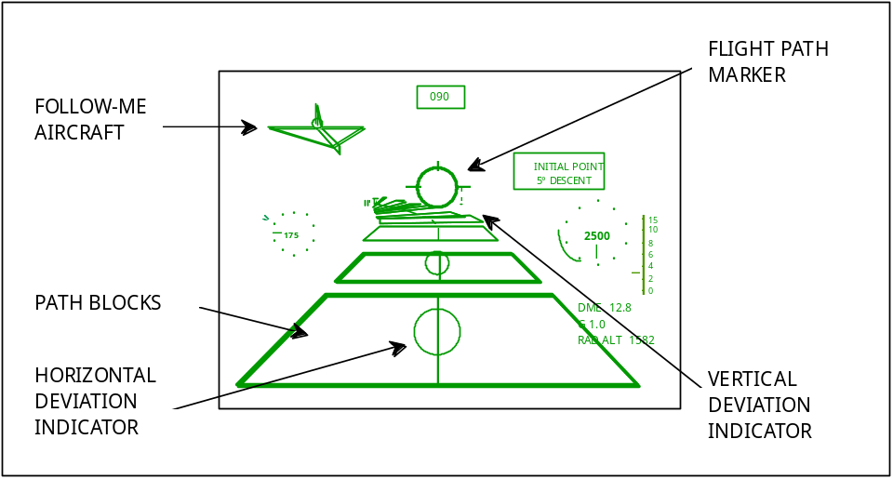
Figure 4-9. An Example of a Perspective Format, the Pathway-in-the-Sky
- Create a perspective format that will most effectively communicate task-relevant information. To accurately depict spatial position on a flat surface, the designer must take into account the human perceptual capabilities, as well as the spatial dimensions involved. When employing color, consider their perceptual differences, such as more saturated colors appearing closer than less saturated ones.
Note. Perspective displays may not show a highly accurate representation of depth, and may de-emphasize vertical terrain features when a large field of view scene is scaled to fit on a cockpit display. Careful consideration must be given to display clutter when mapping the three dimensions using grids or similar types of encoding for representing a third dimension.
Tactical Situation Display Considerations
- If available, consider providing the following with the tactical display: the tactical emitter information with respect to GPS referenced ownship; the tactical bullseye; geographical imagery; the route of flight; threat track history; newly identified emitters; emitter type (e.g., friendly, foe, unknown), category (e.g., air, sea, land) and/or threat type (e.g., SAM6, SAM8); acquisition/engagement radii with respect to the ownship; and, the capability of selecting purge times for the display of emitters.
Note. Purge times could be selectable based on emitter category, type, or threat type.

Imagery Display Formats
This section addresses general guidelines for the presentation and integration of sensor and video imagery for a variety of cockpit applications. Imagery was initially introduced into the cockpit in the form of radar images and has since included other forms such as infrared (IR) and television imagery. Imagery can be presented on head-down dedicated displays, MFDs, HMDs, or HUDs for use in cockpit applications.
Although the use of sensor imagery can enhance SA, extracting detail from the displayed image can be a time-consuming task. Image enhancement, sensor fusion, and symbology overlay (e.g., course lines, waypoint symbols, battle positions, target locations) are several methods that can be used to improve the picture image quality and the information content of sensor-derived imagery. Some form of preprocessing and filtering is generally required and is typically accomplished automatically prior to display or manually at the display interface.
The display of imagery is generally not independent from its method of presentation (e.g., enhancement filter, fusion algorithm); therefore the designer should become cognizant of the various strategies that can be used. These strategies depend a great deal upon the types of information to be displayed or combined. For example, sensor information can be integrated across different sensors, across sensor and collateral data (e.g., stored maps, mission data), or within one sensor across different modes. The more similar sensors are in terms of viewing angle, range, and field-of-view, the easier it is to integrate them into a single format. Sensor information can also be fused prior to display using a data fusion algorithm, or fused at the display level into an integrated format.
Image Enhancement Filtering Capabilities
- Provide image enhancement filtering capabilities to control the dynamic range of imagery data by modification of intensity and contrast.
Obstacle Edges
- Consider using two-dimensional (2-D) filtering of an IR picture to improve edge enhancement and navigation capability.
Image Enhancement for Target Acquisition
- Use high contrast enhancement and ensure picture stability and absence of blur, where feasible, for visual recognition or identification of targets.
- Consider making the imagery background more uniform for tasks which require small target visual acquisition.
Text and Graphic Overlays
- When textual or graphic data (e.g., symbology) is overlaid on imagery data, the designer should ensure that overall display color and clutter does not interfere with sensor image comprehension.
- Provide the crewmember with the control to declutter overlaid text and symbology on sensor image displays.
Interference with Real-World View
- If the imagery is to be displayed on a HUD or HMD, consider the effects associated with the imagery interfering with the out-the-window view.
Screen Snapshot
- Crewmember selectable options should be provided for taking a snapshot of a given screen to add to an on-line database.
Example. Crewmember selectable options may include automatic intervals, time between intervals, and manual select.
Identifying Information
- An imagery display should present identifying information, in a consistent location, about the imagery being displayed.
Naming an Image
- Consider providing the crewmember with the capability for specifying the name of an image or searching the directory of images by some pre-defined criteria.
Imagery Viewing
- If possible, consider providing the capability to zoom or pan an image. See sections 3.3.5 and 3.3.6 for guidelines relevant to display zooming and panning.
Image Registration
- Consider providing the capability for the crewmembers to register geo-referenced images acquired from the same or different sensors (i.e., transform an image so that it aligns with either another image or map projection) and display them together.
Plotting Geographic Data
- Consider providing the capability to plot geographic data on the image, including frame-by-frame plotting to animate the data either forward or backward in time.
Image Rotation
- Consider providing the capability for default image rotation where vertical objects are oriented toward the top of a window and an automatic north rotation where north is oriented at the top of a window. Imagery windows should also permit the crewmember to rotate images in pre-defined increments.
Combined Display Concepts
- When combining registered sensor imagery information, the designer should consider the following techniques: (Dupuis, 1977)
Edge Enhancements. Consider using edge enhancements of one sensor image and the subsequent display of these outlines on a second image.
Example. Using FLIR to outline roads and high thermal gradient objects displayed on a radar map display.
Thresholding. Consider thresholding one sensor image and using highlighted data for display on a second image.
Example. FLIR hot spots were color coded in red and displayed on a black and white radar ground map.

HMD Formats
This section presents general considerations and guidelines for designing HMD formats for use in military aircraft. Guidelines pertaining to HMD hardware design are addressed in section 5, Display and Control Devices. HMDs present unique symbology problems, foremost of which is the maintenance of symbology spatial orientation. With the HMD, the display moves with the movement of the pilot’s head, thus changing the display orientation. Some cues, such as targeting cues, must be corrected to compensate for both the aircraft motion and the pilot head movement.
The Apache Integrated Helmet and Display Sighting System (IHADSS) and the Comanche Helmet Integrated Display and Sight System (HIDSS) are the only operational HMDs. The Apache IHADSS is a monocular display with embedded symbologies. Altitude is shown both digitally and with a thermometer scale, whereas airspeed is only shown digitally. A fixed aircraft head-tracker symbol is shown aligned to the aircraft axis. The pilot’s IHADSS has four operating modes customized for hover, transition, cruise and bob-up. The copilot/gunner HMD formats also include a weapons format. The weapons format focuses on sensor imagery, sensor status, and weapons cueing.
The Comanche HIDSS is a bi-ocular display with portions of the display being aircraft-fixed referenced and portions being world-fixed referenced. As with the Apache IHADSS, radar altitude is shown both digitally and with a thermometer scale. Barometric altitude and vertical speed are shown digitally. The hover symbology contains a world-stabilized plan view of the scene. Nap-of-the-Earth (NOE) symbology appears similar to the hover symbology. The cruise symbology is a world-stabilized primary flight display. The pitch latter is similar to the F-18 in that it is canted to indicate the direction of the nearest horizon (Newman & Haworth, 1994).
Human Perception
- Consider the following human perceptual characteristics when designing formats for an HMD:
Binocular/Stereoscopic Vision. In human vision, depth cues are available and afforded by binocular vision, occurring as the result of two slightly different visual perspectives (one from each eye). This depth perception should be provided in HMD imagery applications in order for the crewmember to function naturally.
Field-of-View. The monocular field-of-view (FOV) of the human eye is approximately 150 degrees in the horizontal and approximately 135 degrees in the vertical. The total FOV is 180 (without head motion). Thus there is a natural binocular overlap of about 120 degrees. The FOV of the HMD should approximate this as much as possible.
Resolution. The human eye is capable of discerning an element size corresponding to about 1 minute of arc at the center of the gaze. Although this resolution is desirable, current HMD technology cannot provide this resolution, especially with the current display sizes used in HMDs.
Visual Orientation
- Ensure that the crewmember’s visual orientation does not restrict the crewmember from information that is essential for successful execution of the mission.
Note. The required flight and mission symbology must be in the crewmember’s instantaneous FOV, regardless of where the crewmember is looking.
Timely, Unambiguous, Readable Format
- Ensure that symbology cues (such as airspeed, altitude, rate-of-closure, drift, rate-of-climb, obstacle clearance, targeting information, weapon status, and external sensor information) are presented to the crewmember in a timely, unambiguous, and readable format. Symbologies should be kept within the central 25-27 degrees to minimize eye movements.
Integration
- The design of HMD symbology should be consistent with design conventions and the symbology used for head-down displays (HDD).
Note. Compatibility and design conventions may conflict with each other, requiring a performance trade-off analysis to be conducted to determine the best convention to implement.
Example. The flight director (FD) collective cue for an Army helicopter was designed to show the pilot the direction and magnitude of the required collective input to maintain a set altitude. The cue used “reverse sensing”, such that lowering the collective caused an increase in the cue’s vertical length. Although this was the only FD cue within this platform that used reverse sensing, designers decided to not change its mechanization so that pilot’s transitioning into this newly fielded aircraft would not make an incorrect input resulting in an accident.
Display Resolution
- Consider HMD design trade-offs for ensuring an adequate display resolution. Careful consideration should be given regarding how FOV requirements will affect the display resolution requirements.
Image Registration
- Consider the effect raster image accuracy (or mis-registration) will have on viewing real-world images and symbology choices.
Note. The large eye-sensor distance for the Apache creates mis-registration for close objects viewed ninety degrees off-axis.
Attitude Information
- Consider presenting attitude information on the HMD with respect to the aircraft’s body axis (non-conformal) rather than real-world (conformal).
Note. Conformal displays may be difficult to interpret and confusing because of the symbology motion caused by aircraft and crewmember head movement.
Altitude Information
- If both absolute (radar) and barometric altitude information are displayed simultaneously, they should be positioned according to their format to prevent unnecessary cluttering, be clearly distinctive, and be easily accessible. In a dual digital format, the barometric altitude should be positioned above absolute altitude. In a dual analog format, they should be located farther from the center of the display. In a combination digital/analog format, the analog scale should be located farther from the center of the display.
Shades of Gray
- Monochromatic HMD displays should provide a minimum of 6 shades of gray for alphanumeric and graphical information.
Note. 9-10 shades of gray are preferable for more complex sensor data.
Symbology Considerations
- Consider that HMD symbology is displayed over real-world out-the-window and/or sensor imagery and needs to be visually distinctive from variations in these backgrounds.
Mode Usage
- To reduce display clutter, consider using mode selection for optional display of non-critical symbology.

HUD Formats
This section presents general considerations and symbology guidelines for designing HUDs for use in military aircraft. Guidelines pertaining to HUD hardware design are addressed in Section 5, Display and Control Devices. Advances in computer graphics have allowed the generation of complex dynamic symbology on the HUD. Weapon aiming symbology, which originally was the only information displayed on the HUD, is now supplemented by basic flight symbology in most aircraft, with current trends toward providing HUDs that are qualified as primary flight displays. Additionally, the use of imaging sensors, such as FLIR, has introduced more information that may be displayed on aircraft HUDs. The designer must be aware of the advantages and limitations associated with HUD presentation, and must also be cognizant of how information presented on the HUD may affect pilot attention and overall task performance.
Compatibility of HUD Design
- Ensure that the design of the HUD is compatible with information displayed in the head-down format including weapons and primary flight data. This can be accomplished by integrating the design of the HUD into the total cockpit system design.
Note. The designer should use caution when designing symbols for HUDs that mimic head-down displays, because some symbols that are appropriate for head-down formats may result in cluttered displays or cause confusion regarding control techniques when used on a HUD.
Primary Flight Reference
- When the HUD will act as the primary flight reference (PFR) within the aircraft, it should provide the pilot with the information required to accomplish an instrument maneuver during a mission segment and should enable the pilot to maintain attitude awareness and to recover from an unusual attitude.
Definition. A PFR is any display or suite of displays or instruments that provide all of the required information for instrument flight and comply with the MIL-STD-1787 requirements for information content and presentation.
Reserved Display “Windows”
- Design the HUD to have reserved display “windows” so that information is displayed in the same relative location for all HUD presentations and in all modes.
Note. These display windows are typically reserved for alphanumeric data presentation or scale presentations.
HUD Configuration Based on Master Modes
- Consider having the HUD automatically configured, based on the current aircraft master mode, for aircraft that support master moding.
Note. This link to master modes will ensure that the HUD presentations are compatible with the HDDs, which are typically controlled via the master modes.
Consistency Between Modes
- Ensure that the information common to different modes is displayed in the same format and same location across all modes.
Symbology Considerations
- Ensure that flight symbology presented on the HUD adheres to the symbology requirements contained in MIL-STD-1787, Aircraft Display Symbology.
Symbol Size
- Symbol size should comply with the requirements specified in AFGS-87213, Displays, Airborne, Electronically/Optically Generated, for HUDs.
Display Font
- Alphanumerics used for HUD presentation should conform to the fonts specified in MIL-STD-1787.
Overuse of Non-Conformal Symbology
- To limit display clutter and reduce crewmember scanning time, avoid the overuse of non-conformal symbology.
Example. An example of non-conformal symbology is symbology that is consistent with the aircraft body orientation rather than the horizon orientation.
Minimization of Information Presented
- Minimize the information presented on a HUD to reduce clutter and to avoid restricting the visibility of objects in the real world.
Declutter Capability
- Provide the crewmember with the capability to declutter the symbology and/or information displayed on the HUD.
- Where possible, the declutter capability should have varying degrees of decluttering, so that the crewmember can remove “layers” of information as necessary.
Note. The designer may want to consider providing a programmable declutter capability so that the crewmember can tailor the HUD information to specific task requirements.
Imagery Considerations
- Ensure that all HUD symbology is visible and distinguishable from any imagery displayed on the HUD.

Presentation and Formatting of Auditory Information
The effectiveness of any auditory display is dependent upon the environment within which the display must operate. A spoken message may be easily obscured by other spoken messages; a particular tonal signal may be masked by or confused with other similar tonal signals; and any auditory signal or message may be masked by frequent, extremely loud bursts of noise, such as would occur during a battlefield bombardment or the noise of a jet aircraft afterburner. In general, periodic tones and non-periodic complex sounds are easily generated and are appropriate for various types of information display. Periodic tones are good for automatic communication of limited information, however, the meaning must be learned. Complex sounds are useful when the sounds are easily identified and have an inherent common meaning to the user (e.g., fire alarm signals).
Voice warnings and messages are more flexible than simple sounds, because they can provide more information while alerting the crewmember to a problem. This may be especially important during high workload, when the meaning of a signal may be forgotten. Voice messages are most effective for the rapid communication of complex, multidimensional information. Because the meaning of speech is intrinsic in signal and context when standardized, there is a minimum of learning required of the user. Voice technology has been shown to offer some advantages in specific situations to both visual and other auditory methods of presenting information. These include: the display of threat identification and location information; the display of aircraft heading, altitude, and fuel under specific mission conditions; the automatic recording of all radio voice messages; and the display of warnings.
Using the guidelines presented in this section, the designer should be able to design effective auditory presentations for the cockpit. Note that these guidelines are applicable to tones or voice messages that are produced and generated electronically. Guidelines for mechanically generated auditory signals such as bells, buzzers, and whistles are not included.

Selection Criteria
The designer should use the following guidelines for selecting the type of auditory display that is most appropriate to a particular cockpit application.
Usage
- Auditory displays should be provided under the following conditions: 1) when the information to be processed is short, simple, and transitory, requiring an immediate or time-based response; 2) when the common mode of visual display is restricted by over-burdening, ambient light variability, operator mobility, degradation of vision by vibration, high g-forces, hypoxia, or other environmental considerations, or anticipated operator inattention; 3) when the criticality of transmission response makes supplementary or redundant transmission desirable; 4) when it is desirable to warn, alert, or cue the operator to subsequent additional response; 5) when custom or usage has created anticipation of an audio display; and 6) when voice communication is necessary or desirable.
Criteria for Auditory Tonal Presentation
- Auditory tones should be used under the following conditions: 1) when the message is extremely simple; 2) when the crewmember has special training in the meaning of coded signals; 3) when a signal designates a point in time that has no absolute value such as a specific point in a sequence of events; 4) when the message calls for immediate action; 5) when voice signals are overburdening the crewmember; 6) when conditions are unfavorable for receiving voice messages (tonal signals can be heard in noise that makes speech unintelligible); or 7) when voice communication channels are overloaded.
Criteria for Voice/Speech Presentation
- Voice messages should be used under the following conditions: 1) when communication flexibility is necessary; 2) when the identification of message source is necessary; 3) when a simple coded signal cannot adequately give direction or instructions to the crewmember; 4) when the crewmember does not have special training in coded signals; 5) when rapid two-way exchanges of information are necessary; 6) when the message deals with a future time requiring some precision such as a missile firing countdown; 7) for stressful situations that might cause the crewmember to “forget” the meaning of the code; 8) when ambient masking noise characteristics prevent the use of simple tonal signals; or 9) when other complex tonal signal possibilities have already been exhausted (i.e., have been assigned and cannot be duplicated).
The following table presents the advantages and disadvantages for different types of audio signals based on the function to be performed.
Table 4-7. Functional Evaluation of Audio Signals
FUNCTION |  | TYPE OF SIGNAL
 | Tones (Periodic) | Complex Sounds  (Non-Periodic) | Speech
 | Poor | Poor | Good
Quantitative Indication | Maximum of 5 to 6 tones recognizable when ideally spaced and sounded alone. | Interpolation between signals inaccurate. | Minimum time and error in obtaining exact value is compatible with response.
 | Poor to Fair | Poor | Good
Qualitative Indication | Difficult to judge approximate value and valuation of deviation from null setting unless presented in close temporal sequence. | Difficult to judge approximate deviation from desired value. | Information concerning displacement, direction, and rate presented in form compatible with response.
 | Good | Good | Poor
Status Indication | Start and stop timing. Continuous information where rate of change of input is low. | Especially suitable for irregularly occurring signals. | Inefficient; more easily masked; problem of repeatability.
 | Fair | Poor | Good
Tracking | Null position easily monitored. Problem of signal-response compatibility. | Required qualitative indications difficult to provide. | Meaning intrinsic in signal.
General | Good for automatic communication of limited information. Meaning must be learned. Easily generated. | Some sounds available with common meaning, e.g., “fire”. Easily generated. | Most effective for rapid (but not automatic) communication of complex, multi-dimensional information. Meaning intrinsic in signal and context when standardized. Minimum of new learning required.

General Auditory Presentation
This section provides guidelines that are applicable to auditory displays generated by either auditory tones or voice message presentations.
Crewmember Request for Repeat of Signal
- Provide the crewmember with the capability to request a repeat of the nonverbal or verbal auditory signal.
Redundant Cues for Auditory Signals
- Ensure that auditory display signals are accompanied by a redundant, visual indication where appropriate. All non-verbal aural annunciations should be accompanied by a visual annunciation which defines the condition.
Example. Visual annunciations within the cockpit can be either an alphanumeric message or graphic on a display screen, or may simply be an annunciator light, depending upon the information to be conveyed.
Auditory Signals as Redundant Cues
- Consider using auditory cues to augment visual cues for out-of-tolerance conditions, such as when crewmembers are monitoring automated actions.
Auditory Feedback
- When normal advisory feedback is presented in audible form, it should be integrated with audible alerts so as not to cause crewmember auditory overload.
Timing of Tones and Voice Signals
- When using tones concurrently with voice annunciation, begin both simultaneously, with the tone terminating approximately 1 second after the voice annunciation.
Dichotic Presentation
- Because crewmembers will be wearing headsets, use a dichotic presentation for auditory signals whenever possible, alternating the signal from one ear to the other by means of a dual-channel headset.

Auditory Tones
Usage
- Auditory tones may be used for presenting status or CWA information following the guidelines presented in this section.
Single Element Signal
- Single element signals should be used when reaction time is critical, and the signal will be of short duration. When single element signals are used, all essential information should be transmitted in the first 0.5 second.
Two Element Signal
- Consider two element signals when complex information must be presented. When reaction time is critical and a two element signal is necessary, an alerting signal of 0.5 - 0.7 second duration should be provided. All essential information should be transmitted in the first 2.0 seconds of the identifying or action signal.
Definition. Two element signals consist of an alerting signal to attract attention and designate a general category of information, followed by an identifying or action signal to designate the precise information within the general class indicated by the alerting signal. They are commonly used for audio warning signals.
Steady Continuous Tone
- Consider using a steady, continuous tone in both ears for feedback of tracking functions.
Example. Present the signal equally loud in both ears, to indicate “on target”. Shift the signal left or right to indicate “off target”.
Note. For this implementation, select the frequency which is least subject to other nonverbal auditory signals or typical vehicle system noises.
Intermittent Tones
- Consider using intermittent tones for the following: 1) representing “start and stop” timing; 2) representing continuous information where the rate of change of input is low; 3) representing irregularly occurring signals (i.e., alarms); 4) as an indicator of speed (i.e., a change in rate of signal occurrence - faster signal repetition indicates an increase in vehicle speed); and 5) for continuous-wave message transmission (i.e., Morse code).
Note. Avoid a “train” of signals which might be confused with similar electrical system noise.
Warble and Undulating Tones
- Consider using warble and undulating tones for the following applications and situations: 1) demanding crewmember attention; 2) when masking noise characteristics are unknown or cover a broad frequency spectrum in random pattern; 3) to represent “up and down” relationships using pitch differences; and 4) for locating a null position such as in orienting a radio beam.
Note. Avoid using signals that sound like any characteristic navigation signal or radio signal such as might occur when two carriers present a “beat frequency” effect. Where distraction is a critical factor, abrupt onset of the audio signal should be avoided, as well as apparent movement of the signal in space.
Signal Conventions and Standardization
- Certain types of signals have been standardized for aircraft use by joint service and international agreement and are recognized and associated with certain activities by the crewmember. Stipulation of audio signals for future aircraft design should be in accordance with these agreements. These established signals should be used, provided they are compatible with the acoustic environment and the requirements specified for the voice communication system. Do not use these characteristic signals for other purposes when the situation is such that the more common convention is in use.
Note. See MIL-STD-411, Aircrew Station Signals, for accepted aircrew signal conventions.
Number of Unique Signals
- The number of auditory signal categories should be limited to no more than four, where absolute discrimination and identification is required.

Signal Characteristics
Frequency
- The signal frequency of auditory displays should be compatible with the midrange of the ear’s response curve for both pitch and loudness, and should differ from the most intense background noise. The commonly recommended frequency range is between 200 and 5,000 Hz with the range between 500 and 3,000 Hz being preferable.
Note. Avoid the use of signals at the extreme ends of the ear’s response curve for either pitch or loudness. Response reliability is more easily masked for signals in this range.
Intensity
- The intensity, duration, and source location of audio alarms and signals should be compatible with the acoustical environment of the intended receiver. As applicable, audio signals should be loud enough to be heard and understood through equipment or garments (e.g., parka hood, NBC protective hood, hearing protective devices) covering the ears of the crewmember. Audio signals should not, however, be of such intensity as to cause discomfort or “ringing” in the ears as an after-effect.
Note. It is recommended that a signal-to-noise ratio of at least 20 dB be provided in at least one octave band between 200 and 5,000 Hz at the operating position of the intended receiver. Audio signals should not exceed a maximum intensity of 110 dB if crewmembers or other personnel may be exposed to the signal without hearing protection.
Note. When the noise environment is unknown or suspected of being difficult to penetrate, consider one or both of the following: 1) use a shifting frequency signal that passes through the entire noise spectrum or 2) combine the auditory signal with a visual signal.
Use of Different Characteristics
- When several different audio signals are to be used to alert a crewmember to different types of conditions, a discriminable difference in intensity, pitch, or the use of beats and harmonics should be employed. When absolute discrimination is required, the number of signals to be identified should not exceed four.
Coding
- Where discrimination of warning signals from each other will be critical to personnel safety or system performance, audio signals should be appropriately coded. Alarms that are perceptibly different should correlate with different conditions requiring critically different crewmember responses (e.g., maintenance, emergency conditions, and health hazards). Such signals should be sufficiently different to minimize the crewmember’s search of visual displays.
Differentiation from Routine Signals
- Audio alarms intended to bring the crewmember’s attention to a malfunction or failure should be differentiated from routine signals and operational noises.
Example. Avoid selecting warning signals with particular characteristics that are easily confused with common signals such as navigation signals, radio or electronic countermeasure signals, and typical electrical interference.
Consistent Alarm Meanings
- An integrated system of presentation for audible alerts, including system alerts, flight parameter alerts, and tactical alerts should be provided so as to present alerts in a consistent method, in order of urgency, and without causing the crewmember auditory overload.
Use with Visual Caution/Warning/Advisory System
- Use auditory signals in conjunction with visual CWA signals.
Caution Signals
- Caution signals should be readily distinguishable from warning signals and should be used to indicate conditions requiring awareness, but not necessarily immediate action.
Warning Signals
- Audio warning signals should be provided as necessary to warn crewmembers of impending danger, to alert a crewmember to a critical change in system or equipment status, and to remind the crewmember of a critical action or actions that must be taken.
Alerting and Action Signal Elements
- Warning signals should normally consist of two elements, an alerting signal and an identifying or action signal.
Alerting Signal: The first 0.5 second of an audio signal requiring fast reaction should be discriminable from the first 0.5 second of any other signal that may occur. The onset of critical alerting signals should be sudden, and of a relatively high sound pressure level as discussed in the intensity guidelines.
Action Signal: The identifying or action segment of an audio warning signal should specify the precise emergency or condition requiring action.
Signal Duration
- Audio warning signal duration should be at least 0.5 second, and may continue until the appropriate response is made. Completion of a corrective action by the operator or by other means should automatically terminate the signal.
- In an emergency situation, signals that persist or increase progressively in level should not be used if manual shut-off may interfere with the corrective action required.
Masking
- Audio warning signals should not interfere with any other critical functions or warning signals, or mask any other critical audio signals. Where masking is a critical factor, warning signals should be concentrated in frequency bands that are unused or little used by primary communication (i.e., command, navigation, advisory, etc.).
- Where a warning signal delivered to a headset might mask another essential audio signal (e.g., navigation and communication signals), separate channels may be provided to direct the warning signal to one ear and the other essential audio signal to the other ear. When such a dichotic presentation is required by operating conditions, the presentation should provide for the alternation of the two signals from ear to ear.
Relation to Visual Displays
- When used in conjunction with visual displays, audio warnings should be supplementary or supportive. The audio signal should be used to alert and direct operator attention to the appropriate visual display.
Prohibited Types of Signals
- The following types of signals should not be used as warning devices where possible confusion might exist because of the operational environment: 1) modulated or interrupted tones that resemble navigation signals or coded radio transmissions; 2) steady signals that resemble hisses, static, or sporadic radio signals; 3) trains of impulses that resemble electrical interference, whether regularly or irregularly spaced in time; 4) simple warbles which may be confused with the type made by two carriers when one is being shifted in frequency (beat-frequency-oscillator effect); 5) scrambled speech effects that may be confused with cross modulation signals from adjacent channels; 6) signals that resemble random noise, periodic pulses, steady or frequency modulated simple tones, or any other signals generated by standard countermeasure devices (e.g., “bagpipes”); and 7) signals similar to random noise generated by air conditioning or any other equipment.

Voice Messages
Usage
- Verbal messages should be used to present CWA signals following the guidelines presented below.
Note. Verbal presentation is typically used for advisory information when: 1) the information merits immediate crewmember awareness of the change from a dangerous condition; 2) the crewmember needs immediate awareness of control input results, but cannot divert attention to look at the control status display; or 3) the crewmember requests information and cannot divert attention to a visual display to obtain the information.
Signal Characteristics
- Speech signals should fall within the range of 200 to 6100 Hz.
- Verbal alarms for critical functions should be at least 20 dB above the speech interference level (SIL) in the anticipated crewmember operational environment.
Definition. SIL describes the effectiveness of noise in masking speech. It is the average (in decibels) of the sound levels of masking noise in the 600 to 1200, 1200 to 2400, and 2400 to 4800 octave bands.
Word Selection
- In selecting words for voice messages, priority should be given to aptness, conciseness, and intelligibility, in that order. Words selected should be compatible with pilot conventions.
- When a set of standard words are chosen (i.e., a phonetic alphabet), select words of two or more syllables rather than one-syllable words to maximize intelligibility, and test the selected words to make sure that no two words in the set sound similar.
Presentation
- Verbal warning signals should be presented in a formal, impersonal manner. Words should be presented at a speaking rate of 180 ± 20 words per minute. The voice used in recording verbal warning signals should be distinctive and mature.
Example. Female voices are typically used in cockpit applications since the frequency range of the female voice is more easily distinguished from the low frequency noise of the ambient cockpit environment.
Critical Warnings
- Speech should be used whenever feasible for critical warning signals. Critical warning signals should be repeated with not more than a 3 second pause between messages until the condition is corrected or overridden by the crewmember.
Verbal Warning Components
- Verbal warning signals should consist of an initial alerting signal (non-speech) to attract attention and to designate the general problem, followed by a brief standardized speech signal (verbal message) which identifies the specific condition and suggests appropriate action.
Combining with Audio Tones
- When using speech messages for warning messages, combine the message with an initial non-speech alerting signal to attract the crewmember’s attention to the subsequent speech message and, if appropriate, to designate the general problem.
Message Priority
- A message priority system should be established and more critical messages should override the presentation of any message occurring below it on the priority list. In the event of a complete subsystem failure, the system should integrate previous messages via electronic gating and report the system rather than the component failure.
Note. If two or more incidents or malfunctions occur simultaneously, the message having the higher priority should be given first. The remaining messages should follow in order of priority.
Visual Backup
- Since audio messages do not provide a permanent record for the crewmember, consider providing a visual backup that can be referred to later as a reminder.

Emerging Auditory Technology

3-D Audio
3-D audio is a relatively new technology that exploits the human’s ability to resolve the spatial location of sounds. Since pilots use headsets during flight, different sounds can be generated for both ears and thus provide a spatial sound or voice. This technique can add a new degree of freedom to the audio input channel. It does, however, require specific hardware capabilities. To maintain the virtual location of the sound source during head movements it is necessary to detect the pilot’s head position in all three axes and to calculate the appropriate sound pattern for each ear. It should also be noted that the spatial location of a sound may require additional attention capacity of the crewmember and that the human tends to turn the head to the direction from which a sudden sound comes. Thus 3-D audio may, for example, be useful for alerting the pilot of an approaching threat if the hardware is capable of detecting the direction of the threat and presenting this information spatially to the pilot.
Use of 3-D Audio
- Consider using 3-D audio cueing properties to increase crewmember SA of attitude, threats, and terrain. The designer may use 3-D audio to cue the crewmember on the direction from which a target or signal is coming, or to help localize where the crewmember needs to focus attention.

References
Advisory Group for Aerospace Research and Development (AGARD). (1995) Advisory Report 349, Flight Vehicle Integration Panel Working Group 21 on Glass Cockpit Operational Effectiveness. Neuilly-Sur-Seine, France.
Andre, A. D., & Wickens, C. D. (1988). The Interaction of Spatial and Color Proximity in Aircraft Stability Information Displays. Proceedings of the 32nd Meeting of the Human Factors Society (pp. 1371-1375). Santa Monica, CA.
Bowen, C. D. (1995). Theater Battle Management (TBM) Human Computer Interface (HCI) Specification, Version 1.1. (MP95B0000035). Mitre Corporation.
Defense Intelligence Agency (DIA). (1990). DIA Standard Military Graphics Symbols Manual, DIAM-65-XX (DRAFT). DIA, Washington, DC.
Dupuis, T. A. (1977). Simultaneous Sensor Presentation Techniques Study (Technical Report ONR-CR213-142-1F). Office of Naval Research, Arlington, VA.
Hamilton, B. E. (1995). Helicopter Human Factors. In D. J. Garland, J. A. Wise, & V. D. Hopkin (Eds.), Handbook of Human Factors In Aviation Systems (DRAFT).
Hanafi, T. R., Cavallaro, J. J., Martin, E. J., Erhart, J. E., Cone, S. M., & Dinnison, M. A. (1996). Control Display Design Document for the Remote Interface Unit (Report No. 63960-96U/P61220). Veda, Incorporated.
Hannen, M. D., & Cloud, T. M. (1995). A Case Study in the Design and Testing of Hands-On Controls - The Longbow Apache Grip Development Process. Proceedings of the 51st Annual American Helicopter Society Meeting. (pp. 1417-1435). Fort Worth, TX.
Helander, Martin. (1991). Handbook of Human-Computer Interaction. Amsterdam: Elsevier Science Publishers.
Holley, C. D., & Busbridge, M. L. (1995). Evolution of the Venom Variant of the AH-1W Supercockpit. Proceedings of the 51st Annual American Helicopter Society Meeting, Fort Worth, TX.
Kuchar, J. K., & Hansman, R. J. (1992). Advanced Terrain Displays for Transport Category Aircraft (FAA Technical Report No. DOT-VNTSC-FAA-92). U.S. Department of Transportation.
Little, J. K., & Hannen, M. D. (1993). Longbow Apache Controls and Displays Management. At the American Helicopter Society Specialists Meeting. Fairfield County, CN.
Lockheed Aeronautical Systems Company. (1992). F-22 Air Vehicle Cockpit Design Description Document and Traceability, Volume 1, Cockpit Control and Display Mechanization, DRAFT.
Marshak, W. P., Kuperman, G., Ramsey, E. G., & Wilson, D. (1987). Situation Awareness in Map Displays. Proceedings of the Human Factors Society, 31st Annual Meeting. Santa Monica, CA.
Mayhew, D. J. (1992). Principles and Guidelines in Software User Interface Design. New Jersey: Prentice Hall.
National Aerospace and Space Administration (NASA), Ames Research Center. (1991). Human-Centered Aircraft Automation: A Concept and Guidelines. (Technical Memorandum 103885). Moffet Field, CA.
Newman, R. L., & Haworth, L. S. (1994). Helmet-Mounted Display Requirements: Just Another HUD or a Different Animal Altogether? Proceedings of The International Society for Optical Engineering (SPIE), 2218, 226 - 237.
North Atlantic Treaty Organization (NATO). (1990). North Atlantic Treaty Organization Standardization Agreement 2019, Military Symbols for Land Based Systems. U.S. Navy, Washington, D.C.
Reising, J., Barthelemy, K., & Hartsock, D. (1989). Pathway-in-the-Sky Evaluation. Proceedings of the 5th International Symposium on Aviation Psychology. The Ohio State University, Columbus, OH.
Reising, J., Zenyuh, J., & Martin, R. (1986). Color Formatting Issues in Pictorial Displays. Proceedings of the Society of Automotive Engineers Aerospace Technology and Exposition. Long Beach, CA, 1986.
Smith, S. L., & Mosier, J. N. (1986). Guidelines for Designing User Interface Software. (Technical Report No. ESD-TR-86-278). Mitre Corporation. Bedford, MA.
Spiker, A., Rogers, S., & Cincinelli, J. (1985). Selecting Colors for a Computer-Generated Topographic Map Based on Perception Experiments and Function Requirements. Proceedings of the 3rd International Symposium on Aviation Psychology. The Ohio State University, Columbus, OH.
Stokes, A., Wickens, C., & Kite, K. (1990). Display Technology Human Factors Concepts. Society of Automotive Engineers.
Toms, M. L., & Kuperman, G. G. (1991). Sensor Fusion: A Human Factors Perspective (Technical Report No. AL-TR-91-0152). Armstrong Laboratory, Air Force Systems Command, WPAFB, OH.
U.S. Air Force. (1996). F-16 Flight Manual, USAF Series Aircraft (Technical Order 1F-16CG-1).
U.S. Air Force. (1994). F-16 C/D Avionics and Nonnuclear Weapons Delivery Manual (Technical Order 1F-16C-34-1-1).
U.S. Air Force. (1997). Air Force Guide Specification, Displays, Airborne, Electronically/Optically Generated, AFGS-87213.
U.S. Army. (1997). U.S. Army Weapon Systems Human-Computer Interface Style Guide (WSHCI), Draft Version 2.
U.S. Army. (1996). Aviation System of Systems Architecture (ASOSA), Framework for Computer, Communication, Electronics, and Power Management (AFCCEM), Volume 8, ASOSA Soldier/Aircrew Machine Interface (SAMI) Style Guide, Draft Version 1.3.
U.S. Army. (1987). Map Reading and Land Navigation, FM 21-26.
U.S. Army. (1985). Authorized Abbreviations and Brevity Codes, AR-310-50.
U.S. Department of Defense. (1996). Department of Defense Technical Architecture Framework for Information Management, Volume 8: Department of Defense HCI Style Guide (TAFIM), Version 3.0. Defense Information Systems Agency Center for Architecture.
U.S. Department of Defense. (1996). Department of Defense Interface Standard, Aircraft Display Symbology, MIL-STD-1787B.
U.S. Department of Defense. (1996). Department of Defense Interface Standard, Common Warfighting Symbology, MIL-STD-2525A.
U.S. Department of Defense. (1996). Department of Defense Design Criteria Standard, Human Engineering, MIL-STD-1472E.
U.S. Department of Defense. (1991). Air Crew Station Alerting Systems, MIL-STD-411E.
U.S. Department of Defense. (1990). Human Engineering Performance Requirements for Systems, MIL-STD-1800A.
U.S. Department of Defense. (1984). Human Engineering Criteria for Helicopter Cockpit Electro-Optical Display Symbology, MIL-STD-1295A.
U.S. Department of Defense. (1984). Legends for Use in Air Crew Stations and on Airborne Equipment, MIL-STD-783D.
U.S. Department of Defense. (1981). Abbreviations for Use on Drawings, Specification Standards, & in Technical Documents, MIL-STD-12D.
U.S. Department of Transportation, Federal Aviation Administration. (1996). Human Factors Design Guide, Final Report. FAA Technical Center, Atlantic City International Airport, NJ.
U.S. Department of Transportation, Research and Special Programs Administration. (1995). Resource Document for the Design of Electronic Instrument Approach Procedure Displays, Final Report. John A. Volpe National Transportation Systems Center, Cambridge, MA.
U.S. Navy. (1997). Situational Awareness Guidelines (Technical Memorandum NAWCADPAX-96-268-TM). Naval Air Warfare Center Aircraft Division. Patuxent River, MD.
U.S. Navy. (1994). NATOPS F/A-18 Flight Manual (Report No. A1-F18AC-NFM-000). Naval Air Systems Command.
Wickens, C. D., & Andre A. D. (1990). Proximity Compatibility and Information Display: Effects of Color, Space, and Objectness on Information Integration. Human Factors, 32 (1).
Wickens, C. D. (1984). Engineering Psychology and Human Performance. Columbus, OH: Merrill Publishing Company.
Woodson, W. E., Tilman, B., & Tilman, P. (1992). Human Factors Design Handbook. New York: McGraw-Hill.

Display and Control Devices
Display and control devices are integral components of the aviation human-computer interface (AHCI), providing the medium upon which AHCI dialogs and formats are implemented. Consequently, they can significantly influence the design of the AHCI. This section presents general guidelines for display and control devices to the extent that they are part of, and impose constraints on, the cockpit AHCI. Many of the guidelines presented in this section can be used as baseline criteria for ensuring that certain performance parameters (e.g., resolution quality) are met and that trade-offs (e.g., resolution versus field-of-view (FOV)) are considered. This section is not intended to be comprehensive nor does it cover detailed design aspects of cockpit display and control devices. Where appropriate, the guidelines refer to other design documentation for specific hardware design guidance. These design documents include: MIL-STD 1472E Human Engineering Requirements for Military Systems, Equipment, and Facilities; AFGS-87213 Electro-Mechanical Displays; and the 1776 Joint Service Specification Guide.
This section is partitioned into 2 major subsections. The first major subsection (5.1) describes current and emerging cockpit display technologies, compares the advantages and disadvantages of these technologies, and provides design guidelines for their implementation in the AHCI. The second major subsection (5.2) describes current and emerging cockpit control technologies, compares the advantages and disadvantages of these technologies, and provides design guidelines for their implementation in the AHCI. It is understood that this division into display and control technologies is somewhat arbitrary since some display devices can also be used as control devices (e.g., touch screens).
The emphasis on mission effectiveness, weapons accuracy, and reduced crewmember workload in recently evolved multi-role cockpits has resulted in greater demands for more flexible display and control technologies. Conventional head-down electro-mechanical instruments are being replaced with more flexible and capable multifunction displays (MFDs), head-up displays (HUDs), and more recently, helmet-mounted displays (HMDs). As more flexible MFDs are being incorporated into modern cockpits, the ability to control aircraft, sensor, and weapon systems functions through software driven keys (e.g., programmable pushbuttons) has resulted in more functions being allocated to the hands-on throttle and stick (HOTAS). Data entry panels have also become more flexible and capable, resulting in the increased demand for greater accessibility and ease of use. Unfortunately, this degree of flexibility has added enormous complexity to both the software and hardware components of the interface design. Guidelines presented in this section, in conjunction with those of the previous sections, address these issues. However, as hardware technologies become increasingly more sophisticated, the designer needs to always consider that ultimately these technologies must support the crewmember in the accomplishment of mission and task activities and promote safe flight performance in all operational conditions.

Cockpit Display technologies
This section describes the various display technologies commonly implemented in military cockpits and provides guidelines relevant to their implementation in the cockpit interface. Special design considerations for emerging display technologies are also presented.
Current cockpit designs generally encompass the following display technologies: MFDs, HUDs, HMDs, and auditory displays. Table 5-1 compares the advantages and disadvantages associated with these various display types.

Table 5-1. Advantages/Disadvantages of Cockpit Display Types
 | Advantages | Disadvantages
MFD | Flexible use of instrument panel space. Reduces the need for individual instrument displays.  Allows for the integration of a variety of sensors into one format. | Does not permit out of the cockpit viewing.  Too much flexibility can lead to poor procedures and confusion.
HMD | Improved head-up capability (over HUD).  Large off-boresight capability. | Potential for lag in display line-of-sight positioning.  Ill-defined symbology.  Poor sighting accuracy.  Increased helmet weight.
HUD | Head-up capability allows outside world to be viewed along with primary flight and sighting information.  Very accurate boresight reference. | Limited FOV and off-boresight capability (fixed line of reference).  Increased visual obscuration; increased potential for visual symbol clutter.
Auditory | Allows head-up, hands-free operation. | Potential for interference with other audio communications and annunciations.

MultiFunction/Head-Down Displays. Multifunction displays provide flexibility in the aircraft cockpit by allowing the same instrument panel area to serve multiple purposes. They typically have multiple page formats and are generally implemented with an associated menu/programmable key architecture. An advantage of implementing MFDs in the cockpit is that they can easily handle vast amounts of information and diverse applications that are common to military cockpits. On the other hand, if improperly designed, they can be cumbersome and confusing to use. Although modern cockpits have almost entirely transitioned to MFDs, dedicated electronic displays may still be reserved for presenting specialized types of information in specific cockpit locations and as backup displays.
MFDs for cockpit applications are generally implemented on cathode ray tubes (CRTs) and active-matrix liquid crystal displays (AMLCDs). Other technologies, such as plasma displays and light emitting diodes (LEDs) are less common, although LEDs can be found on some multi-function warning displays and programmable keys. Images on CRT head-down displays (HDDs) can be generated in either raster or stroke modes. Stroke provides better definition and symbol brightness, however its update rate limits the amount of stroke symbology that can be written. Raster mode is therefore essential for displaying filled areas such as imagery or electronic maps, although brightness limitations should be considered. AMLCDs are increasingly being used as alternatives to CRTs because of their reduced size and weight, lower power requirements, and higher reliability.
Two types of emerging HDD technologies warrant an introduction:
Large Panel Displays. Large panel displays with high brightness and fine resolution are under development. This technology will maximize the effective display area of the cockpit allowing an increase in the flexible, intuitive, and integrated presentation of information such as plan and perspective views, large area tactical map displays, and split screen capabilities.
Stereoscopic/3-Dimensional Displays. In the past, these displays have required the crewmember to wear shuttered or polarizing lenses. Current research efforts are eliminating this requirement.
Head-Up Displays. HUDs are found on nearly all fixed-wing combat aircraft, some military helicopters, and some new transport aircraft. HUDs are typically based on a monochrome CRT and some form of a optical relay system. The HUD optics allow the crewmember to see a reflected, collimated image of the CRT superimposed upon the natural forward view. HUDs are typically used for displaying weapon aiming and flight symbology, but may also be used for displaying sensor imagery such as forward-looking infrared (FLIR) and Low Light Level TV (LLLTV). To achieve adequate brightness in high ambient lighting conditions, HUDs display symbology in stroke mode. HUDs used for the display of imagery are designed with a hybrid stroke/raster image generation capability, using stroke for the generation of symbology and raster for the presentation of imagery. Depending on the type of optical system, the total FOV (i.e., the size of an image that can be viewed with head movements) of current HUDs may be as large as 20 (vertical) by 30 (horizontal) degrees, with an instantaneous FOV (that which is visible from the design eye box) of 17 by 25 degrees.
One of the advantages of HUDs is that it can assist the crewmember in dividing his/her attention between two informational sources (symbology and the real world), allowing the processing of information from one source and the monitoring of events from the other. For example, the pilot can attend to critical flight or targeting parameters while remaining “head-up” to monitor external events in the environment. The strongest limitations of the HUD are its limited FOV and its fixed line-of-sight. Weapon aiming symbology is only provided when the target is within the FOV of the HUD, which requires the pilot to maneuver the aircraft to achieve this condition during weapon engagements. Essential information is lost to the crewmember when there is a need to visually track or search for target outside the HUD FOV.
Wider HUD FOVs would provide the advantage of increasing the engagement and sensing FOV for aircraft weapons and systems. Larger optical elements or dual combiner glasses are currently being researched, however, they are constrained by current cockpit geometry considerations (e.g., obstruction of view). Holographic technology has shown promise by enabling the HUD combiner glasses to provide wider instantaneous and total FOVs while reducing the overall obstruction.
Helmet-Mounted Displays. HMD technology was developed so that the crewmember could retain essential primary flight and weapon information when looking off-boresight, addressing a major limitation of HUDs. Early HMDs were simple gun sights used to control gun turrets and designate targets. Current systems, using miniature CRTs, are capable of presenting flight, navigation, and weapon symbology along with head-steerable sensor imagery. HMDs consist of four basic components: 1) a display or image source (e.g., a CRT) which presents an image to the viewer (for binocular viewing, a display for each eye is required); 2) an optical system that allows the screen to be placed very close to the eyes and head for compactness, collimates the image, magnifies the image as required, and ideally provides a wide FOV; 3) a head mount which provides a base for mounting these components; and 4) a head-tracker that determines the direction of the crewmember’s line-of-sight. The head-tracker may employ infrared (IR), electromagnetic, optic, or acoustic technology, and can provide data for positioning images and symbology that are fixed with regard to the chosen frame of reference as well as driving/tracking signals that can be used to direct a sensor or targeting gimbal system. Depending on the number of image sources and the optical train arrangement, HMDs may be monocular (single image presented to one eye), bi-ocular (same image presented to both eyes) or binocular (unique images presented to each eye). State of the art HMDs typically provide a 30 degree FOV. Larger FOVs are desirable for some applications, but increases in FOV result in a disproportionate increase in weight with current-day technologies.
Because the HMD is worn by the crewmember, size, weight, center of gravity (CG), inertia, FOV, eye relief, exit pupil, interpupillary distance, and comfort are critical issues that must be considered by the designer. Many HMD designs shift the normal CG of the head significantly forward. This, combined with the weight of the optical train and CRT(s) can result in neck strain or injury during high-g maneuvers and ejection. Fit and adjustability of HMDs are also critical, to ensure that all essential information is visible to the crewmember and that it is not lost due to helmet slippage in high-g maneuvers.
Trends in HMD development:
Eye-Trackers. Eye-trackers offer potential advantages for tracking the crewmember’s eye direction, including a more natural and intuitive way to aim weapons and to designate controls within the cockpit. More importantly, an eye-tracker can be used to dampen the effects of turbulence on the HMD (versus a head-tracker) by taking advantage of the eye’s tendency to introduce stability to the visual scene.
Wider FOVs. Systems under development for helicopter programs reflect a trend toward Wider FOV HMDs. With the advances in display technology and optics, the goal is to field operational HMD systems with a 60 degree FOV in the near future.
Miniature Color Liquid Crystal Displays. Current HMDs are based on monochrome CRT technology. Trends suggest that these may be replaced in the near future by miniature color liquid crystal displays (LCDs). Not only can these displays provide color to support viewability in high ambient conditions, they may be able to accomplish this without the potential sacrifice of resolution and luminance.
Auditory Displays and Current Conventions. Auditory displays and the aural communication channel are generally employed in the cockpit for radio communications and audio warning. However, with the information explosion taking place in the modern cockpit, auditory displays are being increasingly considered as an alternative for providing some types of information that have traditionally been displayed visually. Voice messages, consisting of analog recordings or synthesized/digitized speech, may be played into the cockpit audio system to alert the crewmember to aircraft or weapon system status. Voice messages may also be combined with auditory tones, in which case the tone draws the crewmember’s attention, and the voice message provides the informational message.
3-D Audio. 3-D audio is currently being investigated as an emerging technology for auditory displays. With 3-D audio, the crewmember can be provided with spatial information regarding the location of a signal. This can be useful to identify the location of an incoming threat or, more generally, to help focus the crewmember’s attention.

General Guidelines for Electronic Displays
Resolution
- Ensure that the display resolution (i.e., the display’s capability to present sharp edges and details in an image) optimizes human visual performance for the task being performed. Resolution should ensure easy readability under all operating conditions and provide for the smooth movement of dynamic screen elements.
Example. The F-22 optimizes LCD resolution in its tactical displays by using a pixel configuration of 82 quads per inch.
Display Luminance and Contrast
- Display luminance and contrast should provide sufficient readability across the expected range of ambient illumination, with special consideration for any anticipated extreme viewing conditions.
Luminance Uniformity
- The ratio of maximum to minimum luminance should be minimized across the target information on the display.
Note. Large differences in intensity across a display page can result in degraded legibility and eye fatigue.
Dimming Control
- When displays will be used under a variety of ambient illumination conditions, a dimming control should be provided so that the crewmember can adjust the brightness intensity.
Dynamic Response/Update Rates
- The rate of display regeneration should not exceed the crewmember’s perceptual and information processing capabilities.
- Ensure that symbology and other display elements are stable and that the display refresh rates do not produce a discernible flicker or jitter (motion at frequencies above 0.25 Hz).
Example. The refresh rate for dynamic information presented on the F-22’s HUD and MFDs is anticipated to be 60 Hz.
Off Axis Viewabilility
- For those instances where a display must be accessed by more than one crewmember, ensure that the display is designed and located so that it is visible and legible from either crew position.
Night Vision Goggle Compatibility
- Where applicable, displays should be night vision goggle (NVG) compatible.
Note. In general, this requires that the spectral output of the light emitting from or illuminating a display should be less than 600 nm in wavelength. See MIL-L-85762 (or JSSG 1776) for specific design criteria for NVG compatibility.
Nuclear, Biological, Chemical Gear Compatibility
- As applicable, display viewing characteristics should be compatible with nuclear, biological, chemical (NBC) gear, particularly the protective mask.
Raster Versus Stroke Display Generation
- Where possible, raster generated displays should be used for presenting video imagery to maximize imagery updates rates, and stroke generation should be used for presenting symbology, maximizing its clarity.
Note. Some applications use a mixture of raster scanning for displaying imagery with stroke symbology written during the “fly-back” period. Where raster symbols are overlaid on video, they must be perceptually brighter (or otherwise enhanced) than the background video.
Anti-Aliasing
- Where required, anti-aliasing techniques should be incorporated to improve display image quality.
Note. Anti-aliasing has been found to be effective for minimizing the occurrence of motion and spatial artifacts as well as luminance anomalies on AMLCD displays.
Color Performance Envelope and Ambient Conditions
- Consider the color performance envelope of the display hardware and the ambient luminance range of the operational environment when selecting discriminable colors.
Example. Color gamuts can differ considerably within and across hardware display types. For example, the LCD color gamut is typically smaller, displaying less saturated and fewer discriminable colors than the CRT under dark ambient conditions. The reverse is true under high ambient conditions, with the LCD color gamut being larger than the CRT. Both display types, however, produce less saturated colors under dark ambient conditions than high ambient conditions. Figure 5-1 illustrates example CRT and AMLCD color envelopes for dark ambient conditions (Toms and Cone, 1995).
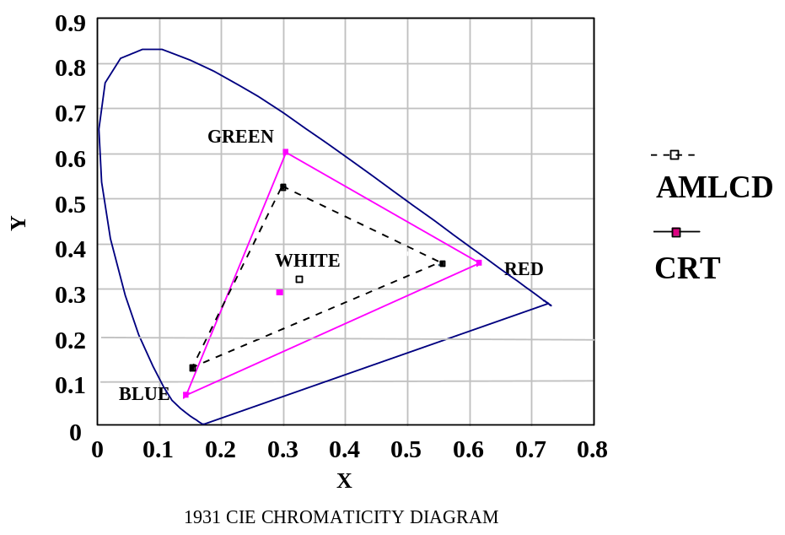
Figure 5-1. Comparison of Notional AMLCD and CRT Color Envelopes
Redundancy
- Ensure display hardware redundancy for displays of critical flight and mission information so that in the event of an electronic single-point failure, aircraft safety or mission completion is not compromised.
Example. For critical flight information, a separate, independent system is generally required.

Multifunction Displays
Usage
- Consider using MFDs to reduce the number of physical controls and displays and to provide a flexible interface where panel surface is limited.
Access to System Functionality
- MFDs should allow access to any of the system functions, and provide redundancy to ensure that system safety is not compromised.
Functional Assignment of Programmable Pushbuttons
- When pushbuttons provide more than one function, as is typical of MFD implementations, the associated actions should be made evident to the crewmember on the MFD.

Helmet-Mounted Displays
Field of View
- Ensure that the FOV optimizes human performance for the task being performed. The chosen FOV should be a function of aircraft mission and should be adequate for all mission segments. It should provide optimum visual search performance, object recognition, and spatial orientation.
Note. Consider that the minimum FOV for HMDs is about 30 degrees, although the desired minimum FOV is 40 degrees. Smaller FOV sizes degrade the crewmember’s ability to acquire spatial information from the surroundings and can contribute to an increase in search time. Finally, consider FOV and resolution trade-offs (preliminary research indicates that pilots prefer an expanded FOV over increased resolution).
Note. Fixed and rotary wing flight characteristics impose considerably different requirements for FOV. High-speed forward flight over level terrain is visually less demanding than a precision hover in a confined landing area. The slower speeds, extremely low altitudes, and higher agility associated with helicopters dictate the widest possible FOV (vertically and horizontally). The vertical FOV dimension is needed to support air-to-air engagements, which require a pilot to maintain visual contact with a vertically maneuverable threat while turning hard and avoiding obstacles.
Multi-Image Helmet-Mounted Display Design
- Consider using the following HMD design implementations when displaying images from multiple sources: a FOV of at least 40 degrees; real-world transmission greater than 70%; one design for both day and night use; symbology contrast greater than 1:2 in daylight without using a visor; NVG gain greater than 2000; and latency of image update relative to real world.
Helmet-Mounted Display Resolution
- Ensure that the resolution of the HMD optimizes human visual performance for the task being performed.
Example. At night, high resolution may be required to make full use of FLIR capabilities.
Time Lag
- When widening the crewmember’s FOV by slaving a sensor device such as a FLIR to the line-of-sight of the HMD, consider the time lag that can occur between the crewmember’s head movement and the display of the sensor output. Time lags can seriously impair the crewmember’s ability to derive control-oriented information from the visual scene.
Note. To offset these potential effects, the crewmember may tend to minimize head rotations. By minimizing head rotations, the crewmember diminishes the wide-angle coverage provided by the slaving sensor, thereby impairing search performance and spatial orientation.
- To accurately compensate for the effects of an eye-slaved display, a head-coupled system with an eye-to-display lag ≤ 40 msec is recommended. This lag is also recommended for continuous HMD head tracking tasks.
Weight, Center of Gravity and Motion Restrictions
- Consider the head-borne weight of the HMD which can cause fatigue after prolonged usage The head-borne weight is also directly related to the FOV and eye relief.
- Ensure that the HMD CG is balanced to minimize neck strain, fatigue, and helmet movement relative to the crewmember’s head.
Note. This is of particular concern in a high-g environment, especially when the head turns quickly.
- Ensure that the HMD’s external attachments (cables, mechanical linkages) or its fundamental design does not restrict the crewmember’s head or shoulder motion.
Head Motion Attenuation
- Ensure that the HMD design attenuates head motion in the 4 hz range.
Note. Complementary adaptive filtering methods may be used to accommodate head motion due to platform accelerations. These methods have been shown to be effective in compensating for the image stabilization error due to the sampling delays associated with HMD position and orientation measurements.
Exit Pupil
- Optimize the area in which the crewmembers can move their eyes and still see the imagery (exit pupil). Allow the greatest amount of vertical and lateral eye motion relative to the display system in which all or some of the symbology will be available.
Note. As the eye moves away from the exit pupil, the amount of the image that is visible decreases until all imagery is lost from view, as occurs when the eye is completely outside the boundary of the exit pupil. The optimum eye position places the entrance pupil of the eye on the same plane as the exit pupil of the imaging system.
Eye Clearance
- Ensure that the eye clearance distance is compatible with military eye wear (e.g., HGU-4/P glasses) and NBC gas masks. HGU-4P glasses require 10 mm clearance and NBC gas masks require a minimum clearance of 22 mm.
Obscuration of Vision
- Ensure that the HMD does not obscure vision and that the crewmember can easily see around the HMD components for viewing cockpit displays and controls.
See-Through Transmittance
- The transmittance and reflectance values of the HMD optical components (beamsplitter and combiner lens) should be set to optimize see-through capability, CRT luminance transfer, or a compromise between both capabilities.

Binocular Considerations
Usage
- Consider using a binocular HMD for combined day and night usage.
Note. Binocular HMDs offer advantages over monocular systems when designing for day and night operations. They provide superior contrast sensitivity, perceptual threshold, visual acuity, and also prevent binocular rivalry between the eyes.
Partial Binocular Overlap Imagery
- Ensure that unnatural high-contrast edges are eliminated to minimize the effects of luminance roll-off.
- Consider eye assignments for increasing the binocular correspondence of the HMD with the natural world.
- Consider contour lines to compensate for the unnatural continuity of binocular/monocular imagery and the black surrounding surface.
- When using partially overlapping monocular images to increase the FOV for NVGs, ensure that the binocular overlap is at least 40 degrees to reduce image breakup effects and eye discomfort.
Adjustability
- Consider providing crewmembers with the ability to adjust image disparity to produce the best depth effect and the optimum diopter.
Binocular versus Bi-ocular HMDs
- Consider the use of bi-ocular displays (which present the identical image to each eye) versus binocular displays where stereoscopic depth judgments are not critical.

Monocular Considerations
Usage
- Monocular HMDs should be used when the crewmember needs one eye for real-world viewing and stereo-optic presentation is not required.
Monocular HMD Use for Night Operations
- Although monocular HMDs may be used for some system operations, careful consideration should be given for their usage in night operations.
Note. Some data have shown that night vision adaptation can be preserved in one eye. Binocular rivalry for night video displays may occur, and therefore monocular HMDs are undesirable for night operations.
Opaque Monocular HMDs
- Consider using an opaque monocular HMD where the HMD symbology and information will be viewed against an additional layer of panel-mounted display information.

Head-Up Displays
Nonreflectivity of HUDs
- Ensure that the HUD is designed to be non-reflective to the outside world, to reduce any external visual signature.
Ease of Repositioning Line-Of-Sight to Increase Field-of-Regard
- Repositioning the line-of-sight to increase a sensor’s field-of-regard should require minimum crewmember effort and should not contribute to confusion about viewing direction or image orientation.
Note. Crewmembers could become confused about viewing distance when the sensor line-of-sight is different from the HUD axis.
Boresight Accuracy
- Imagery and symbology should be conformal to the outside world within ± 0.5 degrees.
HUD Resolution
- Ensure that the resolution of the HUD optimizes human visual performance for the task being performed.
Example. At night, high resolution may be required to make full use of FLIR capabilities.
Raster Image Contrast
- Raster images (i.e., video images) should be presented using a high raster image-to-background contrast ratio and appropriate refresh rates.
Raster Image Luminance
- Ensure that the HUD raster image luminance is approximately 50% of the forward scene luminance.
Exception. If the HUD is restricted to observation of familiar terrain, such as a runway or roadway with high contrast edges, the luminance level should be about 15% of the forward scene luminance.
Eye Position/Exit
- Ensure that the HUD design does not unduly constrain the crewmember’s head or eye positions.
Note. When pupil-forming optics are used, head and eye position should be constrained to a relatively small spatial volume (approximately ±1 inch maximum) to allow viewing of the entire instantaneous FOV.

Audio Displays
Usage
- Consider using audio displays in the following instances: 1) when the information to be processed is short, simple, and transitory, requiring an immediate or time-based response; 2) when the common mode of visual display is restricted by over-burdening; 3) when there exists the possibility of ambient light variability, crewmember mobility, degradation of vision by vibration, high g-forces, hypoxia, or other environmental considerations, or anticipated crewmember inattention; 4) when the criticality of transmission response makes supplementary or redundant transmission desirable; 5) it is desirable to warn, alert, or cue the operator to subsequent additional response; 6) when custom or usage has created anticipation of an audio display; and 7) when voice communication is necessary or desirable.
Capability for Repeat of a Signal
- The crewmember should be provided with the capability to request a repeat of the verbal or nonverbal auditory signal.
Data Transmission Interference
- Ensure that digital data transmission does not interfere with voice communications or auditory signals and is not masked by background noise.

Headset Considerations
High Ambient Noise
- If crewmembers are in a high ambient noise environment (85dB or above), binaural rather than monaural headsets should be provided. Unless operational requirements dictate otherwise, binaural headsets should be wired so that sound reaches the two ears in opposing phases.
Dichotic Presentation
- In cases where a warning signal delivered to a headset may mask another essential audio signal, consider separate channels to direct the warning signal to one ear and the other essential audio signal to the other ear.
Note. In such a situation and when required by operating conditions, this dichotic presentation may further provide for alternation of the two signals from ear to ear.
Example. An example of dichotic presentation is presenting missile warning auditory cues to the left ear while presenting communications traffic to the right ear.
Volume Control
- The minimum setting of the volume control should be limited to an audible level and should not allow an inadvertent disabling of the voice communication system. Separation of the power and volume control adjustment functions is preferred.
Squelch Control
- Where communication channels are required to be continuously monitored, each channel should be provided with a signal-activated switching device (squelch control) to suppress channel noise during no-signal periods. For weak signals, a manually operated on-off switch should be provided to deactivate the squelch.

Audio Warning Signals
Signal Intensity
- Ensure that audio alarms for critical functions are at least 20 dB above the speech interference level at the operating position of the intended receiver.
Definition. Speech interference level describes the effectiveness of noise in masking speech. It is the average (in decibels) of the sound levels of masking noise in the 600 to 1200, 1200 to 2400, and 2400 to 4800 octave bands.
Critical Warning Signals
- Critical warning signals should be repeated with no more than a 3 second pause between messages until the condition is corrected or overridden by the crewmember.
Audio Signal Duration
- Audio warning signal duration should be at least 0.5 seconds and may continue until the appropriate response is made. Completion of a corrective action by the crewmember or by other means shall automatically terminate the signal.
Speech Processing
- Verbal signals should be processed only when necessary to increase or preserve intelligibility, such as by increasing the strength of consonant sounds relative to vowel strength.
Automatic/Manual Shut-Off
- When an audio signal is designed to persist as long as it contributes useful information, ensure that a shut-off switch controllable by the crewmember and/or the sensing mechanism is provided. Whether the shut-off switch is controlled by the crewmember or automatically should be dependent on the operational situation and crewmember safety factors.
- An automatic reset function should be provided so that the warning device can sound again if the condition repeats. The reset function should be controlled by a sensing mechanism that recycles the signal system to a specified condition as a function of time or the state of the signaling system.
Automatic/Manual Volume Control
- The volume of an audio warning signal should be designed to be controlled by the crewmember, the sensing mechanism, or both, depending on the operational situation and crewmember safety factors.
Ganging Volume Control to Mode Switches
- Volume controls may be ganged to mode switches to provide maximum output during mission phases in which intense noise may occur and to provide reduced volume at other times.
Exception. Ganging should not be accomplished if there is a possibility that intense noise may occur in an emergency situation during a mission phase in which the volume would be decreased below an audible level.

Cockpit Control technologies
This section describes the various control technologies that are available to the AHCI designer and their current implementations. Guidelines are presented for the following control types: hands-on controls, pointing/cursor devices, pushbuttons and switches (programmable and dedicated), keyboard data entry devices, voice command systems, and touch screens. A comparison of the advantages and disadvantages of these various control types is presented in Table 5-2.
Table 5-2. Cockpit Control Types Advantages/Disadvantages
 | Advantages | Disadvantages
Hands-On Controls | Allows direct access to key controls during critical phases of flight without taking hands off flight controls. Promotes head-up operation. | Potential for complexity; not enough switches for all uses.
Pointing/Cursor Devices | Good for rapid, unlimited cumulative travel in any direction on a screen.  Appropriate for generating precise X and Y output values and for designating and activating targets/graphical objects on a map display. | May not be optimum for click-and-drag tasks.  Some potential for inadvertent activation.  May be cumbersome to use in some cockpit applications with gloved use and during high turbulence.
Programmable Pushbuttons | Allows flexibility for key functionality. | Potential for confusion when keys change functionality.
Keyboards | Appropriate for alphanumeric data entry. | Full-size keyboard not practical for quick alphanumeric data entry. Speed could be a problem.
Voice Command Systems | Allows for head-up and hands-on control activation. Can provide quick system configuration via “macros”. | Voice commands must be learned; not always intuitively obvious.  Susceptible to speech degradation under various conditions such as noise, vibration, and g forces.
Touch Screens | Allow for quick operation, are easy to learn. Uses space efficiently, and are durable. | Provide low resolution; diminish ability to see through the touch membrane. May be physically tiring to use over an extended period.
Hands-On Controls. The implementation of hands-on controls or HOTAS controls allow for more immediate and effective operation during critical phases of a mission. By enabling the pilot to sustain hands-on critical flight and mission controls, the pilot is alleviated from shifting attention from the outside world to look inside the cockpit to make a control action This is especially important during phases of flight that are both visually and manually intensive, such as during combat or low-level terrain following flight. Some cockpit designs also provide a two-axis controller on the control head. This controller can be used to move a cursor on an MFD or the HUD in order to select various functions. This design minimizes the need for multi-function keys around the MFD, however, the keys are generally provided as back-up.
Pointing/Cursor Devices. Pointing/cursor devices allow for rapid navigation around the screen through direct manipulation. They are typically used in graphic interactions, for object selection and manipulation, or in a menu selection or form-filling capacity to designate a data entry position. Trackballs have been used in military aircraft applications for command and control and for anti-submarine warfare. A trackball is appropriate for generating precise X and Y output values and cumulative travel in any direction. They are considered good for rapid, unlimited 2-D movement, however, there is the potential for inadvertent activation. Trackballs may not be optimum for such tasks as click-and-drag and are typically associated with an execution switch for selection/designation. Multi-directional keys are essentially one-dimensional control devices, each providing movement in a specific direction. They are considered adequate for tasks that require one dimensional positioning and menu selection, but are considered ineffective for tasks that require rapid 2-D movement.
Light pens have been implemented on a limited basis for use in military aircraft (e.g., Navy E-2 aircraft). Light pens have been shown to provide the following advantages over some other pointing devices: 1) fast for simple input; 2) good for tracking moving objects; 3) minimal perceptual motor skills needed; 4) efficient for successful multiple selection; and 5) user does not have to scan to find a cursor somewhere on the screen. Unfortunately, light pens have also been shown to have numerous disadvantages that include the following: 1) requires fine motor control; 2) may lack precision because of the aperture, distance from the CRT screen surface, and parallax; 3) contact with the computer may be lost unintentionally; 4) frequently required button depression may cause slippage and inaccuracy; 5) glare problem if pen is tilted to reduce arm fatigue; 6) fatiguing if pen is held perpendicular to work surface; 7) may be cumbersome to use with alternate, incompatible entry methods, like the keyboard; 8) hand may obstruct a portion of screen when in use; and finally, 9) care must be taken to provide an adequate “activate” area around the choice point. Although light pens may be suitable for certain applications including special purpose workstations, such as those found on command and control aircraft, caution should be exercised when implementing these devices for cockpit applications. A major concern is the aircraft’s vibration that can cause some instability of the light pen movement leading to erroneous selections.
Programmable Pushbuttons. Programmable pushbuttons are typically used in conjunction with MFDs. They are also used as line select keys for some mission computer displays. Dedicated pushbuttons and switches (multi-function, rotary) are currently used in up-front controls (UFCs), console and overhead control panels, control display units, and as HUD/MFD integrated controls.
Keyboards. Typically, cockpit keyboards are miniaturized in some way and tailored to the specific data input requirements of the aircraft platform. Full size QWERTY keyboards are generally not used in military cockpits because of the limited space and operability constraints. Cockpit keyboards generally consist of an array of alphanumeric and function keys to allow the entry of alphanumeric text into the avionics. A small scratch pad area (generally two lines) is provided for key entry feedback. Some cockpits (Army’s Comanche helicopter) have implemented a modified full-size version (2 lines, 46 character device) in which the keys are alphabetically arranged across 4 columns and down 8 rows. Numeric keys are located adjacent to the alphanumeric keys. Current cockpit applications include entry of navigation, communication, and weapon system data.
Emerging Control Technology. The following paragraphs discuss technologies that are emerging as control options for military aircraft applications. These technologies include voice command and control, touch screens, and head-steered and eye-tracking technology. Voice command systems and touch screen technologies have been implemented in commercial industries but are just beginning to be incorporated in the design of military aircraft. Head-steered and eye-tracking systems are also new technologies for providing sensor and cursor control for military aircraft.
Voice Command System. The increased manual and visual task load placed on crewmembers in modern military aircraft has led designers to search for alternative control technologies that would not further overload the crewmembers’ visual and manual systems. Voice control technology could provide the crewmember with the capability to interact directly with on-board computer systems while maintaining hands-on control and visual focus outside the cockpit. The use of voice control as a pilot-vehicle interface has until recently been only a laboratory concept. However, advances in high-speed digital signal processing chips and developments in recognition algorithms have produced voice technology that can withstand the aircraft operational environment. Voice control technology is currently being flight-tested on aircraft in the U.S. and is being implemented on several foreign aircraft including the Rafale and the EF-2000 (Euro-fighter).
The requirements for an aircraft voice control system include high recognition accuracy under all expected operational conditions and a fast response time. Current systems have been shown to be robust under normal flight and various g conditions, producing an accuracy of 97-100 percent, and were preferred by pilots over manual methods for certain tasks (Williamson, 1997). With digital signal processing speed increasing about 20 percent each year, the necessary computing power required to provide high accuracy, real-time speech recognition in the military environment is currently available for command and control applications involving small vocabularies using continuous speech.
In addition to providing an alternate input control method that allows the crewmember to remain both hands-on and head-up, voice control can also be used to as a shortcut, allowing the crewmember to bypass multiple key presses with a single voice command. Voice can be used as an input method in conjunction with various dialog types, including data entry, menu selection, and direct system command. Current and suggested implementations for voice control include: 1) communication channel selection and frequency change, 2) navigation waypoint selection and route manipulation, 3) display format selection and moding, 4) status and tactical information updating, 5) target selection and sensor moding, and 6) data link interaction.
Touch Screens. Touch screens allow the crewmembers to interact directly with the display surface by pointing with their fingers. This technique combines both input and visual feedback into one device. Input to the system is dependent on the technology and may be accomplished either through initial contact with the screen, or through the termination of contact. When termination sensing is used, the initial touch selects the control and termination activates the function. Several technologies have been developed for touch screen applications. These include the following basic types:
Resistive Membrane. A resistive coating is applied to a glass panel along with a transparent foil that has an electrical conduction surface on one side. When the screen is touched, it is sensed by a controller that calculates the location.
Capacitive Panel. Glass plate is equipped with a capacitive coating. Electrodes are mounted on all four sides of the panel, which are connected to an oscillator. Touching the screen causes phase and frequency shifts, with allow for calculating the touch location.
Piezo Electric. A piezo ceramic sensor is located in each corner of the display. When the screen is touched, the force distribution is calculated depending on the touch location.
LED or Infrared Array (LED/IR). Two arrays of LEDs are placed opposite two arrays of photo sensitive transistors. Touching breaks contact and the touch location is calculated.
In general, touch screens are fast, easy to learn, space efficient, and are durable with respect to high volume usage. However, touch panels and screens typically have low resolution and may diminish the crewmember’s ability to see through a touch membrane. Additionally, the crewmember’s arms may become tired when touch screens must be used over an extended period of time due to the lack of arm, hand, and wrist support. Also, the crewmember’s finger can often partially block a view of the screen. Touch screens may also be difficult to use in high vibration, turbulent, or high-g environments. For these reasons, special ergonomic positioning requirements may be introduced for proper touch screen implementation. To date, touch screens have been implemented on a very limited number of military aircraft.
Head-Steered and Eye-Tracking Controls. Head-steered controls are typically used in conjunction with a helmet-mounted cueing system to slew sensors. The crewmember uses head movements to position cross-hairs or a similar aiming cursor to which the sensor is slewed upon the depression of a target designation switch. Eye-tracking systems could be used for sensor slewing and cursor control in a similar manner with the system tracking the crewmember’s eye position. The capability to track eye position provides advantages over head-steered control including more natural aiming, and due to the eye’s natural stability, it could be used to damp out the effects of turbulence on HMD aiming (AGARD, 1995). Although there are several eye-tracking systems which function well in laboratory settings, systems which operate satisfactorily in a cockpit have not yet been developed. In theory, both head-steered and eye-tracking controls would be appropriate for hand-intensive tasks that require hands-on controls.

General Guidelines for Controls
This section presents high-level guidelines for controls. These general guidelines are tailored to the cockpit domain and provide the foundation for the design of all AHCI control types. This section includes guidelines for developing a control and display design that promotes compatibility with crewmember expectations of control movement.
Consistency Across Same Type of Operation
- Controls used for the same type of operation should be designed so that they operate using the same movement relationships. They should not be designed so that they move in opposite directions.
Clockwise Rotational Movement
- For increasing display variables with rotational movement, the control movement should be in a clockwise direction. Likewise, for decreasing display variables, the control movement should be in a counter-clockwise direction.
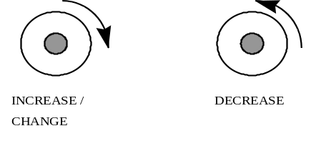
Figure 5-2. Design for Rotational Movement
Upward or Right Linear Movement
- For increasing display variables with linear movement, the control movement should be in an upward or right direction. Likewise, for decreasing display variables, the control movement should be in a downward or left direction.

Figure 5-3. Design for Linear Movement
Proximity of Movement
- The arc of the rotating element that is closest to the moving display should move in the same direction as the display.
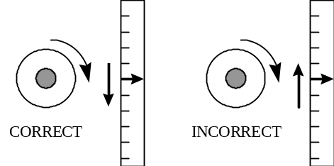
Figure 5-4. Proximity of Movement
Minimal Effort
- Minimize hand movements, switching between control devices, and physical effort involved in control usage.
Usage with Nuclear, Biological, and Chemical Gear
- Controls should be accessible and usable (full range of motion and operation) to the crewmember while seated in the cockpit wearing full NBC gear and with all seating restraints in place.
Task Compatibility
- Ensure that the relationship of a control and its corresponding display is apparent and unambiguous. Functionally related controls should be located in proximity to one another and arranged in functional groups to support the crewmember’s mental model of the task.
Motion Expectancy
- Direction of motor response movement should be compatible with the crewmember’s expectation of the related movement.
Example. The following are control actions and related motion expectancies:
On: up, right, forward, press
Off: down, left, rearward, pull
Right: clockwise, right
Left: counterclockwise, left
Up: Up, rearward
Down: Down, forward
Retract: Rearward, pull, counterclockwise, up
Extend: Forward, push, clockwise, down
Increase: Right, up, forward, clockwise
Decrease: Left, down, rearward, counterclockwise
Either Hand Accessibility
- The location of critical controls should be accessible by either hand for operation.
Redundant Control Device Capability
- Where possible, provide a redundant input device capability.
Indication of Inactive Controls
- Inactive controls should be readily apparent to the crewmember and feedback should be provided to the crewmember upon their attempted activation.
Inadvertent Activation
- Control design should prevent inadvertent activation/deactivation, but not preclude the control from being operated; and should consider the effects of g-forces and turbulence.
Momentary Feedback
- When the effect of a control action is momentary, ensure that the visual feedback is momentary as well.
- When the effect of a control activation is to lock/latch a condition, the feedback should last as long as the condition is locked.
Indication of Activation to Allow Head-Up Operation
- Where possible, feedback should be provided in such a way that the crewmember can remain head-up and eyes-out of the cockpit and still receive the feedback.
Example. Where appropriate, provide tactile or aural feedback.

Hands-On Controls
Blind Reach
- The flight controls should be ergonomically designed so that controls can be easy accessed and instinctively activated to promote blind reach and head-up operation. Common methods for distinguishing controls for head-up operation include size, shape, and location coding.
Example. The grip switches on the Apache AH-64D were designed to allow easy selection without significant repositioning of the hand. The center-to-center 1 inch separation between adjacent switches allow for both effective reach and minimal inadvertent selections. The adjacent switches are in different planes relative to the location of the thumb. The use of several complex planes in the grip surfaces maximizes the three-dimensional spatial separation of the adjacent switches. The switches are typically bordered by hard grip surfaces, such as the jettison guard, or the bottom of the mission grip. These hard surfaces and palm rests were specifically designed to quickly orient the thumb and index finger at night, by feel alone (Hannen and Cloud, 1995).
Gloved Operation
- Test gloved operation when using tactile coding for hands-on controls.
Example. On the Apache AH-64D helicopter, the switches have either convex or concave switch caps which allow some degree of switch differentiation by feel, even when flight gloves are worn.
Sequential Operation
- When several controls (switches) are normally operated in a sequence, arrange them in a systematic order (e.g., left to right).
Movement Characteristics
- When designing hands-on controls, consider the movement characteristics, such as knob rotation, lever movement, and range of movement. Ensure that these characteristics are compatible with the guidance provided in MIL-STD-1472E.
Control Coding
- When designing hands-on controls consider the various coding methods including location, shape, size, and mode of operation. Ensure that the design of the controls adheres to the guidance for control coding provided in MIL-STD-1472E.
Number of Functions
- Limit the number of functions assigned to a single controller so that the crewmember will not be burdened with excessive memory requirements. More functions increase the possibility of actuating the wrong function because of either forgetting the switch assignment or inadvertent inputs.
Example. It has been recommended that no more than six functions be implemented on a single controller. However, with proper design this number may be increased. (The hands-on grips on the Apache AH64D helicopter have over 18 dedicated functions).
Controls Functions Assignment
- Functions assigned to hands-on control switches should be based on the crewmember’s focus of attention (e.g., head-up or head-down), their criticality, and their frequency of use.
Example. On the Apache AH-64D helicopter, the pilot flying the aircraft is able to operate the radar from the hands-on grip switches without touching the MFD pushbuttons, thus keeping the pilot’s focus of attention head-up and eyes-out of the cockpit.
Control Sensitivity for Continuous Adjustments
- For tasks that require smooth, continuous adjustments, hands-on controls should be mechanized to support both course and fine positioning.
Discrete Positioning
- Consider using bump switches or similar types of devices to minimize vibration and shock errors for tabbing from one screen area to another (rather than cursor scrolling), for discrete positioning or for accessing specific areas on the display.
Distribution of Control Activity
- Distribute the control activity across control grips (across the collective and cyclic grips for rotary wing and across the throttle and stick for fighter aircraft) to share the task loading between the left and right hands.
- Distribute the control activity across the fingers and thumb to share task loading and to maximize the positioning dexterity provided with the thumb.
Example. On the Apache AH-64D helicopter, the pilot’s thumbs were assigned to all two-, three-, and four-position switches as well as the cursor control to capitalize on the fine positioning capability of the thumb. The index fingers and ring fingers were assigned to pushbuttons and triggers only, due to their limited dexterity (Hannen and Cloud, 1995).
Motor Response Disruption
- Avoid assigning control operations to two limbs when a simultaneous motion geometry or pattern may cause motor response disruption.
Example. The act of one hand moving a lever forward and another hand moving a similar level aft would be result in a response conflict and an inadequate distribution of workload.

Pointing/Cursor Devices
Cursor Movement Keys
- Cursor movement keys should be arranged in a spatial configuration reflecting the direction of the actual cursor movement.
Navigation Keys
- Consider providing navigation keys (e.g., “hot buttons”) that will allow the crewmember to quickly move the cursor to various display locations.
Facilitate Head-Up Operation
- The placement of the movement surface should allow some orientation without visual reference to the device to facilitate head-up operation.
Activation/Deactivation
- Consider using a discrete mechanism to activate and deactivate the pointing device.
Consistent and Compatible with Task Requirements
- The relative unit change of control action per degree of unit change of pointer/cursor action should be consistent across applications and compatible with the positioning requirements of the task.
Fine and Course Adjustments
- The pointer device should be capable of fine and course adjustments for cursor movement on the display. The velocity sensitivity gain should be user-controlled or automatic, based on predetermined criteria.
Cursor/Pointer Stability
- The cursor should be designed so that it will be stable at a designated position until it can be moved.
Cursor/Pointer Movement
- A crewmember should be able to move the cursor/pointer anywhere on the screen by moving all or part of the pointing device.
Directional Compatibility
- The pointer should move in the same direction as the pointing device.
Combination Controls
- When moving a cursor device in a particular direction, consider placing the associated buttons at the end of the trajectory (it is easier to press a button if it is at the end of the trajectory).
Example. If movement is horizontal, buttons should be placed at the right. If movement is vertical, buttons should be placed at the top or bottom depending on the most frequent direction of movement.
Light Pen Usage
- Light pens may be appropriate if item selection is the primary type of interaction and non-critical, imprecise input functions are required.
- Light pens may also be used as a track-oriented readout device. It can be positioned on the display screen to detect the presence of a computer-generated track by sensing its refresh pattern. The display system can then present a cursor on the track designated by the light pen. With additional circuitry, the cursor can be made to track the movement of the light pen across the surface. This allows the light pen to function as a two-axis controller.
Light Pen Dynamic Characteristics
- When functioning as a two-axis controller, prior movement of the light pen in any direction on the display surface should result in the smooth movement of the cursor in the same direction. The discrete placement of the light pen at any point on the display should cause the cursor to appear at the corresponding coordinates and to remain steady in position so long as the light pen is not moved. The refresh rate for the cursor should be sufficiently high to ensure the appearance of a continuous track whenever the light pen is used for the generation of free-drawn graphics.
Light Pen Dimensions and Mounting
- The light pen should be between 120 - 180 mm (4.7 - 7.1 in) long with a diameter of 7 - 20 mm (0.3 - 0.8 in). A clip should be provided to hold the light pen when not in use.

Pushbuttons
Blind Reach
- Design of the pushbuttons should allow for as much activation/deactivation without the use of sight as is possible.
Grouping Pushbuttons
- Provide adequate button separation to avoid inadvertent operation of adjacent switches.
Efficiency of Operation
- Pushbuttons should be located where they can be reached and manipulated with optimum speed, accuracy, and comfort, taking into consideration the nature of the controlled functions, the crewmember’s capabilities and limitations, and the relative significance of the controlled functions.
Relative Importance/Frequency
- Less important or infrequently used pushbuttons and switches can be placed in relatively less accessible areas or “low priority” locations that may require the crewmember to be head-down for operation (e.g., console control panels).
- Pushbuttons that are used with great frequency or precision during normal operation should be placed in preferred areas where they can be easily reached and manipulated (e.g., on the UFC panel).
Functional Grouping
- Functionally related pushbuttons and switches should be located in proximity to one another and arranged in functional groups.
Interference with Other Controls
- Pushbuttons should be located with sufficient clearance from other controls and objects to allow for the safe, efficient, and effective activation/deactivation of the required pushbutton/switch, without hindering the operation of other controls when the crewmembers are wearing flight and/or NBC gloves.
Pushbutton Control Sensitivity
- Consider the vibration within the cockpit when designing pushbutton sensitivity.
- Consider the tactile “feel” or response required for gloved operation when designing pushbutton sensitivity.
Special Considerations for Dedicated/Fixed Function Keys
- Consider using dedicated keys in the following instances: for time-critical, error-critical, or frequently used control inputs; for functions continuously available regardless of mode; for control functions that are discrete or limited in number; and, for functions that require immediate application where menu selection is inappropriate.
Reassignment of Functions
- When a fixed function key has been assigned a given function, ensure that that function will not be reassigned to another key.
Special Considerations for Multi-function Pushbuttons
- Consider using multi-function pushbuttons when the total number of functions can not be conveniently handled by dedicated pushbuttons or when control input requirements vary significantly for different modes.

Keyboards
Layout and Configuration
- When designing a keyboard layout, consider that the key configuration and the number of keys are dependent upon the predominant type of information to be entered into the system.
Note. Two major forms that keyboards can take are: 1) the numeric keyboard using a 3x3+1 matrix with the zero digit centered on the bottom row and, 2) the alphanumeric keyboard.
Multiple Keyboards
- Systems containing more than one keyboard should maintain the same configuration for alphabetic, numeric, and functions keys throughout the system.
Dimensions, Resistance, Displacement, and Separation
- The control dimensions, resistance, displacement, and separation between adjacent edges of the pushbuttons which form keyboards should conform to the criteria in MIL-STD-1472E.
Indication of Activation and Feedback
- Feedback should be provided to indicate if a key was pressed. If keys are inactive, feedback should be provided upon attempted activation.

Voice Command and Controls

Voice Control Design and Application
Usage
- Voice control is most appropriate for tasks performed in a multi-tasking environment when the crewmember’s visual and manual resources are overloaded.
Note. Voice control is not recommended for those tasks that are time-critical and can be performed quicker manually. The interface to time-critical functions may be better provided by HOTAS control. Examples include, chaff and flare dispensing, dogfight switch, weapon selection, etc.
Example. Voice control can be used to augment the crewmember’s ability to control and display information in the cockpit. It can provide an alternate means of controlling aircraft systems, receiving information from on-board computer systems, and managing off-board data (Williamson, Barry, Ligget, 1996). Examples of functions typically considered for voice control include: 1) system status queries and tactical information read-out; 2) target selection and sensor moding; 3) radio channel selection and frequency change; 4) navigation waypoint selection and route manipulation; and 5) display formation and moding.
Natural Interface Design
- Design the voice interface so that the commands are natural and intuitive to the crewmember. The vocabulary should be modeled after the crewmember’s normal discourse and compatible with existing conventions and jargon.
Short Vocabulary Phrases
- Keep the vocabulary phrases as short as possible. One word commands are often preferable.
Example. Recent studies have indicated that pilots preferred shorter phrases when using voice commands. For example, to request information regarding aircraft systems, requiring the pilot to say the word “Systems” was preferable to requiring the pilot to say “Report system status.” Similarly, “Slew next” was preferred to “Slew next steerpoint” (Barry, Ligget, and Williamson, 1997).
Appropriate Syntax Design
- The syntax should be designed so that the resulting phrases make logical sense. Proper syntax design can decrease the amount of words the system must recognize, and thus can improve recognition accuracy.
Example. When programming a syntax for an ultra-high frequency (UHF) change, only the digit words “2” and “3” should be allowed as the first words in the phrase, since all valid UHF frequencies start with a 2 or 3 (Barry et al., 1997).
Voice “Macros”
- Where possible, design the voice interface so that a short voice command replaces multiple key presses or multiple vocabulary utterances.
Example. In a recent study, pilots preferred the voice input method for entering communication frequencies and waypoint latitudes and longitudes over the manual data entry method. An even more preferable method would be to replace the digit by digit voice utterances with one simple voice command. This voice command would be analogous to a radio preset (Barry et al., 1997).
Example. Voice technology can also be used to extend the display configuration master moding concept without adding new hardware switches. The air-to-air and air-to-ground master mode switches on various fighter aircraft are used to configure the display suite for the selected mode. There are however, a limited number of hardware switches available for such options. Voice “macros” could be used to configure the display suite for other mission phases (e.g., ingress) thus bypassing multiple key presses on the displays themselves, without the necessity of addition hardware.
Audible Feedback
- Aural feedback should be provided when there is no obvious visual change. When a change is obvious, such as a display format change, no aural feedback is necessary.
- Aural feedback should be kept short; one or two words is preferable.
Redundant Control Method
- Provide redundant control methods for those functions implemented with voice control.
Effective System Training
- For speaker dependent systems, the designer should ensure that the training process or “template enrollment” is representative of how the crewmember will actually speak to the system in the aircraft.
Note. If templates generated from the training process are not representative of the real-world situation in which the voice system will be used, performance will be degraded. Training a speech system is a two-way process. The system “learns” how the speaker says a particular word or phrase while at the same time the speaker learns how to talk to the system in a way that will maximize accuracy. The more experienced a speaker is with a particular system, the better the performance (Williamson et al., 1996).

Speech Transmission/Recognition Equipment
Robust Recognition Equipment
- Ensure that the speech recognition system selected provides robust recognition in all expected operational environments and for all expected operators.
Note. There are two primary sources for speech signal degradation: noise and speech variability. Noise sources in the aircraft environment include: 1) ambient background noise produced by aircraft engines, environmental control system, and the sound of air moving past the aircraft; 2) channel noise or distortions produced by the microphone transducer and electrical noise conducted in the wiring to the speech system; and 3) speaker noise or non-vocabulary speech sounds such as lip smacks, breath noise from an oxygen mask, or grunting sound produced under anti-g straining maneuvers. There are various techniques commonly used to reduce the effects of noise including training in the environment, preprocessing, and noise cancellation algorithms. Speech variability occurs when the crewmember’s voice changes due to various factors including g forces, workload stress, and fatigue. Typically, there is little application for speech recognition above 6 g’s. The speech variability that occurs during high g conditions can be compensated for with the proper closed-loop feedback of g level to the speech system, and control vocabulary and grammar structure can be limited to only enable those few tasks that a pilot may want to access by voice (Williamson, 1997).
Audio System Effectiveness
- Microphones, pre-amps, intercom systems, automatic gain control (AGC), and aircraft wiring all should be carefully considered in order to achieve a successful speech interface. Audio wiring to the speech system must be shielded and grounded properly to prevent interference on the speech signal.
Frequency
- Microphones and associated voice input devices should be designed to respond optimally to that part of the speech spectrum most essential to intelligibility (200 to 6200 Hz).
Note. Where system engineering necessitates narrower speech transmission bandwidths, the minimal acceptable frequency bandwidth is 250 to 5000 Hz.
Noise-Canceling/Shields
- In very loud, low frequency noise environments (100dB), noise canceling microphones should be used. These microphones should be capable of effecting an improvement of not less than 10 dB peak speech to root-mean-square noise ratios as compared with non-noise canceling microphones of equivalent transmission characteristics.
- A noise shield should be provided when the crewmember has to talk in an intense noise field.
Non-Interference with Standard Communications
- Where possible, the voice system should be designed and integrated to use the microphone that is already implemented for the aircraft.
- The crewmember should be provided with a push-to-talk device to switch between the standard communication channel and communicating with the voice system. The push-to-talk device should be implemented as a manual switch, preferably on the HOTAS.
Note. Some applications have attempted to implement the push-to-talk control via a keyword activation where the user would say a phrase such as “Mic on” and the voice system would then response aurally with “Ready” or “What.” This voice system is then designed to time-out after a certain period with no voice communication from the user. This technique however, where the user must wait for the system to perform a verbal handshake, negates the speed benefit of voice technology. The push-to-talk device is quicker to access if implemented on the HOTAS.

Touch Screens
Touch Screen Usage
- Touch screens should be considered where: 1) direct visual reference access and optimum direct control access are desired; 2) data entry is limited; 3) flexibility of layout or language is required; 4) display and input device must be in a confined area; or 5) hardware durability is a concern.
- Touch screens should not be used when high resolution monitors are needed or if the crewmember will be making numerous data inputs.
Touch Screen Luminance Transmission
- Touch panels should have sufficient luminance transmission to allow the display to be clearly visible under all expected operational conditions.
Positive Touch Screen Feedback
- A positive indication of touch screen activation should be provided to acknowledge the system response to the control action.
Cursor Movement for Finger Removal Activation
- When activation of a control target is performed by the removal of the finger from the touch screen control surface, the initial touch of the control should cause the cursor to relocate onto the control (causing the control to be selected) unless there are safety or critical mission requirements associated with the control.
Lack of Cursor Movement with Finger Movement
- When activation is performed by removal of the finger from the display surface, if the crewmember’s finger slides off the control before removing it from the screen surface, no selection should take place, but the cursor should remain on the last control touched unless there are safety or critical mission considerations associated with the control.
Inadvertent Activation Protection
- Provide a method, such as a screen saver with a password, to make the screen secure when not in use. This will preclude inadvertent activation due to casual touching.
Touch Screen Application Development
- Application screens should be built using touch interaction technology rather than pointing device technology.
Touch Screen Menu Design
- Touch screen menu design should be simple. Typically, the menu tree should have no more than 5 to 7 menus, and the number of menu items should be minimized (between 3 and 5).
Touch Screen Drawing Capability
- Where an operational need exists, consider providing the capability for crewmembers to perform drawing functions with a touch screen through continuous control.
Definition. Continuous control occurs when the user moves a finger or pointer from place to place on the screen without lifting it off.
Touch Screens and Auto-Completion Capability
- When crewmembers must perform data entry with a touch screen, the designer should provide an auto-completion capability to reduce the number of keystrokes required.
Definition. Auto-completion is where data fields are automatically filled-in by the system from a database.
Window Input Focus with Touch Screens
- In touch screen systems with window applications, a window should receive input focus when the crewmember touches it. Thus, when a crewmember touches a screen with multiple windows, the window that is touched becomes active and ready to receive input.
Touch Force/Resistance
- The force required to operate force-activated touch screens should be low to reduce fatigue and should conform to those forces specified in MIL-STD 1472E. In general, resistance should be similar to that for alphanumeric keyboards:
Table 5-3. Recommended Resistance for Touch Screen Touch Force
 | Numeric | Alphanumeric | Dual Function
Minimum | 3.5 oz | 0.9 oz | 0.9 oz
Maximum | 14.0 oz | 5.3 oz | 5.3 oz
Target Size
- Touch screen targets should have a minimum size of 19 mm (0.75 in) and a maximum size of 38 mm (1.5 in) as shown in Figure 5-5. Where vibration is of concern or when crewmembers must operate the touch screen while wearing gloves, the target size should be at least 1 inch square.
Definition. Input through a touch screen is accomplished by contact with an on-screen control, or target. A target is composed of the icon, symbol, or text that identifies the control. A target is usually surrounded by a touch zone, which encompasses the target and the area around the target in which action is enabled.
Touch Zone Size Relative to Visual Target Size
- Touch zones should be designed to be larger than their associated visual target. This will compensate for the fact that users tend to touch below an object, for possible mis-registration between the video and touch screens, and for sloppy touching.
Target Separation
- Touch screen targets should be separated from each other and from the edge of the display by at least 3 mm (0.13 in). The maximum target separation should be 6 mm or (0.25 in) as shown in Figure 5-5.

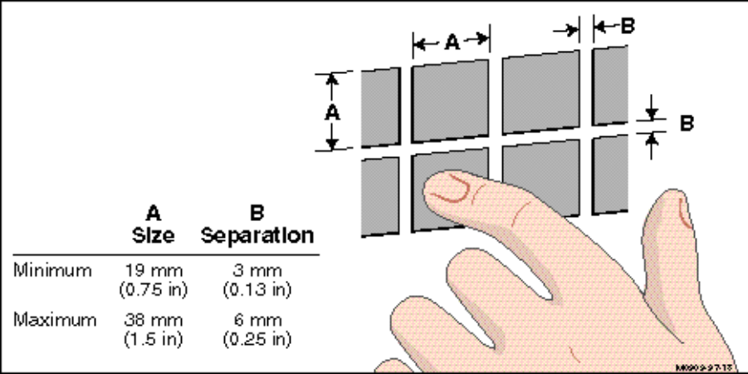
Figure 5-5. Touch Screen Area Dimensions
Visual Feedback for Touch Screens
- Visual feedback should be provided when a touch screen target is touched. The feedback should be visually different for selection and subsequent activation of the function, such as when the finger is removed to activate.
- Display of a crewmember command or action feedback for touch panels should not exceed 0.25 seconds.
Touch Zone Visual Cues
- The touch zone should be marked with some visual cue such as color, shape, graphics, or text.

References
Advisory Group for Aerospace Research and Development (AGARD). (1995) Advisory Report 349, Flight Vehicle Integration Panel Working Group 21 on Glass Cockpit Operational Effectiveness. Neuilly-Sur-Seine, France.
Barbato, G., Cone, S., & Boucek, G. S. (1997). Integrating Cockpit Technologies to Improve Aircrew Situation Awareness and Performance in a Ground Attack Mission. NAECON Conference Proceedings. Dayton, Ohio.
Barry, T. P., Liggett, K. K., & Williamson, D. T. (1997). Human-Electronic Crew Communication: Applications for Speech Recognition in the Cockpit. At The Human-Electronic Crew: The Right Stuff Workshop. Kreuth, Germany.
Goins, R. T. (1993). Integrated Cockpit/Avionics for Transports, Pilot-Vehicle Interface Trade Studies (Draft AFMC Wright Laboratory Technical Report, Contract F33615-92-C-3803). McDonnell Douglas Corporation, Burbank, CA.
Hannen, M. D., & Cloud, T. M. (1995). A Case Study in the Design and Testing of Hands-On Controls - The Longbow Apache Grip Development Process. Proceedings of the 51st Annual American Helicopter Society Meeting. (pp. 1417-1435). Fort Worth, TX.
Hopper, D., & Desjardins, D. (1995). Requirements for AMLCDs in U.S. Military Applications. Cockpit Displays II: Proceedings of The International Society for Optical Engineering (SPIE), 2462, 130-141.
MacKenzie, I. S. (1992). Fitt’s Law as a Research and Design Tool in Human-Computer Interaction. Human-Computer Interaction, 7, 91-139.
Nerius, K. J. (1995). Comanche (RAH-66) Crew Station Display System. Cockpit Displays II: Proceedings of The International Society for Optical Engineering (SPIE), 2462, 104-112.
Newman, R. L., & Haworth, L. A. (1994). Helmet-Mounted Display Requirements: Just Another Head-Up Display (HUD) or a Different Animal Altogether? Helmet-and Head-Mounted Displays and Symbology Design Requirements, Proceedings of The International Society for Optical Engineering (SPIE), 2218, 226-237.
Toms, M. L., & Cone, S. M. (1995). Subjective LCD-CRT Comparison of USAF Transport Aircraft Cockpit Electronic Display Formats. Cockpit Displays II: Proceedings of The International Society for Optical Engineering (SPIE), 2462, 36-46.
U.S. Air Force. (1997). Air Force Guide Specification, Displays, Airborne, Electronically/Optically Generated, AFGS-87213.
U.S. Army. (1996). Aviation System of Systems Architecture (ASOSA), Framework for Computer, Communication, Electronics, and Power Management (AFCCEM), Volume 8, ASOSA Soldier/Aircrew Machine Interface (SAMI) Style Guide, Draft Version 1.3.
U.S. Army. (1997). U.S. Army Weapon Systems Human-Computer Interface Style Guide (WSHCI), Draft Version 2.
U.S. Department of Defense. (1996). Department of Defense Design Criteria Standard, Human Engineering, MIL-STD-1472E.
U.S. Department of Defense. (1994). Aircrew Station and Passenger Accommodations, MIL-STD-1776A.
U.S. Department of Defense. (1990). Human Engineering Performance Requirements for Systems, MIL-STD-1800A.
U.S. Department of Defense. (1987). User Computer Interface, MIL-STD-1801.
U.S. Department of Transportation, Federal Aviation Administration. (1996). Human Factors Design Guide, Final Report. FAA Technical Center, Atlantic City International Airport, NJ.
U.S. Navy. (1997). Situational Awareness Guidelines (Technical Memorandum NAWCADPAX-96-268-TM). Naval Air Warfare Center Aircraft Division. Patuxent River, MD.
Williamson, D. T., Barry, T. P., & Ligget, K. K. (1996). Flight Test Performance Optimization of ITT VRS-1290 Speech Recognition System. AGARD Conference Proceedings 596, Audio Effectiveness in Aviation. Copenhagen, Denmark.
Williamson, D. T. (1997). Robust Speech Recognition Interface to the Electronic Crewmember: Progress and Challenges. At The Human-Electronic Crew: The Right Stuff Workshop. Kreuth, Germany.
Woodson, W. E., Tilman, B., & Tilman, P. (1992). Human Factors Design Handbook. New York: McGraw-Hill.

APPENDIX A: AHCI STYLE GUIDE ACRONYMS

ADI Attitude Director Indicator
AGC Automatic Gain Control
AHCI Aviation Human Computer Interface
AMLCD Active-Matrix Liquid Crystal Displays
ASSB Aircrew Systems Sub Board
AWACS Airborne Warning and Control System
CDTI Cockpit Display of Traffic Information
CG Center of Gravity
CP/G Copilot/Gunner
CRT Cathode Ray Tube
CSDP Crew System Development Process
CWA Caution/Warning/Advisory
DOD Department of Defense
FCR Fire Control Radar
FD Flight Director
FLIR Forward Looking Infrared
FOV Field of View
GM Ground Map
GPS Global Positioning System
HCI Human Computer Interaction
HDD Head-Down Display
HF High Frequency
HIDSS Helmet Integrated Display and Sight System
HMD Helmet-Mounted Display
HOTAS Hands-on Throttle and Stick
HSI Horizontal Situation Indicator
HUD Head-Up Display
ICAO International Civil Aviation Organization
IFF Identification Friend or Foe
ILS Instrument Landing System
IHADSS Integrated Helmet and Display Sighting System
INS Inertial Navigation System
IR Infrared
JACG Joint Aeronautical Commanders Group
LANTIRN Low Altitude Navigation and Targeting Infrared for Night
LCD Liquid Crystal Display
LED Light Emitting Diode
LLLTV Low Light Level TV
MOE Measure of Effectiveness
MOP Measure of Performance
MOW Measure of Workload
MFD Multi-Function Display
NBC Nuclear, Biological, Chemical
NOE Nap of the Earth
NVG Night Vision Goggle
NVIS Night Vision Imaging System
OSB Option Select Button
OS-JTF Open Systems Joint Task Force
PFD Primary Flight Display
PFR Primary Flight Reference
RF Radio Frequency
RTIC Real-Time Information in the Cockpit
RWS Range While Search
SA Situational Awareness
SAL Semi-Active Laser
SAM Surface-to-Air Missile
SIL Speech Interference Level
TACAN Tactical Air Navigation
TAFIM Technical Architecture Framework for Information Management
UFC Up Front Control
VHF Very High Frequency
APPENDIX B: INDEX

3-D displays, 5-3

abbreviations, 2-3
access
display, 2-15
multiple, 2-19
active-matrix liquid crystal displays, 5-2
acronyms, 2-3
alerts
auditory, 2-13, 2-22
alphanumeric data entry, 3-28
abbreviations, 3-31
and errors, 3-33
bezel buttons/pushbuttons, 3-28
CANCEL key, 3-31
consistent editing method, 3-30
crewmember paced, 3-30
cursor control, 3-31
decimal point, 3-31
defaults, 3-33
DELETE key, 3-35
display area, 3-34
editing capability, 3-34
ENTER key, 3-30
entered once, 3-30
familiar units, 3-34
feedback, 3-32, 3-33
interrupt, 3-34
keypad/keyboard, 3-28
overwrite method, 3-30
prompted, 3-28, 3-33
related data, 3-34
shift keying, 3-31
short codes, 3-31
single method, 3-30
system response, 3-32
unprompted, 3-28, 3-34
voice command, 3-29
word wrapping, 3-35
alphanumeric formats, 4-27
abbreviations, 4-29
capitalization, 4-28
character size, 4-28
character spacing, 4-28
clarity of wording, 4-30
conventions for text, 4-29
font, 4-29
presentation of series, 4-29
scrolling text, 4-29
textual screen density, 4-29
word spacing, 4-29
auditory formats, 4-1, 4-49, 5-4
3-D audio, 4-58, 5-5
action signal, 4-55
alarms, 4-55
alert signal, 4-55
and CWA, 4-55, 5-13
coding, 4-54, 4-55
complex sounds, 4-49
dichotic presentation, 4-52
discriminable difference, 4-54
feedback, 4-52
frequency, 4-54
high ambient noise, 5-12
intensity, 4-54, 5-13
integrated, 4-57
intermittent tones, 4-53
masking, 4-56, 5-12
message priority, 4-57
periodic tones, 4-49, 4-50, 4-52
prohibited signals, 4-56
redundancy, 4-52, 4-56, 4-58
request for repeat, 4-51, 5-12
shut-off, 5-13
signal characteristics, 4-54
signal conventions, 4-53
signal duration, 4-55, 5-13
single element tones, 4-52
squelch control, 5-13
steady continuous tones, 4-53
two element tones, 4-52
unique signals, 4-54
usage, 4-49, 5-12
verbal, 4-57
verbal presentation, 4-57, 5-13
verbal warning, 4-57
voice, 4-49, 4-50, 4-56, 5-4
voice characteristics, 4-57
volume control, 5-13, 5-14
warble tones, 4-53
aural messages, 2-13
automated systems, 1-4, 2-1, 2-13, 2-21, 2-22
and flexibility, 2-23
crewmember involvement with, 2-23
error and, 2-23
failure of, 2-22
limited authority of, 2-23
manual override, 2-23
monitoring, 2-24
awareness
of responsibilities, 2-18

bezel buttons, 3-12, 3-15

cathode ray tubes, 5-2
cautions/warnings/advisories, 1-4, 2-1, 2-13, 2-14
and formats, 4-4
cognitive processes, 2-8
color coding, 4-6, 4-19
and ambient illumination, 4-24
and luminance contrast, 4-21
and symbol brightness, 4-21, 4-24
and symbol size, 4-21
applications, 4-20
compatibility with NVIS, 4-20
conservative use, 4-20
consistency, 4-20
conventions, 4-23
discrimination, 4-22
highlighting data, 4-24
pairing of colors, 4-24
redundancy, 4-20
related information, 4-20
small areas, 4-21
tonal, 4-24
use of blue, 4-24
communication/data communication display formats, 4-3
compatibility
control, 2-8
display format, 2-8
display-control, 2-8, 2-9
with task requirements, 2-8, 3-3
configural formats, 4-33
emergent features, 4-33
consistency
dialog, 2-5
feedback, 2-5
format, 2-4
functional, 2-3, 2-22
in automation logic, 2-4
in system philosophy, 2-3
control, 3-3
consistent sequence, 3-4
redundancy, 3-4
user-paced, 3-4
control indication, 2-18
control technologies, 5-1
accessibility, 5-20
consistency, 5-18
emerging, 5-16
eye-tracking, 5-18
feedback, 5-20
hands-on controls, 5-15
head-steered controls, 5-18
inactive controls, 5-20
inadvertent activation, 5-20
keyboards, 5-15, 5-16, 5-26
light pens, 5-16, 5-24
linear movement, 5-19
minimal effort, 5-19
motion expectancy, 5-20
NBC gear, 5-19
pointing/cursor devices, 5-15
proximity of movement, 5-19
pushbuttons, 5-15, 5-16, 5-24, 5-25
redundancy, 5-20
task compatibility, 5-20
touch screens, 5-15, 5-17, 5-29, 5-30, 5-31
trackballs, 5-15
voice command, 5-15, 5-17, 5-26, 5-27, 5-28
voice equipment, 5-28, 5-29
conventions, 2-3, 2-8
crew system development process, 1-6
crew-centered design, 1-3, 1-6
cross-checking, 2-19
cross-monitoring, 2-22
cursor
actuation, 3-32, 5-23
consistent placement, 3-32, 3-34
design, 3-21, 3-32, 3-34, 3-35,5-23
distinctive point designation, 3-21
independence of, 3-32
movement ratio, 3-32, 5-23
pointer shapes, 3-21
prohibited movement, 3-32
stability, 3-21, 5-23
cursor control keys 3-12,3-17, 5-23
and head-up operation, 5-23
default position, 3-17

data
alphanumeric, 1-4
authorization, 1-4
incomplete, 2-13
input, 1-4
modification of, 2-15
update of changed, 2-15
data entry
prompted, 3-2
unprompted, 3-2
data entry formats, 4-30, 4-31
distinctive fields, 4-30
familiar units, 4-31
field labeling, 4-30, 4-31
prompt symbol, 4-30
prompted data fields, 4-30
decision aiding
alternatives and, 2-26
and data, 2-26
and ease of use, 2-27
and input logic, 2-27
and meaningful patterns, 2-26
and new developments, 2-26
complexity of, 2-27
intelligent adaptive aiding, 2-26
when to use, 2-25
declutter, 2-13, 2-14
technique, 2-12
defaults, 2-15
defensive systems management, 4-6
dialogs
alphanumeric, 3-2
direct system command, 3-2
graphical interaction, 3-2, 3-18
menu selection, 3-1, 3-8
direct system command
feedback, 3-37
hands-on controls, 3-36
predictability, 3-37
pushbuttons, 3-36
voice command, 3-36
display options
mirrored, 2-19
redundancy, 2-19
side-by-side, 2-19
tailorable, 2-14
tandem, 2-19
display technologies, 5-1

electronic checklists, 2-26
electronic displays
ambient conditions, 5-6
anti-aliasing, 5-6
color envelope, 5-6
contrast, 5-5
dimming control, 5-5
dynamic response, 5-5
luminance, 5-5
NBC gear compatibility, 5-6
NVG compatibility, 5-6
off axis viewability, 5-6
raster versus stroke, 5-6
redundancy, 5-7
resolution, 5-5
electronic interfaces, 1-1
error
consequences of, 1-3, 1-5
correction, 1-5
detection, 1-5, 3-6
management, 1-5, 3-6
messages, 3-6, 3-7
minimization, 2-8, 3-7
recovery, 1-5, 3-3
reduction, 1-5

feedback
availability, 3-6
of crewmember actions, 3-5
process completion, 3-5
system functioning, 3-5
flexibility, 2-10
function allocation, 2-18
functional grouping, 2-9
functional requirements, 1-4, 1-7

graphic manipulation
click-and-drag, 3-19
click-and-point, 3-19
graphical elements
labeling, 4-32
orientation, 4-35
representation of, 4-32
symbol size, 4-33
graphical formats, 4-31
and situational awareness, 4-31
complexity, 4-34
critical data, 4-32, 4-34
grids, 4-33
scaling, 4-33
stable reference, 4-33
usage, 4-31

hands-on controls, 1-2
blind reach, 5-21
coding, 5-21
control sensitivity, 5-22
discrete positioning, 5-22
distribution, 5-22
functional assignment, 5-22
gloved operation, 5-21
motor response, 5-22
movement characteristics, 5-21
number of functions, 5-21
sequential operation, 5-21

head-up displays, 1-2, 4-2, 4-4, 4-42, 5-1, 5-3
boresight accuracy, 5-11
eye position, 5-12
non-refelctive, 5-11
raster contrast, 5-11
raster luminance, 5-11
repositioning line of sight, 5-11
resolution, 5-11

head-up display (HUD) formats, 4-47
clutter, 4-48
compatibility, 4-47
imagery, 4-48
modes, 4-47, 4-48
primary flight reference, 4-47
reserved areas, 4-47
symbology, 4-48
helmet-mounted displays, 1-2, 4-2, 4-4, 4-42, 5-1,
5-3
and head motion, 5-9
binocular, 5-4, 5-10
binocular versus bi-ocular, 5-10
bi-ocular, 5-4
center of gravity, 5-4, 5-9
clearance, 5-9
comfort, 5-4
exit pupil, 5-4, 5-9
eye relief, 5-4
eye-trackers, 5-4
field of view, 5-4, 5-8
inertia, 5-4
interpupillary distance, 5-4
miniature color liquid crystal displays, 5-4
monocular, 5-4, 5-10, 5-11
multiple images, 5-8
obscuration of vision, 5-9
resolution, 5-8
size, 5-4
time lag, 5-8
transmittance, 5-10
weight, 5-4, 5-9
wider field of view, 5-4
helmet-mounted display (HMD) formats, 4-44
altitude, 4-46
and visual orientation, 4-45
attitude, 4-46
human perception and, 4-45
image registration, 4-46
modes, 4-46
monochromatic, 4-46
resolution, 4-46
symbology, 4-46
symbology integration, 4-45
horizontal situation indicator, 4-3

imagery formats, 4-42
alignment, 4-43
and out-the-window view, 4-43
and overlays, 4-43
combinations of, 4-44
edge enhancement, 4-42, 4-44
enhancement filtering, 4-42
identifying information, 4-43
image enhancement, 4-43
image names, 4-43
orientation, 4-44
panning, 4-43
snapshots, 4-43
zooming, 4-43
independent display/control, 2-20
information
critical, 1-5, 2-8, 2-10, 2-11, 2-13
direct access, 2-10
filtering, 1-4, 2-12
integration, 2-10
management, 1-4
integration, 2-10
prioritzation, 1-4
random access of critical, 1-4
integration, 2-10
inverse video, 2-7

landing information, 4-3
large panel displays, 5-3
laser eye protection, 1-4
light emitting diodes, 5-2

map formats, 4-35
and color coding, 4-35
available coverage, 4-37
changing data, 4-38
color coding, 4-36
declutter, 4-38
dedicated information area, 4-38
labeling features, 4-35
large areas, 4-35
linear features, 4-37
orientation, 4-35
overlaid symbology, 4-37
overlays, 4-36, 4-37, 4-38
panning, 4-37
perspective display, 4-41
planviews, 4-40
provision of distance, 4-39
provision of position determination, 4-39
reference frames, 4-39
return to default, 4-39
symbol selection, 4-40
tactical situation display considerations, 4-42
terrain display, 4-40
textural patterns, 4-36
tonal coding, 4-36
use of highlighting, 4-36, 4-40
zooming, 4-37, 4-38
menu formats, 4-25
display of all options, 4-25
distinction from other information, 4-25
indication of unavailable options, 4-25
option/title labels, 4-26
ordering/grouping options, 4-26
mode(s)
accessibility, 2-17
and organization, 2-16
awareness, 1-5, 2-16, 2-17, 2-21, 2-22
control, 2-15
format/data entry, 2-16
operational, 2-16
transitions, 2-17
multifunction displays, 1-2, 2-8, 4-5, 4-25, 4-42
5-1, 5-2
programmable pushbuttons, 5-7
system access, 5-7
usage, 5-7
multiple-resource theory, 2-7

navigation/tactical situation display formats, 4-2
night vision goggles, 1-4
nuclear, biological, and chemical gear, 1-4

performance
crewmember, 1-5, 1-7
disruption of task, 2-22
simultaneous task, 2-18
pictorial formats, 4-33
animation, 4-34
realism, 4-34
schematics, 4-34
usage, 4-34
plasma displays, 5-2
primary flight display, 4-2
prioritization
of messages, 2-14

raster mode, 5-2, 5-3
resource allocation, 2-21

semi-automatic systems, 1-4, 2-1
simplicity, 2-21
situational awareness, 1-2, 1-4, 1-8, 2-1, 2-21
stroke mode, 5-2, 5-3symbol
meaning, 2-3, 2-4
system status display formats, 4-5

task sequence
awareness, 2-7
templates, 2-14
time-sharing, 2-7

visual coding, 2-13
brightness, 2-13
color, 2-13
flash, 2-13
visual formats, 4-1, 4-7
alphanumeric coding, 4-17
alphanumeric data, 4-8
analog versus digital, 4-9
brightness coding, 4-18
brightness inversion, 4-18
coding applications, 4-16
coding congruency, 4-16
command versus status display, 4-9
compatibility, 4-7, 4-8
consistency, 4-10
consistent coding, 4-16
consistent with crewmember convention, 4-10
content, 4-9
critical information, 4-8, 4-10, 4-16
display clutter, 4-13, 4-14, 4-15, 4-18
display density, 4-14
display title, 4-12
distinctive categories, 4-11
flash coding, 4-18
integrated use, 4-8
line coding, 4-17
meaningful units, 4-12
multiple display pages, 4-13
reserved areas, 4-13
sequencing, 4-15
shape coding, 4-17

graphic symbols, 4-8
information organization, 4-11
integrated design, 4-8
integrated displays, 4-8
size coding, 4-18
special symbols, 4-17
trend information, 4-9
visual momentum, 2-8

weapon systems formats, 4-4
sensor data, 4-5
stores management, 4-5
symbology, 4-5workload, 1-3, 1-5, 1-8

